UNITED  NATIONS |  | BC  UNEP/CHW/EWG-E-WASTE.2/1
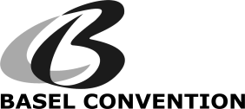 |  |  | Distr.: General  13 April 2018  English only
EWG on e-waste technical guidelines meeting
Geneva, Switzerland, 17-19 April 2018

Provisional agenda
- Opening of the meeting.
- Organizational matters:
- Adoption of the agenda;
- Organization of work.
- Proposals on outstanding items;
- Other matters and next steps.
- Closure of the meeting.
____________________

