PRACTICAL INFORMATION FOR PARTICIPANTS

REGIONAL PREPARATORY MEETING FOR THE 2015 MEETINGS OF THE CONFERENCES OF THE PARTIES TO BASEL, ROTTERDAM AND STOCKHOLM CONVENTIONS
AND
REGIONAL WORKSHOP IN SUPPORT FOR THE RATIFICATION AND EFFECTIVE IMPLEMENTATION OF THE MINAMATA CONVENTION ON MERCURY
FOR THE CENTRAL AND EASTERN EUROPE AND CENTRAL ASIA REGION
7 TO 10 APRIL 2015, BRATISLAVA, SLOVAKIA

Meetings venue

The regional preparatory meeting for the 2015 meetings of the conferences of the parties to the Basel, Rotterdam and Stockholm conventions and the regional workshop in support for the ratification and effective implementation of the Minamata Convention will be held back to back at:

Hotel Baronka
Mudrochova 2
835 27 Bratislava
Tel.: +4212 4487 2324
E-mail: recepcia@hotelbaronka.sk
http://www.baronka.sk

Dates and openings

- The regional preparatory meeting for the 2015 meetings of the conferences of the parties to the Basel, Rotterdam and Stockholm conventions will start at 9:00 a.m. on Tuesday, 7 April 2015 and is scheduled to finish by 6:00 p.m. on Wednesday, 8 April 2015.

- The regional workshop in support for the ratification and effective implementation of the Minamata Convention will start at 9:00 a.m. on Thursday, 9 April 2015 and is scheduled to finish by 6:00 p.m. on Friday, 10 April 2015.

Registration

Registrations for both meetings will be open at 8:00 a.m. on Tuesday, 7 April 2015.

Languages

Both meetings will be conducted in English and Russian, with simultaneous interpretation.

Accommodation

Hotel rooms for funded participants have been booked and paid for at Hotel Baronka. Funded participants are however responsible for payment of other miscellaneous expenses upon check-out.

Non-funded participants are welcome to stay at the Hotel Baronka at the same rate, as meeting participants. The room rate, including breakfast, is 37 EUR nett/room/night. Bookings have to be made directly via Hotel Baronka (Tel.: +4212 4487 2324; E-mail: recepcia@hotelbaronka.sk; http://www.baronka.sk). The reservation code for non sponsored particpants is: SAZP2015.

Daily subsistence allowance (DSA) and payment

UNEP will provide sponsored participants with a round trip economy class air ticket from the country of origin to the venue of the meeting by the most economic and direct route. Sponsored participants will also receive daily subsistence allowance (DSA) during the meeting, in line with UN rules and regulations, to cover dinners and other incidental expenses. These liabilities should be settled directly by the participants.

Lunch will be provided to sponsored meeting participants at the meeting venue.

For non-funded participants, restaurants at the meeting venue are available. Other restaurants are also available in the area.

To facilitate the payment of the DSA, sponsored participants are requested to provide their passports and inbound boarding passes to the BCRC-Slovakia, at the meeting venue.

UNEP shall not be liable for any costs, including but not limited to:

Costs incurred by participants for travel insurance, accident insurance, medical expenses and hospital expenses in connection with their participation in the meetings;

Compensation for death, disability or illness of the participants through their participation in the meetings;

Expenses and costs of international travel, such as passport fees, visas, immunizations, port calls, travel to and from the airport;

Loss or damage to personal property of participants;

Purchase of property and compensation for damage caused by weather or other conditions;

Other unforeseen expenses.

Contacts in Bratislava

Dana Lapešová

Tel.: + 421 2 906 314 733

Mob: + 421 905 968 146

Email : dana.lapesova@sazp.sk

Ivana Jasikova

Tel.: + 421 2 906 31 4708

Email: ivana.jasikova@sazp.sk

Basel Convention Regional Centre (BCRC)

for Training and Technology Transfer

for Central Europe in Bratislava
Slovak Environment Agency
Karloveská 2

840 00 Bratislava

P.O.Box 132
Slovak Republic
Tel: +421 (2) 6020 1639
Fax: +421 (2) 6428 2683

Visa Arrangements

All participants requiring visa for entering into Slovakia are responsible for obtaining the appropriate entry visa prior to their departure. Please note that a Schengen visa is required even for transiting through Schengen zone European Countries. The time needed for a request for visa to be processed may vary from case to case. It is therefore strongly recommended to make your application with sufficient time in advance, so that a Schengen visa can be issued.

Participants are also responsible for obtaining any transit visa that may be necessary for their travel.

Information on visa for entering Slovakia is available at:
http://www.slovak-republic.org/visa-embassies/

Transportation from the airport

Due to available flight connections, participants will generally arrive by airplane at the Vienna Airport (Austria).

There is a frequent bus connection between Vienna Airport and Bratislava. In front of the Vienna Airport building you will find a bus stop for buses to Bratislava. The main operator is EUROLINES with buses operating hourly for approximately 7,70 € for one way tickets. There is a possibility to buy an open return ticket for approximately 14, 30 €. More information and the timetable are available at: http://www.eurolines.sk/en.html.

The buses arrive at Bus Terminal station in Bratislava "Mlynske Nivy". From the Bus terminal, there are two possibilities how to get to the Hotel Baronka:
- By taxi: approximately 20 € (The taxi stand is in front of the bus terminal)
- By public transport: A 60-minute ticket for public transport can be purchased (0.90 €) in kiosks or at ticket machines. You could either take bus number 21 for 2 stops or trolley bus number 210 for 4 stops and get out at the stop “Racianske myto”. There, you turn right and go ahead to the tram stop. You take tram number 3 or 5 to stop "Detvianska" (direction “Komisarky”). The hotel is approximately 100 meters from the tram stop on the left-hand side.

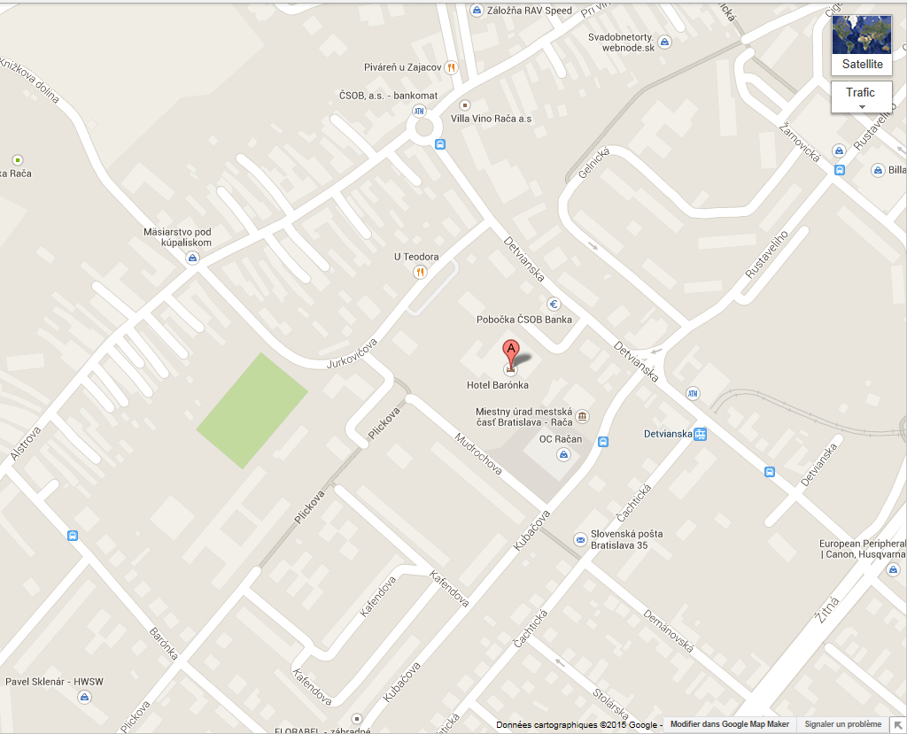
Map of the hotel surroundings

Electricity supply

Voltage: 220 volts
Frequency: 50 Hz
Plugs/sockets: C (CEE 7/16), E/F (CEE 7/4 or CEE 7/5)

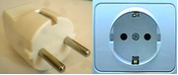

Currency

The currency used in Slovakia is the Euro.

