Assessing possible incentives to encourage the private sector to invest in environmentally sound management
(July 2016)

Prepared by: Dr. Leila Devia, BCRC Argentina and Mr. Ross Bartley, Bureau of International Recycling

List of acronyms
Acronym | Description
BAT | Best Available Technique
BC | Basel Convention on the Control of Transboundary Movements of Hazardous Wastes and their Disposal
BCRCs | Basel Convention Regional and Coordinating Centres
BIR | Bureau for International Recycling – the World Federation of the Recycling Industries
BREF | Best Available Technique Reference document
COP | The Basel Convention Conference of the Parties
CPEs | Core Performance Elements of the OECD Recommendation of the Council on the Environmentally Sound Management of Waste C(2004)100
CLI | Country Led Initiative
ESM | Environmentally Sound Management
EMS | Environmental Management System
EPR | Extended Producer Responsibility
EU | European Union
MPPI | Mobile Phone Partnership Initiative
OECD | Organisation for Economic Co-operation and Development
OSH | Occupational Safety and Health
PACE | Partnership for Action on Computing Equipment
PAYT | Pay As You Throw, variable charging
SME | Small and Medium Sized Enterprises
TBM | Transboundary Movement
ULAB | Used Lead Acid Battery
UNEP | United Nations Environment Programme

Contents
List of acronyms 2
I. Introduction 4
II. Defining ESM 4
A. Pre-2004 4
B. 2004 to 2013 5
C. From 2013 (COP-11) 6
III. Strategies to implement ESM 8
A. A view from Asia 9
B. Different strategies to ensure ESM in OECD countries 10
IV. Economics 12
A. Investment in facility equipment and personnel 14
B. Investments to demonstrate ESM 14
1. Compliance with strict legislation demonstrating ESM 14
2. Third Party Certification replacing regulatory enforcement 14
3. Assessing facility performance against the Basel Convention technical guidelines 16
V. Incentives for ESM 16
A. License, Permit, or Other Authorisation to Operate 17
B. Direct financial support 18
C. Indirect financial effects 18
D. Economic instruments 19
1. Charges for waste disposal and treatment 19
2. Pay-as-you-throw (PAYT) schemes 19
3. Extended Producer Responsibility (EPR schemes) 20
E. Support from Trade Associations 21
F. Awards 21
VI. Benefits of ESM in the Private Sector 21
VII. Conclusions 22
Annex I – References 23
Annex II – Adopted Technical Guidelines 24

I. Introduction
- By decision BC-11/1, the eleventh meeting of the Conference of the Parties to the Basel Convention (COP-11) adopted the “Framework for the environmentally sound management (ESM) of hazardous wastes and other wastes” (hereafter referred to as the ESM Framework) which establishes a common understanding of what ESM encompasses; identifies tools to support and promote the implementation of ESM; and identifies strategies to implement ESM. By the same decision, an expert working group was mandated to further elaborate and implement actions on initial short-term work items and to develop a work programme for additional priorities and key work and actions for the implementation of ESM.
- The expert working group on ESM met in December 2013 and decided on several short-term activities to implement ESM. This report deals with the request of COP-11 and the expert working group to assess possible incentives to encourage the private sector to invest in ESM.
- Importantly, efforts needed to implement ESM will vary significantly from country to country, from site to site, and from waste type to waste type. Regarding the latter waste types, the scope of the ESM Framework is for hazardous wastes and other wastes.

II. Defining ESM

A. Pre-2004
- “Environmentally sound management (ESM) of waste” is one of the underlying principles of waste management policies and has been referred to in most legislation regarding the transboundary movement of waste and in other international, regional and/or national regulations. A basic condition to allow or prohibit an export or import is whether, or not, the receiving facility has the capability to handle the waste in an environmentally sound manner.
- Managing hazardous or other wastes in an environmentally sound manner is a fundamental obligation of Parties to the Basel Convention, where a number of technical guidelines have been developed for specific waste streams, such as used tyres, plastic waste, lead-acid batteries, ships, biomedical and healthcare waste. In the context of the Mobile Phones Partnership Initiative (MPPI), guidelines on the ESM of end-of-life mobile phones have been developed. Furthermore in the context of the Partnership for Action on Computing Equipment (PACE), guidelines on the ESM of computing equipment have been developed.
- At the fifth meeting of the Conference of the Parties to the Basel Convention in December 1999, Parties adopted the “Basel Declaration on environmentally sound management”, which called for moving from the concept of ESM to its implementation. The concept encompassed the objectives of preventing, minimising, recovering and disposing of wastes in an environmentally sound manner, while taking into account social, technological and economic constraints. To achieve these ESM objectives, a number of tools and actions were recommended, such as the use of cleaner technologies, the reduction of transboundary movements of waste, the prevention and control of illegal traffic, the promotion of institutional and technical capacity-building, the transfer of environmentally sound technologies to developing countries, the development of training and information exchange, etc.
- In addition, the following criteria were recommended for Basel Parties to assess environmentally sound management:
(a) There exists a regulatory and enforcement infrastructure that ensures compliance with applicable regulations;
(b) The facilities are authorised and possess the adequate technology for treating hazardous waste and controlling pollution;
(c) The effects from waste treatment activities are monitored by facility operators;
(d) Appropriate action is taken in case of unacceptable emissions arising from waste management;
(e) Employees of waste facilities are adequately trained.
- Prior to 2004 there was no international agreement on exactly what comprises ESM. Regarding transboundary movements of both hazardous waste and non-hazardous waste, competent authorities relied on their and others’ national registration systems, licensing and permitting systems etc., and so it was assumed that if a waste management facility was licensed, permitted or otherwise authorised that the waste would be managed in an environmentally sound manner.
- At this time, the Technical Guidelines developed under the Basel Convention (see Annex B) were used by some countries and facilities in assessing ESM.

B. 2004 to 2013
- As it was apparent that ESM varied greatly from one country to another, this led the OECD Council to adopt its “Recommendation on the ESM of waste” on 9 June 2004. The Recommendation set out the scope and level of ESM for OECD Member countries and their waste management facilities handling both hazardous wastes and non-hazardous wastes for both recovery and disposal.
- The OECD Council Recommendation set out the following recommendations for its member countries:
“THE COUNCIL… RECOMMENDS that Member countries elaborate and implement policies and/or programmes to ensure that waste be managed in an environmentally sound and economically efficient manner. Domestic policies and/or programmes implemented under this Recommendation shall not lead to or create unnecessary obstacles to international trade of waste destined for recovery operations.
For the purpose of this Recommendation, taking into account the size of the enterprise, especially the situation of small and medium size enterprises (SMEs), the type and amount of waste, the nature of the operation and their domestic legislation, Member countries should:…”
Recommendation 1: “have an adequate regulatory and enforcement infrastructure at an appropriate governmental level, consisting of legal requirements such as authorisations/licences/ permits, or standards;”
Recommendation 2: “develop and implement practices and instruments that facilitate the efforts of competent authorities to monitor the implementation of the Core Performance Elements (CPEs) listed in Annex I to this Recommendation and control compliance of waste management activities with applicable national and international rules and regulations. In case of non-compliance with existing rules, prompt, adequate and effective actions should be undertaken;”
Recommendation 3: “ensure that waste management facilities are operating according to best available techniques while taking into consideration the technical, operational and economic feasibility of doing so, and work towards continually improving environmental performance;”
Recommendation 4: “encourage, through appropriate measures, information exchange between producers, waste generators, waste managers and authorities, including participation in sectoral trade or industry association activities addressing these issues, in order to foster waste prevention, optimise recovery operations and minimise quantities as well as potential risk of waste destined for disposal or recovery;”
Recommendation 5: “integrate into national policies and/or programmes the CPEs listed in Annex I to this Recommendation, which constitute the basic requirements to ensure ESM of waste;”
Recommendation 6: “consider incentives and/or relief measures for facilities that fulfil the CPEs listed in Annex I to this Recommendation;”
Recommendation 7: “implement the technical guidance for ESM of waste that has been developed by the OECD and, where appropriate, work towards the implementation of other ESM guidance referred to in Annex III to this Recommendation;”
Recommendation 8: “move towards internalisation of environmental and human health costs in waste management, taking into account the differences between hazardous and non-hazardous waste;”
Recommendation 9: “provide incentives to take part in environmentally sound recycling schemes;”
Recommendation 10: “encourage the development and implementation of an environmental liability regime for facilities that carry out risky or potentially risky activities to ensure adequate measures upon definite cessation of activities and to prevent environmental damage”.
Recommendation 11: “ensure that the implementation of the CPEs listed in Annex I to this Recommendation does not discourage recycling in Member countries, recognising, in particular, the flexibility appropriate for each Member country to increase the rates of environmentally sound recovery of low risk waste”.
- The OECD Council Recommendation set out six CPEs that a facility should comply with to be considered environmentally sound. These are:
(a) The facility should have an applicable Environmental Management System (EMS) in place;
(b) The facility should take sufficient measures to safeguard occupational and environmental health and safety;
(c) The facility should have an adequate monitoring, recording and reporting programme;
(d) The facility should have an appropriate and adequate training programme for the personnel;
(e) The facility should have an adequate emergency plan;
(f) The facility should have an adequate plan for closure and after-care.

C. From 2013 (COP-11)
- The Conference of the Parties to the Basel Convention at its eleventh meeting adopted the “Framework for the Environmentally Sound Management of Hazardous Wastes and Other Wastes” (the ESM Framework).
- The ESM Framework sets out its scope and objectives and its guiding principles. The Framework goes on to elaborate a common understanding of what ESM encompasses; it provides advice on tools to support and promote the implementation of ESM; and strategies to implement ESM. The role of key stakeholders, such as governments and other stakeholders, is provided. The ESM Framework goes on to explain the linkage between ESM and transboundary movements of waste. It provides indicators for the verification of performance, and sets out recommendations. Its annexes provide guiding principles and a non-exhaustive list of resource documents.
- The ESM Framework is a more complex document than the OECD Recommendation. For facilities it sets out in its Section VI the role of stakeholders, wherein it states for:
Waste management facilities
33. Waste management facilities that handle wastes should meet all basic requirements to ensure ESM of wastes and commit to continual improvement in their operations.
34. The whole life cycle of the facility should be covered, from planning and construction of a facility to its operation and subsequent dismantling or site remediation (in the event of accidents or spills during operation) or site clearance at end of life, as appropriate. As such, a facility should have the following, which should meet the approval of the competent authorities concerned:
(a) Appropriate design and location of the plant, taking into account potential risks to the environment, including environmentally sensitive areas;
(b) Where appropriate, an environmental and social impact assessment, which should be conducted and approved by the appropriate authorities before a facility is constructed;
(c) Sufficient measures in place to safeguard OSH, including:
(i) Measures which meet the requirements of national OSH legislation;
(ii) Appropriate actions to address significant actual and/or potential risks to the health and safety of the public and of workers, based on a risk assessment, and to correct deficiencies that have been identified, including contingency arrangements in the event of plant breakdown or accidental spillages;
(iii) An appropriate and adequate training programme for personnel, to ensure employees have an appropriate level of awareness, competency and training with respect to the effective management of occupational risks, including the effective management of wastes;
(d) Sufficient measures in place to protect the environment, including:
(i) Measures to control pollution taking into account emission limit values to air, water and soil;
(ii) Appropriate actions to address significant actual and/or potential risks to the environment, based on risk assessment, and to correct deficiencies that have been identified, including contingency arrangements in the event of plant breakdown or accidental spillages;
(iii) Waste acceptance and handling criteria, including measures to ensure due diligence and proper collection, sorting, pre-treatment, treatment, storage and downstream management of wastes and residuals;
(e) An applicable environmental management system in place, if feasible and appropriate, which:
(i) Describes, assesses and reviews the design, construction, operation, monitoring, management and maintenance of the facility and which will be periodically reviewed;
(ii) Demonstrates compliance with applicable legislation and regulations;
(iii) Demonstrates the commitment of management to integrating a systematic and consistent approach to achieve ESM in all aspects of facility operations;
(iv) Includes provisions to support transparency and confirm implementation of ESM by the facility, subject to appropriate protection of confidential business information, which can help assure the public that operations and activities are compatible with ESM. Such provisions may include third-party audits and inspections;
(f) An adequate and transparent monitoring, recording, reporting and evaluation programme21 which covers:
(i) Relevant legal requirements, including key process parameters;
(ii) Compliance with applicable safety requirements;
(iii) Effluents and emissions;
(iv) Records of incoming, stored and outgoing wastes;
(g) An adequate emergency plan and response mechanism;
(h) An adequate plan for closure and aftercare, which includes the identification and remediation of contaminated sites.

III. Strategies to implement ESM
- The ESM Framework suggests the following strategies to implement ESM:
(a) Strategies should be developed to foster and enhance implementation of ESM of wastes at the international, regional, national, local and facility levels. These strategies should respect the waste management hierarchy and be compatible with the concepts presented in part V, sections A and B of this framework.
(b) It is recognized that implementation of ESM is an evolutionary process that takes time to achieve and that existing provisions can vary greatly from country to country and from facility to facility. The capabilities and challenges faced by least developed countries, developing countries and countries with economies in transition need to be considered. In light of this, strategies should be devised to address variations in circumstances. To ensure effective strategy development, it is critical to systematically anticipate, identify and prioritize issues that need to be addressed by compiling baseline information on a variety of waste-related aspects such as:
(i) Types and quantities of wastes generated;
(ii) Potential for waste prevention and minimization;
(iii) Actual or potential risks posed to human health, worker safety and the environment;
(iv) Available infrastructure and capacity to manage wastes;
(v) Applicable laws and enforcement provisions;
(vi) Waste facility or sector-based measures in place to support ESM;
(vii) Approaches used to validate whether facilities achieve ESM;
(viii) Types of informal waste management activities;
(ix) Availability of necessary funding to achieve ESM.
(c) Any strategy should include a series of core goals to provide a general overview of how its overarching vision will be achieved. Taken together, the following goals represent tangible outcomes or milestones that are considered to be essential to achieve ESM:
(i) Establish a comprehensive legal framework to:
a. Effectively govern all waste management operations;
b. Protect the public and workers’ health and safety;
c. Protect the environment;
d. Address movements of wastes in accordance with applicable international and regional agreements and conventions, including the Basel Convention;
(ii) Implement effective compliance and enforcement measures to assure conformity with applicable legal requirements;
(iii) Build sufficient domestic infrastructure and capacity to ensure availability of adequate facilities to undertake waste management operations and ensure these facilities achieve ESM.
(d) A comprehensive legal framework establishes a level playing field to protect human health and the environment by obligating all stakeholders involved in waste management operations to comply with legal requirements. Such requirements include provisions that respect international and regional obligations. While law-making is typically a function of Governments and their agencies, it is important for all stakeholders to be aware of, and comply with, existing and emerging legal requirements in the jurisdictions where they conduct business.
(e) Effective compliance and enforcement measures ensure that legal requirements are being met by waste management operations. Governments should ensure that consistent measures are in place to enable the competent authorities to confirm whether waste management operations are achieving ESM. Other opportunities also exist and may pertain to compliance promotion efforts, training for inspectors and enforcement officers, joint investigations and intelligence-led inspection activities and court prosecutions. From a facility perspective, compliance with applicable legal requirements is a prerequisite for bona fide businesses and failure to comply with legal requirements can be very costly for an organization. Working with legally compliant suppliers and service providers is also important because it fosters ESM through management of the supply chain and serves to protect business reputations by meeting the expectations of investors, customers, regulators and the public. Voluntary certification schemes may be useful for confirmation of ESM. A number of standards and voluntary certification schemes are identified in annex II to the framework.
(f) Building sufficient domestic infrastructure and capacity to ensure availability of adequate facilities to undertake waste management operations allows wastes to be managed in close proximity to where they are generated, minimizing the need for them to be exported for management elsewhere, and provides opportunities for enhanced resource recovery, economic growth, employment and increased competitiveness within the global marketplace. Domestic infrastructure needs for waste management may vary considerably from country to country and include but are not limited to: collection services for wastes and recyclable materials; refurbishing, composting, material recovery and recycling facilities; and treatment and final disposal facilities for wastes.
(g) The highest levels of support should be sought by key stakeholders to ensure acceptance of the vision and goals of their strategies to implement ESM and that adequate resources will be made available to support delivery. The importance and benefits of any strategy developed to foster and enhance implementation of ESM of wastes should also be well communicated to broaden awareness and foster acceptance of such strategies amongst key stakeholders.

A. A view from Asia
- The Institute of Developing Economies, Japan External Trade Organization (IDE-JETRO) in its publication “Policy for Fostering ‘Sound’ Recycling Industries” covered topics such as: Stakeholders in Recycling and the Current Status in Asia; Occupational Health and Safety, Pollution Control, and Quality Management; What is a ‘Sound’ Recycling? Strategies for Fostering Sound Recycling; Best Practices in Fostering Sound Recycling Industries; and the Voice of Sound Recyclers.
- The key points of Chapter 5: Strategies for Fostering Sound Recycling are presented in the box below.
Best Practices in Fostering Sound Recycling Industries in Asian countries

1. Organizing Waste Pickers
2. Organizing Junk Shops
3. Waste Collector Parks for Recyclable Waste
4. Quality Standards for Recyclable Waste and Recycled Products
5. Eco-labelling and Green Purchasing
6. Extended Producer Responsibility
7. Recycling Industrial Park
8. Award Program for Excellent Recyclers
9. Tax incentives, Subsidies, and Low-interest Loans

B. Different strategies to ensure ESM in OECD countries
- A review of the way, and extent to which, OECD Member Countries implemented the ESM Recommendation took place three years after its adoption (i.e. in 2007). That review showed that the OECD Member countries have different strategies to ensure ESM whereby certain means or a combination of means carried out by governments and other stakeholders ensure their facilities are ESM, for example:
(a) By strict prescriptive legislation on what to do and how to do it:
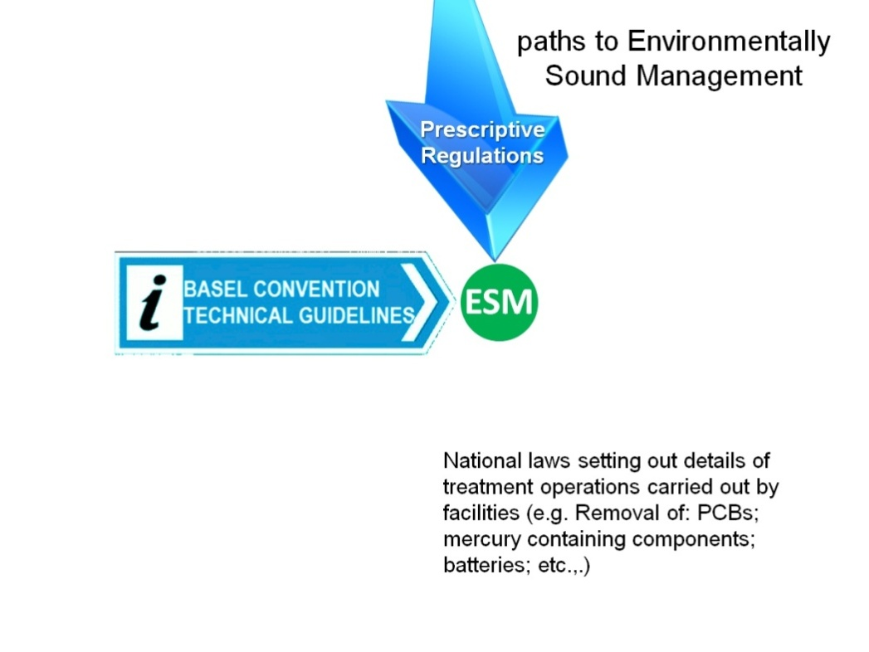
(b) By ensuring proper application of a generic Management System with a plan – do – check - act model that will determine what to do and how to do it, in combination with less prescriptive framework legislation:
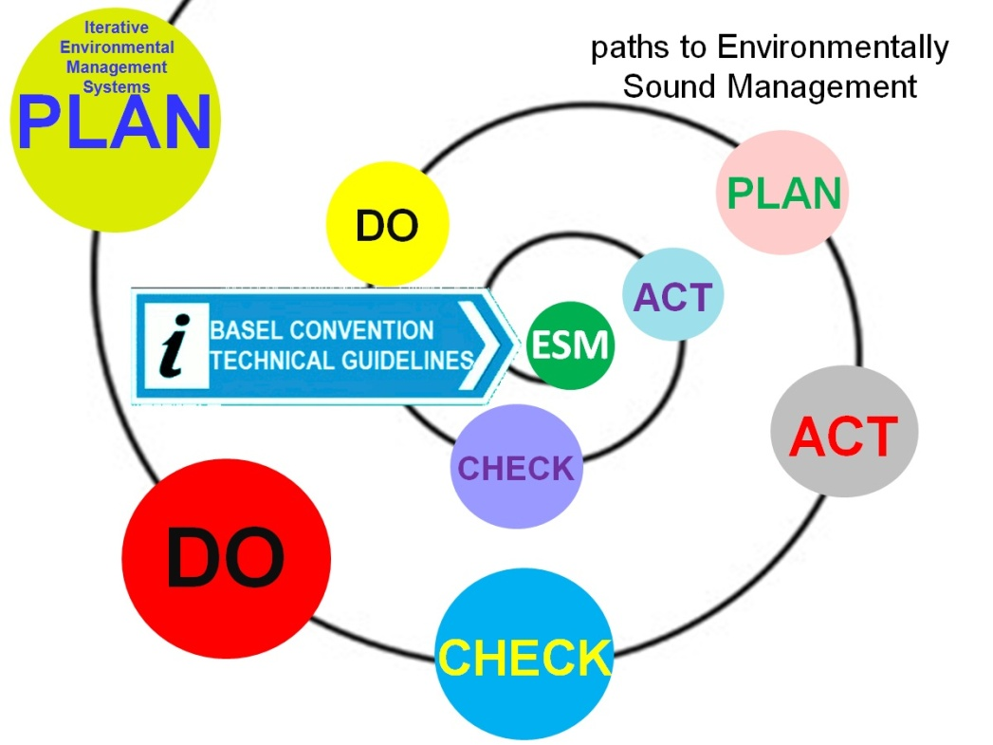
(c) By tailor made sector specific EMSs on what to do and how to do it, in combination with less prescriptive framework legislation:
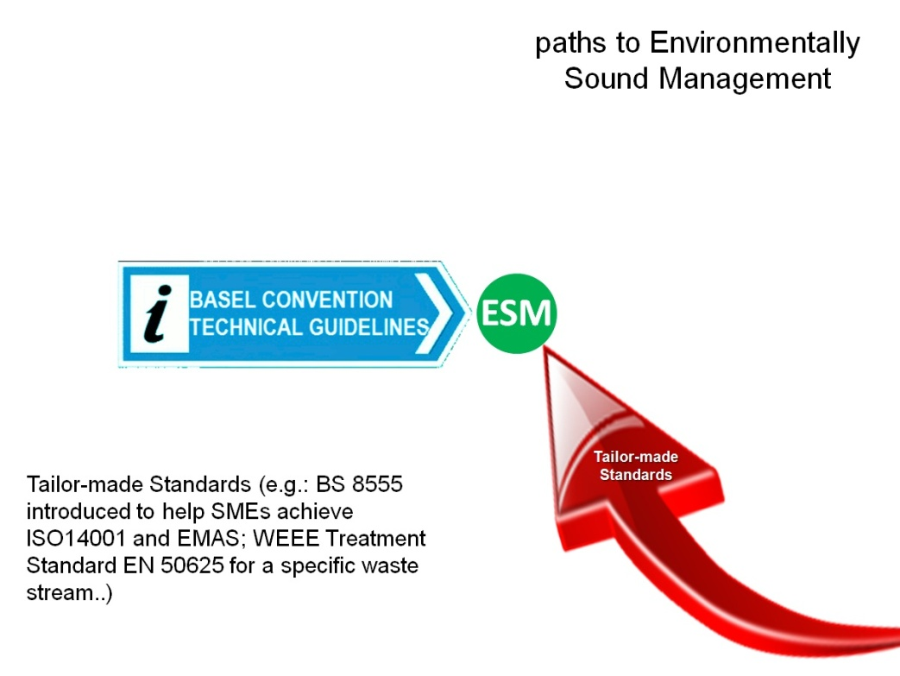

(d) Linking with respective Basel Convention Technical Guidelines:
Over 20 years, the Basel Convention has adopted and promulgated technical guidelines principally on the ESM of certain wastes, and on disposal operations such as landfilling and incineration on land, but also on other technical issues such as hazard characterisation. Annex B lists the adopted technical guidelines. The practical linkage of facility operations with the Basel Convention Technical Guidelines has not been fully exploited for all final disposal or recovery operations. Assessing facility ESM against relevant Basel Convention Technical Guidelines is another path to ESM, with many benefits for the Basel Convention itself. The experience of the Green Lead Initiative which has developed and made applicable an assessment method for verifying compliance with ESM for Used Lead Acid Batteries (ULABs) is related here below.
The Green Lead initiative
The basic philosophy behind the Green Lead initiative is the use of an audit tool to assess the recovery and recycling procedures and processes for the sound management of the lead life-cycle to determine the degree of compliance with the respective national environmental and occupational health legislation, the Basel Convention for the transboundary movement of ULAB and conformance with the Basel Technical Guidelines for the ESM of ULAB.
In 2002, as part of a ULAB recovery and recycling project in Central America and the Caribbean Island States, the Basel Secretariat initiated work on the development of an assessment tool to measure conformance with the Basel Convention and the Basel Technical Guidelines. In 2004, the Secretariat decided to pool resources with the Green Lead Initiative, which was also developing an ESM assessment tool for the lead industry and to adopt the term “Green Lead” for its assessment tool.
The Green Lead Assessment Tool identifies any adverse impacts associated with lead during the ULAB recovery and recycling phases and provides a platform to establish procedures to minimize or eliminate these impacts. In this respect the Green Lead Assessment Tool is a pro-active product stewardship instrument aimed at contributing to broader and better sustainable development outcomes for the lead industry through the sound management of the lead product life cycle.
The basic process concept of Green Lead is the identification of impacts associated with lead, the establishment of protocols and subsequent mechanisms to minimize these impacts and recognition of organizations that achieve compliance with the protocols through the Green Lead Award for ESM and Sustainable Recovery and Recycling of ULAB in compliance with prevailing legislation, the Basel Convention and the respective Technical Guidelines.
The Green Lead Assessment Tool is applicable to Mine Sites, ULAB storage units, ULAB transportation and recycling plants. In principle, this means that a Green Lead Assessment Program should direct all sectors in the life-cycle of a Lead Acid Battery: that is, the lead mines, the primary and secondary smelters, the battery manufacturers, the consumers and the recyclers, in practices and procedures that are sustainable and minimize or negate any potential adverse impacts on either the environment or the population.

IV. Economics
- The basic economics of a waste management business involve firstly establishing the business with start-up capital, and secondly and most importantly, running the business so that it breaks even, or if it is run as a commercial enterprise, that it makes a profit. The required start-up capital will include such items as:
(a) Investments:
(i) Business premises;
(ii) Equipment;
(b) Working Capital:
(i) For licensing, permitting or other authorisation;
(ii) Stocks of raw materials;
(iii) Wages and salaries;
(iv) Rent.
- The most important types of start-up capital are:
(a) Owner’s equity - equity or owner’s contribution means the private money the owner puts into the business;
(b) Loans - from such as: banks; government credit schemes; non-government credit schemes; or private e.g. from friends;
(c) Grants - an allowance that a government or an organization gives to support business creation.
- The scope of the ESM Framework is reiterated here as for hazardous wastes and other wastes, due to the nature and classification of these wastes, their ESM will typically be costly.
- The Basel Convention lists in its Annex IVA operations which do not lead to the possibility of resource recovery, recycling, reclamation, direct re-use or alternative uses. For most, if not all of these operations, the start-up capital would likely be outside the means of small-sized enterprises, whilst running these disposal operations will commonly entail a “gate fee” where the facility operator charges those who wish to dispose of wastes dependent on the waste characteristics, such as hazardous waste or other waste, and on its volume or weight. The operations include:
D1 Deposit into or onto land, (e.g., landfill, etc.)
D2 Land treatment, (e.g., biodegradation of liquid or sludgy discards in soils, etc.)
D3 Deep injection, (e.g., injection of pumpable discards into wells, salt domes of naturally occurring repositories, etc.)
D4 Surface impoundment, (e.g., placement of liquid or sludge discards into pits, ponds or lagoons, etc.)
D5 Specially engineered landfill, (e.g., placement into lined discrete cells which are capped and isolated from one another and the environment, etc.)
D6 Release into a water body except seas/oceans
D7 Release into seas/oceans including sea-bed insertion
D8 Biological treatment not specified elsewhere in this Annex which results in final compounds or mixtures which are discarded by means of any of the operations in Section A
D9 Physico chemical treatment not specified elsewhere in this Annex which results in final compounds or mixtures which are discarded by means of any of the operations in Section A, (e.g., evaporation, drying, calcination, neutralization, precipitation, etc.)
D10 Incineration on land
D11 Incineration at sea
D12 Permanent storage (e.g., emplacement of containers in a mine, etc.)
D13 Blending or mixing prior to submission to any of the operations in Section A
D14 Repackaging prior to submission to any of the operations in Section A
D15 Storage pending any of the operations in Section A
- The Basel Convention lists in its Annex IVB, operations which may lead to resource recovery, recycling, reclamation, direct re-use or alternative uses. Its chapeau explains that “section B encompasses all such operations with respect to materials legally defined as or considered to be hazardous wastes and which otherwise would have been destined for operations included in Section A”.
- For some of these operations, the start-up capital could be within the means of small- and medium-sized enterprises (SMEs). The running of these re-use or recovery operations may entail a “gate fee” where the facility operator charges those who send their wastes to be recovered dependent on the waste characteristics, such as hazardous waste or other waste, and on its volume or weight. The operations include:
R1 Use as a fuel (other than in direct incineration) or other means to generate energy
R2 Solvent reclamation/regeneration
R3 Recycling/reclamation of organic substances which are not used as solvents
R4 Recycling/reclamation of metals and metal compounds
R5 Recycling/reclamation of other inorganic materials
R6 Regeneration of acids or bases
R7 Recovery of components used for pollution abatement
R8 Recovery of components from catalysts
R9 Used oil re-refining or other reuses of previously used oil
R10 Land treatment resulting in benefit to agriculture or ecological improvement
R11 Uses of residual materials obtained from any of the operations numbered R1-R10
R12 Exchange of wastes for submission to any of the operations numbered R1-R11
- Waste management facilities may be operated by private business enterprises (whether large, medium or small), as well as by public authorities, such as municipalities, where they organise and carry out waste collection and management themselves.

A. Investment in facility equipment and personnel
- Only a minority of countries around the world need or can sustain every type of hazardous waste management facility principally due to the various types and volumes of wastes arising domestically and the economics of installing capacity and running waste management facilities sustainably and in an environmentally sound manner. Though the total cost of facilities may vary considerably depending on local economies and the characteristics of the waste being handled, indicative costs of ESM waste management facilities can be in the order of: $20 million for a sanitary landfill; sorting plant - $10 million; waste to energy plant - $150 million; bottom ash recovery plant - $2 million; and anaerobic digestion plant – $30 million.
- For countries that lack sufficient funding for investments themselves, in order to move to the sustainable and ESM of domestic wastes arising, foreign direct investment may be necessary. In that respect companies weighing up a long-term decision to invest in waste management facilities look to the reliability and clarity of a host government’s administration and the transparency of its decision-making process. Besides which waste management needs high-quality regulation and enforcement, otherwise waste will find its way to illegal operations and destinations.
- For every country, no matter its size, location or level of development, attracting investment is a competitive exercise. Thus, all countries and local communities alike must be prepared to provide waste management businesses with the right environment, including a transparent and predictable policy framework, for investment in new or expanded facilities. Some of the important elements of concern to investors would include, but are not limited to:
(a) The content of national laws, such as planning regulations, waste legislation, labour laws;
(b) The reliability of the banking and legal system as well as the predictability of the regulatory and fiscal environment;
(c) That the judicial system is efficient, accountable and predictable;
(d) The presence of constitutional guarantees regarding ownership of property (e.g. land, equipment, wastes).

B. Investments to demonstrate ESM

1. Compliance with strict legislation demonstrating ESM
- Where countries have strict regulations for certain waste streams, the regulatory authority ensures compliance with those regulations through licensing, permitting or other authorisations and hence the compliant facility will be ESM.

2. Third Party Certification replacing regulatory enforcement
- Some authorities are considering replacing the role of the regulatory authority by requiring facilities to obtain third party verified certificates of compliance with specified standards, for example with an Environmental Management System (EMS). Several variables, including the size (micro, small, medium and large) and type (public or private) of organisations or the region in which they are registered, influence the costs of implementing an EMS.
- Facilities will then face costs to introduce the required EMS or Standard. Such costs for an SME are in the region of $15,000 in developed countries. These costs include:
External consultant
- Support may be needed for the initial review, auditing, training and ongoing implementation of the EMS. Internal costs are incurred by organisation staff to implement, administer and report. The costs include the following aspects:
(a) Environmental review;
(b) Development of EMS;
(c) Internal audit;
(d) Preparation of environmental statement;
(e) Internal staff training;
(f) Attaching certification logo;
(g) Modifications to Information Technology systems;
(h) Publication of environmental statement;
(i) Other costs related to administration.
- The typical personnel commitment to implement an EMS varies from a few persons per month in a small company in the service sector to several persons per year in large corporations with many sites.
- These facilities will also face annual costs in maintaining the required certification.
- Such costs for an SME are in the region of $7,000 per annum in developed countries and include:
(a) Validation and verification fees
Environmental verifiers are private consultants and therefore charge the usual market prices for consultancy services. SMEs without complex environmental impacts can be verified in one or a few days only.
(b) Registration fees
Registration fees are different from verification costs and can vary from zero to $1500 in the case of large companies.
(c) External consultancy
External consultancy costs may be approximately one third of those incurred in the first year.
(d) Fixed costs
Fixed costs of adding certificate logo to stationary and producing publicity material.
- It follows that where a country has over a certain number of waste management facilities, it would likely be less costly for all to have a strict regulatory regime together with government or agency personnel for inspection and enforcement.
Examples of Green Lead being applied on the ground
The best case of applying Green Lead occurred in Guatemala, when the Acumuladores Iberia ULAB Recycling facilities applied for a Green Lead award and the process started with a guided self-assessment, with the participation of an international consultant hired by the Basel Secretariat, which produced a list of non-conformities, as well as a scheduled plan of action on how to resolve them. Once the company estimated that there were significant advances in eliminating the non-conformities, a further series of visits from the consultant was arranged to verify compliance and clarify the pending non-conformities. Three visits of the international consultant were required during a period of two years (2007-2009) to obtain full compliance with the Basel Technical Guidelines and the Green Lead Protocols, ending with a visit by the Guatemalan Minister for the Environment and Natural Resources in February 2009, when he was present for the first ever Green Lead Award delivered to the Acumuladores Iberia ULAB Recycling facility.
A second Green Lead Award was given to Acumuladores Iberia in 2011, but this time around the verification of compliance was made by a Guatemalan professional, who was trained in a workshop organized by BCRC-CAM with funding from the Secretariat of the Basel Convention on June 2009, when 20 Central Americans were trained as Assessors. Moreover, in order to obtain this second Green Lead Award, Acumuladores Iberia had to demonstrate that they have made an effort to train one of their major suppliers to collect ULAB in an environmentally sound manner, following strictly the corresponding Basel Technical Guidelines.
Other practical applications of Green Lead advanced in ULAB Recycling facilities in Costa Rica (PB Metals), Colombia (MAC), and the Dominican Republic (Verde Ecoreciclaje Industrial), as well as in two Salvadoran temporary facilities, but they could not be finalized because Green Lead lacked proper funding to move to full certification accreditation. Thus, Green Lead helped to set up a new standard on ESM of ULAB recycling and temporary storages in Central America and the Caribbean. Additionally, Green Lead had an impact in Senegal, Ghana, Cambodia, China and India, though with another twist, aiming for a more limited approach of obtaining quick wins to motivate further advances in ESM.

3. Assessing facility performance against the Basel Convention technical guidelines
- In the previous section on Strategies for ESM, the Green Lead Initiative was introduced. Recall that the basic process concept of Green Lead is the identification of impacts associated with lead, the establishment of protocols and subsequent mechanisms to minimize these impacts and recognition of organizations that achieve compliance with the protocols through the Green Lead Award for the ESM and Sustainable Recovery and Recycling of ULAB in compliance with prevailing legislation, the Basel Convention and the respective Technical Guidelines.

V. Incentives for ESM
- The ESM Framework identifies incentives for ESM as follows:
(a) A common understanding of what ESM encompasses
ESM of wastes requires the development and implementation of a system of policies, legislation and regulations, monitoring and enforcement, incentives and penalties, technologies and other tools in which all key stakeholders participate and cooperate.
(b) Tools to support and promote the implementation of environmentally sound management
Tools to support and promote the implementation of ESM include a combination of legislative and regulatory tools, guidelines and/or codes of practice, voluntary certification schemes, voluntary agreements and schemes, mechanisms for cooperation at the international, regional, national and local levels, including with industry, training and awareness programmes and incentive schemes. They may be tailored to address specific waste streams. The framework outlines examples of tools in each of these categories and a supportive list of resource documents is provided in annex II.
(c) Economic and non-economic incentives:
(i) Price incentives to promote and stimulate sorting at source;
(ii) Relief measures for facilities, such as reduced tax for a certain period, extension of a licensing period for an ESM facility, or other measures that reduce procedural or administrative burdens;
(iii) Recognition or award.
(d) Roles of key Stakeholders
In many cases, environmental and human health costs resulting from waste management are not fully reflected in the financial costs of waste management. These external costs may vary considerably depending on factors such as local conditions or the nature of the waste. The financial costs of waste management may therefore be less than the total social costs, with the difference being borne by other economic operators. As long as this is the case, waste generators and managers may not have sufficient incentives to adopt an appropriate level of waste management within their facilities. In the same way, any environmental benefits should be internalized into waste management decisions at the facility level.
Governments should foster continual improvement within the waste management sector, including provision of incentives (e.g., economic incentives, regulatory relief measures such as fewer inspections, taxes, etc.) for facilities which adopt improvements going beyond the minimum performance elements outlined for the achievement of ESM at the facility level. Such measures could increase recycling and recovery rates, optimize resource productivity and minimize generation of waste residuals after recovery processes.
Governments should provide incentives to foster the development of infrastructure for relevant waste management technologies and facilities that support the leading elements of the waste management hierarchy and ESM such as waste prevention, including:
(i) Measures to increase waste prevention, reduction, reuse, recycling and recovery rates, taking into consideration sustainable management of materials;
(ii) Incentives to recognize environmental stewardship in the private sector and foster the development of voluntary certification programmes, consistent with the Basel Convention and other applicable international rules, relevant decisions of its Conference of the Parties, technical guidelines, relevant national implementing legislation, regulations and other measures.
(e) Indicators for the verification of performance
Indicators to measure progress at Government level may include schemes at the national or regional level to foster continual improvement within the waste management sector, including measures to ensure facilities operate according to appropriate BAT and BEP, encourage information exchange, provide incentives and implement the relevant technical guidance and guidelines adopted by the Basel Convention.
Incentives
In many Asian developing countries, with the exception of China and India, the economic scale of operations is not so large that the volume of recyclable waste generated is enough to run a large plant. In addition, if enforcement of pollution controls is not strict enough, informal and small scale recyclers without pollution controls can collect recyclable waste at a higher price than formal recyclers. In such situations, formal recyclers may not be able to continue their operations and investors who want to comply with regulations may be hesitant to invest in recycling businesses. Therefore, it is better to provide incentives to reduce the costs incurred by sound recyclers. Examples of economic incentives that may be considered include direct subsidies and tax exemptions for pollution prevention investment and the reduction of import duties on pollution control equipment. Logistically, it is important for recyclers to collect enough volumes of waste to operate a plant. To ensure that a sufficient volume is sent to sound recyclers, it should be required for waste generators to send their waste to formal recyclers. In addition, government sectors should send their waste to formal recyclers that are licensed and have pollution controls for the factory and downstream operations.

A. License, permit or other authorisation to operate
- Fulfilling the requirements in order to obtain a license, or a permit or another means of authorisation to operate a waste management facility will entail investments in the facility and in its personnel. These investments will differ from country to country, and likely within a country be dependent on the level of government that provides the authorisation.
- Where legislation is prescriptive and in detail for example in Europe with the Waste Framework Directive, the Waste Shipment Regulation, the Incineration Directive, the Landfill Directive, the Industrial Emissions Directive and furthermore with prescriptive Priority Waste Stream Directives for Packaging & Packaging Waste, Batteries and Accumulators, Waste Electrical & Electronic Equipment, End-of-Life Vehicles etc., this legislation in combination with the respective authorisation to operate ensures ESM.
- The necessity to obtain a license, permit or other authorisation to operate is an incentive for ESM, although a ‘stick’ rather than a ‘carrot’. This approach works when government agencies and ministries ensure an adequate level of enforcement to prevent that illegal facilities operate in competition with the fully compliant ESM waste management sector.
Permit and Regulatory Incentives
Although technically not falling under the definition of market-based incentives, it is useful to discuss permit and other regulatory incentives. Permit incentives come in the form of expedited permitting, increased permit flexibility, multimedia permitting, and self-certification permit programs, among many different options. Also, experimental regulatory incentives in the form of "grace period" laws were being explored in the mid-1990s. Grace period laws are designed to more clearly focus limited public resources on serious violations. When a "minor" violation is discovered, the relevant environmental agency must provide the violator with a "notice to comply" or a "notice of violation". The notice identifies the violation and provides a time period in which the violator must come into compliance.
Yet another form of regulatory incentive is the environmental "amnesty" law. These laws are designed to encourage businesses to request technical assistance, and/or to voluntarily engage in pollution prevention activities. Regulatory agencies will ignore a committed offense if the violator requests technical assistance or participates in an officially sponsored voluntary pollution prevention program. Amnesty laws are targeted toward small businesses, which may not have adequate resources or expertise to conduct an environmental self-audit. By not levying fines during these "amnesty" periods, businesses attain a very real financial benefit.
An example of a permit incentive program is the Florida’s Department of Environmental Protection "team permitting" approach in the USA. Applicants who need to receive permits from multiple agencies can agree to have team permits known as "ecosystem management agreements". In exchange, applicants must have exemplary compliance records and must demonstrate that this approach will result in a "net ecosystem benefit" to the affected ecosystem and a reduction in overall risks to human health and the environment. This program has resulted in increased permit flexibility, expedited permit processing, alternative monitoring and reporting requirements, cooperative inspections and hundreds of thousands of dollars in savings for private sector participants.

B. Direct financial support
- Certain levels of government may provide grants for waste management companies to introduce EMSs, for example by providing financial support (facilities having an EMS may be wholly or partly exempted from registration/permit fees, or have part of their EMS implementation costs reimbursed, etc.).
Subsidies
Subsidies are a commonly used tool in environmental management. Some examples used at all levels of government are grants, low-interest loans, favorable tax treatment, and environmentally preferable procurement policies. Subsidies are used to promote pollution prevention, the clean-up of contaminated industrial sites, farming and land preservation, sustainable/green energy, environmentally friendly fuels and vehicles, and municipal wastewater treatment. These subsidies are sometimes criticized because the government is helping to bear the costs that should be the responsibility of the polluter. Some examples of subsidies include tax benefits for the purchase of a hybrid vehicle and the $500 voucher incentive for hazardous waste management offered by King County Local Hazardous Waste in Seattle, USA.

C. Indirect financial effects
- There are a range of incentives that governments that have a comprehensive regulatory infrastructure in place can use to encourage facilities to introduce EMSs. Those that have an indirect financial effect include:
(a) Reducing the frequency of regulatory inspections or of monitoring requirements and facilitating emission controls which can be performed by the staff itself;
(b) Reducing reporting requirements that are duplicating those of EMSs in place;
(c) Expediting and consolidating environmental permits/licences and auditing and certifying facilities;
(d) Waiving certain environmental regulations that are duplicating the provisions of EMSs: for example, in certain European countries where environmental reporting is mandatory through national law, EMAS-registered facilities are exempted from environmental reporting under national law;
(e) Providing technical assistance and information;
(f) Providing preference for recyclables through public procurement.
- Governments may use any form of incentive they choose. However, caution is recommended, in order to avoid introducing measures which could have a counter-productive effect, e.g., relief measures, such as the exemption from being subject to a regulation where the activities of many such exempt SMEs could undermine the ESM of certain waste streams.
- Governments may seek to encourage SMEs to implement an EMS through various incentives or relief measures. Additional examples of incentives include:
(a) The development of EMSs, specifically designed for SMEs. For example, the Eco-Action 21 in Japan includes its own auditing and certification procedures;
(b) Relaxing verification and reporting procedures, by spacing out the due dates of inspections and reporting less frequently (for example, every three years instead of every year);
(c) Exemption from certain national regulations which may duplicate the EMS’s provisions;
(d) Free provision of information, advice and expertise concerning EMSs and their benefits, related environmental regulations and subsidisation programmes;
(e) Public recognition and advertising of such facilities through the publication of their environmental performance or special registers;
(f) Financial incentives, such as assistance for investments, financial support for workers’ training on environmental matters, reimbursement of part of the auditing and certification costs (sometimes up to 75 % of the external consultant costs), and reduction of inspection fees and preference in public procurement.

D. Economic instruments
- Economic instruments encompass a range of policy tools from pollution taxes and marketable permits to deposit-refund systems and performance bonds. The common element of all economic instruments is that they operate on a decentralized level through their impact on market signals.
- Economic activity to generate goods and services incurs costs not only to the private parties involved in production and consumption (known as “private costs”) but also to the public (known as “social costs”). Social costs include costs of pollution, depletion of natural resources or degradation of the environment. As these costs are often not included in prices paid by consumers and producers they are borne by society as a whole. The failure to consider these “external costs” in private decision-making may be corrected through the use of economic instruments, by including them in the prices of goods and services, so as to convey more accurate market signals. Economic instruments are therefore a means of implementing the “Polluter Pays Principle”.

1. Charges for waste disposal and treatment
- Besides landfill operators fees to dispose of wastes in sanitary landfills, some countries have introduced landfill taxes that besides having the effect in concert with landfill bans to divert recyclables away from landfill, the collected taxes may be used to fund improved waste management infrastructure.
- Likewise operators of incinerator plants commonly charge fees for their services, some countries have introduced incineration taxes that besides having the effect in concert with incineration bans to divert recyclables away from incineration, the collected taxes may be used to fund improved waste management infrastructure.

2. Pay-as-you-throw (PAYT) schemes
- PAYT Schemes may provide funds for investment in waste management infrastructure. However as the amounts charged would need to be affordable and at a level that does not encourage those liable to avoid the PAYT fee, such systems would need to provide stability and so operate for extended periods of time.

3. Extended Producer Responsibility (EPR) schemes
- The OECD has published its Extended Producer Responsibility: Updated Guidance for Efficient Waste Management in 2016, updating the 2001 Guidance Manual for Governments on Extended Producer Responsibility.
- Regarding incentives, one of the key rationales for EPR schemes is to incentivise the design for the environment, so that products contain less or no hazardous materials that would present problems for their end-of-life management.
- It should be recognised that business-to-business contracts between producers and their service suppliers may require the meeting of set minimum performance standards, including meeting set environmental management standards, quality management standards and occupational health and safety management standards.
- Regarding disincentives associated with EPR schemes, those included the undermining of investment, uncertainty surrounding ownership of material and forcing vertical integration through the value chain, as well as the abuse of the market power given to producer responsibility organisations. SMEs in the recycling and recovery sector typically express concerns of being threatened by EPR schemes.
Chinese Case of Private Sector Incentives for ESM of WEEE
Referring to developed countries’ experience and China’s own practice, especially the home trade-in policy, a new policy, the Administrative Measures on the Collection and Using of Waste Electrical and Electronic Equipment Treatment Fund (hereinafter called “Fund”), was issued by the Ministry of Finance (MOF), Ministry of Environmental Protection (MEP), National Development and Reform Commission (NDRC), Ministry of Industry and Information Technology (MIIT), General Administrative of Customs (GAC), State Administration of Taxation (SAT) of the People’s Republic of China and enforced on July 1st, 2012 after a certain long time of deliberate modification.
The whole content of the Fund is divided into six parts in the original document: (1) general principles; (2) Fund collection; (3) Fund use; (4) supervision and regulations; (5) legal liabilities; (6) supplementary provisions.

The incentives generated by the Fund
Different from previous laws and regulations, this policy has its own features and provides evident incentives.
Firstly, this system’s establishment elevates the industry access threshold concerning WEEE treatment. As a consequence, some enterprises have to improve their comprehensive abilities to get this certain qualification primarily, which will lead the whole industry to standardization, modernization and industrialization. A group of enterprises with prominent treatment technologies can make certain guarantees for the pollution control, which is caused by WEEE and created during treatment processes.
Secondly, the subsidy enables and encourages authorized recyclers and treatment companies to collect more WEEE in certified way. Aiming for that, these appointed enterprises will expand the publicity of certified WEEE recycling systems to improve public awareness about WEEE management.
Altogether, the foundation of the Fund greatly stimulated China’s WEEE management. According to official figures, by 2014, there have been 106 enterprises that gained the fund subsidy, which have achieved an accumulated amount (from July 2012 to the end of 2013) of 3.93 billion RMB and with a total number of 47.464 million appliances subsided. More importantly, some changes concerning the ESM of WEEE have taken place in China. It has been proved that effective operation and implementation of the Fund can benefit the development of China’s society, economy and environmental protection tremendously.

E. Support from trade associations
- Depending on their statutes, trade associations have a long history of supporting their member companies to comply with regulatory requirements. Furthermore, a number of trade associations provide assistance for companies operating in their sector to introduce environmental, quality and occupational, health and safety management systems and standards. In certain sectors, trade associations have provided tailor-made EMSs for companies.
- Governments may encourage the legal establishment of trade associations for the waste management and recycling sectors, and include those NGO’s together with other stakeholders in the elaboration of waste management policy and legislation.

F. Awards
- Companies will react positively to awards or other acknowledgments for performing well. Such awards help companies, giving them positive social visibility, which creates motivation for them to continue or for others to follow the good examples:
(a) Providing special recognition or award;
(b) Providing information about the value of EMSs.

VI. Benefits of ESM in the private sector
- Chapter II, Part C above, sets out the basic requirements that waste management facilities should meet to ensure ESM. The subsequent three chapters regarding the: Strategies to implement ESM; Economics; and Incentives for ESM; point in part to some benefits that waste management facilities may experience from meeting those requirements.
- The overriding consideration is that facilities that are not in the future environmentally soundly managed should no longer be economically viable as their competent authorities should withdraw their permit, license or other authority to operate. The facilities should indeed not be able to access hazardous waste and other waste. Business competitors that are compliant will certainly press their competent authorities to clamp down on companies that are seeking to undercut the market by not being environmentally soundly managed. In respect of access to hazardous wastes and other wastes, and their import and export, as controlled by the competent authorities, facilities that do not meet all the basic requirements to ensure ESM of wastes should find their ability to operate and their access to those wastes that are their business cut off.
- There are positive benefits to meeting all the basic requirements of ESM of which implementing an applicable EMS is a means for a company to improve their environmental performance. The introduction of an EMS, performing audits and assessing one’s environmental performance stimulates continual improvement of the company’s environmental performance. In the process, the company should assess its compliance with legislation and regulations. If the company gains a third party certification by an accredited assessor that may assist the company in its relationship with its competent authorities. Some countries rely on third party certification instead of employing government inspectors to verify compliance with permit or registration conditions.
- Some countries encourage companies to implement EMSs by providing incentives, such as a reduced inspection frequency. Other possible incentives are covered in the preceding Chapter V. EMSs help to evaluate both environmental and related performance through a systematic framework which should increase the companies resource and energy efficiency, and lead to a continuous reduction in waste generation and so reduce associated costs.
- Companies certified by independent environmental verifiers may increase their credibility and reputation towards business partners and business competitors, and towards their competent authorities. Implementation of an EMS firstly requires a strong commitment from top management and thereafter typically involves employees at all levels. The implementation of the EMS will empower and motivate employees. Increased staff involvement and their increased awareness may well lead to cost saving innovations.
- A key point for the future is the difficulty to achieve a level playing field between economic operators in the same business. Meeting the requirements of the ESM Framework will enable companies to be recognised globally.
- It would be desirable that facilities with specialist skills for managing hazardous wastes and other wastes which come under the scope of the Basel Convention are recognised. Some systems for the use of competent authorities and other stakeholders give international recognition to what are termed pre-consented facilities.

VII. Conclusions
- In reviewing the collected material it can be concluded that a wide range of incentives have been identified and are available with which to initiate actions by governments, NGOs and waste management facilities.
- However, whilst this report gathers together some details of the necessary business conditions and incentives to encourage the private sector to invest in ESM, there are many case studies that go into sufficient detail to enable easy replication across other jurisdictions. It could therefore be beneficial to gather case studies and best practices regarding each and all of the incentives that have encouraged investment in new ESM waste facilities, and those that have led to the successful upgrade of existing waste facilities to an ESM level.
- Engaging with the Economic Departments of well recognised Universities in the different UN Regions, or via their related Basel Convention Regional and Coordinating Centres (BCRCs) may be a way forward to provide such case studies of the economics of hazardous waste and other waste management in both developing and developed countries where progress towards ESM, and ESM is achieved, for those waste streams.

Annex I – References
- UNEP Basel Convention Framework for the Environmentally Sound Management of Hazardous Wastes and Other Waste – http://www.basel.int/Portals/4/Download.aspx?d=UNEP-CHW.11-3-Add.1-Rev.1.English.pdf

- OECD: Guidance Document on Extended Producer Responsibility - http://dx.doi.org/10.1787/9789264189867-en

- OECD: Guidance Document on Sustainable Materials Management -http://www.oecd.org/env/waste/smm-makingbetteruseofresources.htm

- ISO 14000 – http://www.iso.org/iso/iso14000

- EMAS - The EU Eco-Management and Audit Scheme (EMAS) - http://ec.europa.eu/environment/emas/index_en.htm

- Cost and benefits of EMAS - http://ec.europa.eu/environment/emas/pdf/news/costs_and_benefits_of_emas.pdf

- Integrated Solid Waste Management in Northern Lisbon - http://ec.europa.eu/regional_policy/sources/docgener/evaluation/pdf/projects/valorsul_lisbon.pdf

- The OECD Guidelines for Multinational Enterprises - http://www.oecd.org/corporate/mne/48004323.pdf

- Papers on investment ex: Business and Industry Advisory Committee to the OECD - Comité Consultatif Economique et Industriel Auprès de l’ OCDE - http://biac.org/major-publications/ and http://biac.org/wp-content/uploads/2014/12/141216-BIAC-at-DAC-HLM1.pdf

- Economic Instruments for Environmental Protection - http://www.unep.ch/etu/publications/UNEP_Econ_Inst.PDF

- Policy for Fostering “Sound” Recycling Industries: Institute of Developing Economies, Japan External Trade Organization (IDE-JETRO) URL: http://www.ide.go.jp/

Annex II – Adopted Technical Guidelines
(http://www.basel.int/Implementation/TechnicalMatters/DevelopmentofTechnicalGuidelines/AdoptedTechnicalGuidelines )

Basel Convention Technical Guidelines
The Framework Document 1994 on the preparation of technical guidelines for the environmentally sound management of wastes subject to the Basel Convention
Technical guidelines on the environmentally sound management of wastes consisting of, containing or contaminated with pesticides
Technical guidelines on the environmentally sound management of wastes consisting of, containing or contaminated with hexabromocyclododecane (HBCD)
Technical guidelines for the environmentally sound management of wastes consisting of, containing or contaminated with POP-PBDEs
Technical guidelines for the environmentally sound management of wastes consisting of, containing or contaminated with PCBs, PCTs or PBBs, including HBB
Technical guidelines on the environmentally sound management of wastes containing or contaminated with unintentionally produced PCDD, PCDF, HCB, PCB or PeCB
Technical guidelines for the environmentally sound management of wastes consisting of, containing or contaminated with perfluorooctane sulfonic acid (PFOS), its salts and perfluorooctane sulfonyl fluoride (PFOSF)
General technical guidelines on the environmentally sound management of wastes of wastes consisting of, containing or contaminated with persistent organic pollutants

Technical guidelines on transboundary movements of electrical and electronic waste and used electrical and electronic equipment, in particular regarding the distinction between waste and non-waste under the Basel Convention

Technical guidelines on the environmentally sound management of wastes consisting of, containing or contaminated with mercury or mercury compounds

Revised technical guidelines for the environmentally sound management of used and waste pneumatic tyres
Technical guidelines on the environmentally sound co-processing of hazardous wastes in cement kilns
Technical guidelines for the environmentally sound management of wastes consisting of elemental mercury and wastes containing or contaminated with mercury
Technical guidelines on the environmentally sound co-processing of hazardous wastes in cement kilns
Technical guidelines for the environmentally sound management of wastes consisting of elemental mercury and wastes containing or contaminated with mercury
Updated general technical guidelines for the environmentally sound management of wastes consisting of, containing or contaminated with persistent organic pollutants (POPs).
Technical guidelines for the environmentally sound management of wastes consisting of, containing or contaminated with polychlorinated biphenyls (PCBs), polychlorinated terphenyls (PCTs) or polybrominated biphenyls (PBBs).
Technical guidelines for the environmentally sound management of wastes consisting of, containing or contaminated with 1,1,1 trichloro 2,2 bis(4 chlorophenyl)ethane (DDT)
Technical guidelines on the environmentally sound management of wastes containing or contaminated with unintentionally produced PCDDs, PCDFs, HCB or PCBs
Technical guidelines on the environmentally sound management of wastes consisting of, containing or contaminated with the pesticides aldrin, chlordane, dieldrin, endrin, heptachlor, HCB, mirex or toxaphene or with HCB as an industrial chemical
Technical guidelines for the identification and environmentally soundmanagement of plastic wastes and for their disposal
Technical guidelines for the environmentally sound management of the full and partial dismantling of ships
Guidance paper on hazardous characteristic H6.2 (Infectious substances)
Work on hazard characteristics - Approach to Basel Convention hazard characteristic H11: characterization of chronic or delayed toxicity
Interim guidelines on the hazardous characteristic H12-Ecotoxic
Interim guidelines on hazard characteristic H13 of Annex III to the Basel Convention
Basel Convention Technical Guidelines on Hazardous Waste from the Production and use of Organic Solvents (Y6)
Basel Convention Technical Guidelines on Waste Oils from Petroleum Origins and Sources (Y8)
Technical Guidelines on Wastes Collected from Households (Y46)
Basel Convention Technical Guidelines on the Identification and Management of Used Tyres
Basel Convention Technical Guidelines on Specially Engineered Landfill (D5)
Basel Convention Technical Guidelines on Incineration on Land (D10)
Basel Convention Technical Guidelines on Used Oil Re-Refining or Other Re-Uses of Previously Used Oil (R9)
Basel Convention Technical Guidelines on Hazardous Waste Physico-Chemical Treatment (D9) / Biological Treatment (D8)
Technical Guidelines for the Environmentally Sound Management of Waste Lead-acid Batteries
Technical Guidelines on the Environmentally Sound Management of Biomedical and Healthcare Wastes (Y1; Y3)
Technical guidelines on the environmentally sound recycling/reclamation of metals and metal compounds (R4)
____________________

http://www.basel.int/Implementation/CountryLedInitiative/EnvironmentallySoundManagement/ESMFramework/tabid/3616/Default.aspx
http://www.basel.int/Implementation/Publications/TechnicalGuidelines/tabid/2362/Default.aspx
http://www.basel.int/Implementation/TechnicalAssistance/Partnerships/MPPI/Overview/tabid/3268/Default.aspx
http://www.basel.int/Implementation/TechnicalAssistance/Partnerships/PACE/Overview/tabid/3243/Default.aspx
http://archive.basel.int/meetings/cop/cop5/ministerfinal.pdf
http://acts.oecd.org/Instruments/ShowInstrumentView.aspx?InstrumentID=51&InstrumentPID=48&Lang=en&Book=
Use of best available techniques implies the use of technology, processes, equipment and operations that are based on scientific knowledge, whose functional value has been successfully tested in operative comparable plants.
http://www.basel.int/Implementation/CountryLedInitiative/EnvironmentallySoundManagement/ESMFramework/tabid/3616/Default.aspx
Disposal operations refer to any operation specified in Annex IV (sections A and B) to the Basel Convention.
https://pub.iges.or.jp/pub/policy-fostering-sound-recycling-industries
http://www.oecd.org/env/waste/environmentallysoundmanagementofwaste.htm
http://www.ilmc.org/pub.html
http://www.ilmc.org/Basel%20Project/Guatemala/Acumuladores%20Iberia/Assessment/ESM%20Site%20Assessment%20-%20Acumaladores%20Iberia%20Nov%202008.pdf
http://www.hazwastehelp.org/BHW/voucher.aspx
http://www.env.go.jp/policy/j-hiroba/ea21/guideline2009_en.pdf
http://www.oecd.org/development/extended-producer-responsibility-9789264256385-en.htm
http://www.oecd.org/env/tools-evaluation/extendedproducerresponsibility.htm
http://www.step-initiative.org/china-administrative-measures-for-waste-electrical-and-electronic-equipment-treatment-fund-notice-no-34-2012-855.html
http://www.basel.int/Partners/RegionalCentres/Overview/tabid/2334/Default.aspx

