First meeting of the Small Intersessional Working Group on specially engineered landfill (D5) and incineration on land (D10) and energy recovery (R1)

Ottawa, Canada, 18-19 March 2020

PRACTICAL INFORMATION FOR PARTICIPANTS

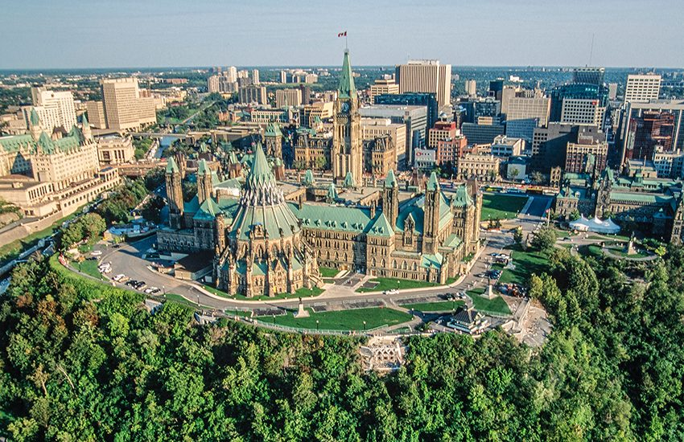

1. Meeting Venue
Westin Ottawa
11 Colonel By Drive
Ottawa, Ontario, K1N 9H4
https://www.marriott.com/hotels/travel/yowwi-the-westin-ottawa

2. Registration

Registration for the meeting will open at 8:00am on Wednesday March 18th, 2020.

3. Accommodation

Participants are responsible for making their own accommodation arrangements. A block of rooms have been set aside at the meeting venue, the Westin Ottawa, at a rate of CAD $199 plus applicable taxes. To qualify for this rate, participants must make arrangements for their accommodations at this link. Alternately, participants can call Marriot reservations directly at 1-888-627-8528 and identify themselves as being with Environment and Climate Change Canada or quote the three letter code “ECO”. To secure the group rate, reservations must be made by Tuesday February 18, 2020.

The following is a list of hotels located near the meeting venue:

- Les Suites Hotel Ottawa – 130 Besserer Street
- Delta Hotel – 101 Lyon Street
- Marriot Hotel – 100 Kent Street
- Sheraton Hotel – 150 Albert Street
- Capital Hill Hotel & Suites – 88 Albert Street
- Novotel Ottawa – 33 Nicholas Street

4. Local Transportation
4.1 Transportation to/from the airport
Ottawa Macdonald-Cartier International Airport is located 10km south of downtown Ottawa, and is served by taxis, ridesharing services, and public transport. For further information please visit https://yow.ca/en/parking-transportation/ground-transportation-options
Taxi | Cost: ~CAD $35  Time: ~25 minutes  Location: Arrival level of the airport (Level 1).
Public transit | Cost: CAD $3.60  Time: ~40minutes  Location: Arrival level of the airport (Level 1), pillars 13-16.  Bus route 97 offers frequent all day service, seven days a week, from the airport to Hurdman station, which has train service to downtown.

4.2 Transportation within the city/to and from the meeting venue
The meeting venue is located in downtown Ottawa and is attached to the Rideau Shopping Centre. The venue can be accessed via public transit, taxi, or by walking. Downtown Ottawa is well serviced by taxis and many hotels are located within a 10 minute walk of the meeting venue.
Central Ottawa is pedestrian friendly and is serviced by the O-Train, a rapid transit light rail line which runs through the downtown core. Some hotels are located on the train line, and Rideau Station is connected to the Westin Hotel via the Rideau Shopping Centre.

5. Visa support and Electronic Travel Authority

Visa-exempt nationalities require an Electronic Travel Authority to enter Canada, with some exceptions. A list of nationalities that require an ETA, and exceptions, can be found here: https://www.canada.ca/en/immigration-refugees-citizenship/services/visit-canada/entry-requirements-country.html#visaExempt. An ETA costs CAD $7, can be done online, and is usually approved within minutes. Information on the ETA application process can be found here: https://www.canada.ca/en/immigration-refugees-citizenship/services/visit-canada/eta.html.
The Canadian co-leads will be issuing letters of invitation for the meeting to participants that require a visa to enter Canada. A list of nationalities that require a visa to enter Canada can be found here: https://www.canada.ca/en/immigration-refugees-citizenship/services/visit-canada/entry-requirements-country.html#visaRequired.

6. Meals and water
All meals will be at the expense of the participants. The meeting venue has a restaurant on-site, and the attached Rideau Shopping Centre has a food court. Tap water is safe to drink.

7. Laptops and electricity
The meeting will be paperless. All participants are encouraged to bring their own laptop, with power supply and North American adaptors. Wireless internet will be available at the meeting venue, free of charge.

8. Language and Geographic Information
The working language of the meeting will be in English. The primary languages spoken in Ottawa are English and French. The weather in March for Ottawa ranges from a high of 5°C to a low of -10°C overnight. Roads and sidewalks are quickly cleared in the event that it does snow. The time zone in Ottawa is GMT -5.

9. Emergency Numbers
Emergency services (medical, fire, and police) can be reached by dialling 911 from any phone.

10. Currency and Banking
The Canadian dollar (CAD $) is the currency of the country. Bank notes are available in $5, $10, $20, and $100, and coins are issued in 5c, 10c, 25c, $1 and $2. One hundred cents make up one dollar. ATMs are located throughout the city and operate 24 hours a day. Credit cards are widely accepted, with Visa and MasterCard being the most commonly accepted cards.

11. Health Services
Ottawa is equipped with multiple hospitals, and walk-in clinics are widely available for non-urgent needs. Pharmacies are typically open from 7:00am to 10:00pm every day and are plentiful.

