Annex
Guidance to improve the implementation of paragraph 11 of Article 6 of the Convention
(Draft 4 February 2016)
Executive Summary
The Conference of the Parties, in its decision BC-12/7, mandated the Committee Administering the Mechanism for Promoting Implementation and Compliance with the Basel Convention to develop guidance to improve the implementation of paragraph 11 of Article 6 of the Convention (hereinafter, “the Provision”) on insurance, bond and guarantee, for consideration by the Conference of the Parties at its thirteenth meeting. In accordance with the mandate of the Conference of the Parties, this guidance has been developed, taking into account the report on the implementation of the Provision prepared by the Committee in the context of its 2014-2015 work programme (hereinafter “the Report”),1 and in consultation with the expert working group on environmentally sound management (EWG on ESM).
This guidance is based on the following additional sources of information:
(a) Responses to the questionnaire distributed on this subject in 2014 (hereinafter, the “Questionnaire”)2;
(b) Information contained in the draft “Practical manual: insurance and liability” developed by the EWG on ESM and lessons learned from the relevant project activities undertaken by that group;
(c) Legal instruments and guidance adopted by the Parties;
(d) Decisions and guidance adopted by the Organisation for Economic Co-operation and Development (“OECD”);
(e) Responses to inquiries directed to Parties and other experts and stakeholders;
(f) Other publically available information.
Information derived from these sources indicates that Parties implement the Provision through a wide variety of methods, including differing legal requirements, scope of application, beneficiaries, and means of calculating the amount to be covered by a financial guarantee, bond, or insurance. While little difficulty has been reported in the actual operation of the Provision, the differing legal requirements between States, especially the differences in methodologies for determining the required amount of coverage, were most often cited as the main challenges to wider use of the Provision.
The objectives of the guidance are set out in part I of the document. Part II of the guidance presents background information on the Provision, including:
A. The genesis and purpose of the Provision, including:
1. The definition and scope of the Provision;
2. The application of the Provision;
3. The meaning of the terms “insurance”, “bond” and “guarantee”;
4. The relationship between the Provision and Articles 8, 9 and 14 of the Convention;
5. The relationship between the Provision and the Protocol on Liability and Compensation;
6. The relationship between the financial guarantees under the Provision and other insurances required by other international legal instruments for the transport of dangerous goods/substances.
B. Steps taken by Parties to implement and improve the implementation of the Provision; and
C. Recommendations from Parties and other stakeholders on how to further improve the implementation of the Provision.
Part III of the guidance offers suggestions on how to address specific difficulties faced by Parties in their implementation of the Provision, and identifies other steps that could improve the implementation of the Provision.
I. Objectives of the guidance
- This guidance, developed in accordance with the work programme of the Committee Administering the Mechanism for Promoting Implementation and Compliance for the biennium 2016–2017, as approved by the COP in its decision BC-12/7, is intended to improve the implementation of the Provision by helping Parties to formulate requirements for insurance, bond or other guarantee (collectively referred to hereinafter as “financial guarantees”) applicable to the transboundary movement (“TBM”) of hazardous wastes and their disposal. The guidance recognizes that the Provision is written in general terms, giving Parties flexibility to determine what type of financial requirements best fit their needs. At the same time, the emergence of differing approaches among Parties presents challenges to implementation of the Provision.
- This guidance is intended to assist in meeting these challenges. It is hoped that the information contained in the guidance, particularly the detail on the practices and legal approaches of some Parties, will assist Parties in cooperatively developing and revising measures to implement the Provision. Parties could examine the specifications for the various guarantees allowed, including their scope of application, method of calculation, and provisions to ensure that the guarantees may be drawn upon and used in a timely manner.
- The guidance is not intended to restrict the Parties’ flexibility or to be prescriptive in any way. Instead, after summarizing some of the issues associated with financial guarantees and Parties’ methods of implementing the Provision, the guidance suggests a number of approaches that Parties may wish to consider in implementing the Provision. Harmonization of national requirements in this regard, while not required by the Convention, could facilitate the issuance of financial guarantees covering TBM of hazardous wastes.
II. Background information
- The genesis and purpose of paragraph 11 of Article 6 of the Basel Convention
- Definition and scope of the Provision
- Article 6 of the Basel Convention sets forth conditions and procedures applicable to the TBM of hazardous wastes. Paragraph 11 of the Article provides:
“Any transboundary movement of hazardous wastes or other wastes shall be covered by insurance, bond or other guarantee as may be required by the State of import or any State of transit which is a Party.”
- The financial guarantees referred to in the Provision “are intended to provide for immediate funds for alternative management of the wastes in cases where shipment and disposal cannot be carried out as originally intended. These guarantees may take the form of an insurance policy, bank letters, bonds or other promise of compensation for damage, depending on the countries concerned.” Problems associated with TBM and subsequent disposal of hazardous wastes may include, without limitation: improper classification of wastes, improper packaging and labeling of wastes; accidents in transit involving the releases or threatened releases of hazardous wastes; unavailability of appropriate facilities for disposal of the wastes in the importing or transit country; and releases or threatened releases of hazardous substances associated with the management of the wastes prior to disposal. Protection of health and the environment may depend on the ready availability of financing to remedy these problems.
- As explained by the updated Guide to the Control System adopted by the Conference of Parties at its twelfth meeting, the exporter/notifier is to “arrange any financial guarantees and insurances for the movement of wastes required by the national legislation of the countries concerned. Some countries may require the financial guarantee to cover the cost of any necessary re-import and alternative disposal operations should the need arise, including cases referred to in Articles 8 and 9 of the Basel Convention. Additionally, they may require separate insurance against damage to third parties, held as appropriate by the exporter, carrier and the disposer.”
- The eighth meeting of the Conference of Parties to the Basel Convention invited Parties to use a standard movement and notification document for TBM of hazardous wastes. The standard notification document provides, in block 17, that “the exporter-notifier/generator-producer certify (inter alia) that . . . any applicable insurance or other financial guarantee is or shall be in force covering the transboundary movement.” Block 15 of the standard movement document requires (inter alia) that “the exporter-notifier/generator-producer certify . . . that any applicable insurance or other financial guarantee is in force covering the transboundary movement and that all necessary consents have been received from the competent authorities of the countries concerned.”
- Application of the Provision
- The Provision applies when the State of import and/or transit requires that a TBM be covered by a financial guarantee. By definition, risks associated with TBM and subsequent disposal of hazardous wastes are most likely to arise in those countries, as TBM is defined as “movement of hazardous wastes from an area under the national jurisdiction of one State to or through an area under the national jurisdiction of another State ...”. The importing and transit countries may decide that they need to be assured that funds will be available to cover the costs of actions to remedy those problems. As noted above, in cases where a financial guarantee is required, the notification document should certify that the guarantee is or will be in force. In addition, Parties who require a financial guarantee as a condition of export generally do not provide an exemption, or otherwise provide relief, in cases where the State of import or transit also requires a financial guarantee, regardless of what the country of import or transit might require. However, the country of export must keep in mind the need for compliance with importing and transit country requirements.
- Meaning of the terms “insurance”, “bond” and “guarantee”
- The terms, “insurance”, “bond”, and “guarantee” are not defined in the Basel Convention. All are similar in that they denote financial guarantees intended to assure the availability of funding for specified activities (e.g., transportation, storage, disposal or other means of ESM of wastes) in cases where the TBM and subsequent disposal of hazardous wastes is not being undertaken in accordance with the notification documents or the terms of the Convention. The terms are often used interchangeably, but may have specific meanings and characteristics under national law.
- “Insurance” is commonly defined as: “a contract by which one party (usually a company or corporation) undertakes, in consideration of a payment (called a premium) proportioned to the nature of the risk contemplated, to secure the other against pecuniary loss, by payment of a sum of money in the event of destruction of or damage to property (as by disaster at sea, fire, or other accident), or of the death or disablement of a person;
- “Bond” has many meanings and definitions. In this context it has been defined as: “an insurance agreement pledging surety for financial loss caused to another by the act or default of a third person or by some contingency over which the third person may have no control.”
- As suggested by the above definition, the type of bond envisioned under the Provision appears to be a surety bond, which has been defined as a “written instrument evidencing a contract of suretyship: a bond guaranteeing performance of a contract or obligation.” Perhaps more germane to the subject of this guidance is the definition of “surety bond” used by the United States Environmental Protection Agency with respect to financial assurance for the treatment, storage and disposal of hazardous wastes: “A guarantee which certifies that a surety company will cover the . . . financial assurance requirement on behalf of the owner and operator.”
- While some surety bonds may share some characteristics of insurance policies, a bond generally provides that the issuer will either: perform the requisite activity in accordance with the plan on behalf of the guaranteed party; or pay out the face value of the bond to a designated fund or authority. With either type of bond, the Surety retains the right to seek reimbursement from the guaranteed party for funds paid on its behalf. Thus, the Surety provides the guaranteed party with its financial backing. In return, the Surety generally receives a premium or fee based on the face value of the bond and on the financial strength of the guaranteed party.
- A “guarantee” has been defined as “the action of securing, warranting, or guaranteeing; something which secures or guarantees the existence of a thing.” Guarantees are often referred to as “financial guarantees,” “bank guarantees,” or “corporate guarantees.” OECD guidance explains that “[a] financial guarantee may take the form of an insurance policy, bank letters, bonds or other means of compensation, depending on the countries concerned.”
- There are many similarities and some degree of overlap among these three financial guarantees. Perhaps the principal difference is that insurance policies are based on the principle of spreading risk. They involve the payment of a premium, based on the likelihood of an event occurring that would trigger payment on the policy, and the costs likely to arise from such an event. The cost of an insurance premium is typically far less than the cost arising from the covered events. However, the premium is generally non-refundable. At the same time, the insurer generally does not have recourse against the insured for monies paid out under the insurance policy. By contrast, the issuer of a financial guarantee typically does not intend to assume more than a modest risk in exchange for a premium. Rather, the issuer (or “guarantor”) generally has determined that the guaranteed party has the financial capacity to the pay the amount guaranteed. Furthermore, the guarantor has a right of recourse against the guaranteed party in cases where monies are paid under the guarantee. In many cases, the purchaser of the guarantee is required to post collateral to cover the guaranteed amount. The fees for the issuance of guarantees are more dependent on the financial condition of the purchaser, rather than the risk that a particular event will occur; in this case, a mishap during TBM of wastes.
- Financial guarantees are known by many names, whose meanings and structure may vary from State to State. A meaningful definition of any particular instrument can only be provided with reference to national law. But in the end, the name attached to the guarantee is not important, as far as providing protection against mishaps in the TBM of hazardous wastes. What is important is the protection it provides, and especially how readily available it is, if needed, to finance a timely response to difficulties arising during the TBM of hazardous wastes and its disposal.
- Relationship between the Provision and Articles 8, 9 and 14 of the Convention
- Article 8 of the Convention prescribes a duty to re-import when TBM cannot be completed in compliance with the Convention. In that case, the State of export must ensure that the wastes are taken back by the exporter, if alternative arrangements cannot be made for disposal in an environmentally sound manner. A financial guarantee issued pursuant to the Provision may be useful in assuring that the State of export can meet its obligations in this regard. Because of this, financial guarantee requirements are imposed not only by States of transit or States of import but also by States of export primarily to ensure that their responsibilities under Article 8 of the Convention can be discharged.
- Article 9 of the Convention defines “illegal traffic” as follows:
“1. For the purpose of this Convention, any transboundary movement of hazardous wastes or other wastes:
(a) without notification pursuant to the provisions of this Convention to all States concerned; or
(b) without the consent pursuant to the provisions of this Convention of a State concerned; or
(c) with consent obtained from States concerned through falsification, misrepresentation or fraud; or
(d) that does not conform in a material way with the documents; or
(e) that results in deliberate disposal (e.g. dumping) of hazardous wastes or other wastes in contravention of this Convention and of general principles of international law.”
- A financial guarantee is unlikely to be obtained in a situation described in subparagraph (a), as an exporter who does not notify is unlikely to comply with other requirements, such as the obtaining of a financial guarantee. Similarly, if the export occurs without consent of the States concerned, as described in subparagraph (b), compliance with the financial guarantee requirement seems unlikely. However, the circumstances described in Article 9.1(c), (d), and (e) do not appear to be inconsistent with the prior obtaining of a financial guarantee, so it seems likely that a guarantee would be available only in those situations.
- The Article prescribes three sets of required procedures for addressing illegal traffic, depending on whether it results from conduct of the generator/exporter (Article 9.2), conduct of the importer/disposer (Article 9.3), or where responsibility cannot be determined (Article 9.4). In the case of illegal traffic caused by the generator or exporter, the State of export must ensure that the wastes are taken back by the exporter, generator, or State of export; or, if that is not practicable, that the wastes are otherwise disposed of in accordance with the Convention. If the illegal traffic is caused by the importer or disposer, the State of import must ensure ESM disposal by the importer or disposer, or itself within 30 days of the time it has learned of the illegal traffic. Where responsibility cannot be determined, the Parties concerned or other Parties, as appropriate, are to ensure that the wastes in question are disposed of as soon as possible in an environmentally sound manner.
- Financial guarantee requirements are imposed by States of export primarily to ensure that their responsibilities under the Convention can be discharged. Hence, the financial guarantee, as imposed by the State of export, would appear to be most relevant in the first category (Article 9.2). However, financial guarantee requirements imposed by Parties to date are not limited to these situations. In addition, States of import and transit might require that exporters obtain financial guarantees to cover situations described in Article 9.3 and 9.4.
- Article 14.2 of the Convention provides that the Parties “shall consider the establishment of a revolving fund to assist on an interim basis in case of emergency situations to minimize damage from accidents arising from TBM of hazardous wastes or other wastes or during the disposal of those wastes.” Use of a financial guarantee under the Provision would reduce the need to use this revolving fund. Alternatively, financial guarantees could designate the revolving fund as the beneficiary.
- Relationship between the Provision and the Protocol on Liability and Compensation
- The Provision is expressed in broad terms. Its scope of coverage is not delineated. As noted above, the Guide to the Control System explains that "these guarantees are intended to provide for immediate funds for alternative managements of the wastes in cases shipment and disposal cannot be carried out as originally intended." While this formulation might be read to imply that coverage of liability for damages was not contemplated under the Provision, the Guide goes on to say that “guarantees may take the form of an insurance policy, bank letters, bonds or other promise of compensation for damage, depending on the countries concerned.” The Guide further notes that some countries “may require separate insurance against damage to third parties, held as appropriate by the exporter, carrier and the disposer.”
- Some Parties have incorporated liability elements into their implementation of the provision. Nonetheless, it should be recognized that an entire Protocol has been developed to address liability issues.
- The “Protocol on Liability and Compensation for Damage Resulting from Transboundary Movements of Hazardous Waste and Their Disposal” was adopted at the fifth meeting of the Conference of Parties. The objective of the Protocol is to provide for a comprehensive regime for liability as well as adequate and prompt compensation for damage resulting from the TBM of hazardous wastes, including incidents caused by illegal traffic. The Protocol addresses who is financially responsible in the event of an incident. Each phase of a TBM, from the point at which the wastes are loaded on the means of transport to their export, international transit, import, and final disposal, is considered. Those who are strictly liable under the Protocol, i.e. exporters and disposers, have to establish insurance, bonds or other financial guarantees covering their liability. The Protocol, which has yet to enter into force as of 15 December 2015, does not specifically cover the costs of completing the TBM and providing for ESM of wastes, although it does cover the costs of “preventive measures,” which could include some of the foregoing.
- Relationship between the financial guarantees under the Provision and other insurances required by other international legal instruments for the transport of dangerous goods/substances
- Two adopted, but not yet effective, multilateral international agreements require guarantees or insurance for the transport of dangerous goods/substances. First, Article 12 of the International Convention on Liability and Compensation for Damage in Connection with the Carriage of Hazardous and Noxious Substances (HNS) by Sea, 2010 requires:
- “The owner of a ship registered in a State Party and actually carrying hazardous and noxious substances shall be required to maintain insurance or other financial security, such as the guarantee of a bank or similar financial institution, in the sums fixed by applying the limits of liability prescribed in article 9, paragraph 1, to cover liability for damage under this Convention.”
- The HNS Convention is not yet in force (as of 15 December 2015). Should it enter into force, its coverage may overlap with the Basel Convention, as there is no exemption in the HNS Convention for hazardous wastes, and no exemption in the Basel Convention for hazardous wastes covered by the HNS Convention. It should be recognized, however, that the HNS Convention’s requirements do not apply to the full period of TBM of hazardous wastes and its disposal. Rather, the HNS Convention’s coverage is limited to “the period from the time when the hazardous and noxious substances enter any part of the ship’s equipment, on loading, to the time they cease to be present in any part of the ship’s equipment, on discharge. If no ship’s equipment is used, the period begins and ends respectively when the hazardous and noxious substances cross the ship’s rail.” Thus, the HNS Convention would not appear to apply to disposal of hazardous wastes in the country of import.
- Second, the Convention On Civil Liability For Damage Caused During Carriage Of Dangerous Goods By Road, Rail And Inland Navigation Vessels (CRTD Convention) complements the HNS Convention by covering transportation of dangerous goods on land and inland waterways. That Convention also contains mandatory insurance requirements. The CRTD Convention applies from the beginning of the process of loading the goods onto the vehicle for carriage until the end of the process of unloading the goods. Thus, it would not appear to apply to the disposal of hazardous wastes. In any event, the CRTD Convention has not entered into force as of 15 December 2015.
- Steps taken by Parties in implementing and improving the implementation of the Provision, and challenges met
- The Provision’s general terms allow Parties considerable flexibility to tailor implementing policies in ways that best suit national needs and circumstances. It is natural that Parties have implemented the provision in different ways. Different forms of guarantee are allowed, along with differences in the timing and scope of application, calculation of the amount required, and other requirements. At the same time, some Parties have identified this variation, as well as complexities associated with the development of effective financial guarantee requirements, as challenges to their own implementation of the Provision.
- Based on input from the Parties and others, it is believed that the following are among the most important variables in implementing the Provision:
  - Who is required to obtain the financial guarantee?
  - What forms of financial guarantee instruments may be used, and who may issue them?
  - What risks and costs should be covered by the financial guarantee?
  - Temporal scope: During what period of time does the financial guarantee need to be effective?
  - Who should be the beneficiary of the financial guarantee?
  - What amount of funds needs to be guaranteed?
  - What are the criteria for activation of the financial guarantee?
  - How can compliance with financial guarantee provisions be monitored?
  - How can differences in requirements among the States of export, transit, and import be addressed?
- A brief summary of how Parties have met the challenges identified above follows. This information is based on national reports submitted for the years 2010 and 2011, as well as responses to the Questionnaire, reference to existing legislation and guidance, and additional inquiries to and responses from Parties and others.
- Many of the existing national regulations and guidance on implementation of the Provision are based on Regulation (EC) 1013/2006 of the European Parliament and of the Council of 14 June 2006 on shipments of wastes. The Regulation applies to shipments of wastes among EU Member States and between Member States and countries outside of the region. Article 6 of the Regulation is devoted to the financial guarantee, and requires that Member States establish a financial guarantee or equivalent insurance (hereinafter, “financial guarantee”) for any TBM of wastes for which notification is required. The Regulation is implemented through national law of EU Member States. Information about the content of the Regulation and national law of EU Member States and other existing national legislation and guidance is provided below.
- It should also be noted that some Parties have prohibited the import or transit of hazardous wastes, thus decreasing, the need, for these Parties, to develop financial assurance requirements and limiting this need to cases of illegal traffic. In addition, at least one Party has not found it necessary to develop such requirements for other reasons.
- Who is required to obtain the financial guarantee?
- The exporter, generator or other person who is responsible for notifying the State of export of an intent to export hazardous wastes is generally responsible for obtaining the financial guarantee. A few Parties also require that the importer or disposer obtain the guarantee, presumably when they are the State of import. The guarantee is essentially a contract between the notifier and the institution providing the financial guarantee, although as discussed below, the beneficiary of the guarantee will usually be the competent authority. Some Parties also allow a third party to obtain the financial guarantee on behalf of the notifier, presumably with assurance that the competent authority will have access to the instrument.
- What forms of financial guarantee instruments may be used, and who may issue them?
- The Provision employs the general terms, “insurance, bond or guarantee.” As discussed above, there is considerable overlap among these terms, which only have precise meaning under applicable national law. Some Parties allow only the use of certain types of guarantees, or restrict the type of entity who may issue them. The overarching concern is that funds secured by the financial guarantee are readily available when needed. To that end, provisions have been put in place to assure that: banks or other institutions will be willing to issue such guarantees; the guarantee is payable promptly upon demand; the financial guarantee is immune from other claims; and the issuer of the guarantee is financially healthy. These points are briefly discussed below.
- A bank or other financial institution is unlikely to issue a financial guarantee unless it is assured that it will be able to disburse guaranteed funds without fear of recourse from the guaranteed party or others. This concern can be addressed, depending upon national law, by the wording of the financial guarantee. For example, the Finnish financial guarantee template includes the following language:
“For the avoidance of doubt, in the event of a payment being made hereunder by us to the competent authority, then our liability shall be reduced by the amount of any such payment and we shall only be liable to the extent of the residual amount, if any, remaining under this guarantee at that time.”
- At the same time, if a financial guarantee is to fulfil its function, funds guaranteed must be readily available for response to problems arising in the course of TBM of hazardous wastes and their disposal. The competent authority needs to be assured that the funds will be available for such problems , and that the guarantee cannot be used to satisfy other demands of the guaranteed party or its creditors.
- Assuring such availability can dictate the type of guarantee deemed acceptable, the drafting of the guarantee, and the criteria governing who may issue the guarantee. Required legal proceedings, claims of creditors, and resistance from the guaranteed party can all interfere with the ready availability of funds. As emphasized in the German guidance, in order to assure prompt access to the guarantee by the competent authority:
“It is important to ensure that the bank gives a guarantee of payment as co-principal debtor to the competent authority for the set security amount (waiving the objections of voidability, offsettability and need for preliminary proceedings against the principal debtor).”
- Presumably for the same reason, the Czech Republic and Cyprus require that the guarantee be “a sum of money available in a bank to which only the competent authority has access.”
- It should be recalled that a financial guarantee is generally issued by a bank or other disinterested third party, based on the financial solvency of the guaranteed party and/or the posting of a deposit or collateral. As noted in German guidance: “it is important to ensure effective protection from bankruptcy and unconditional access for the recipient in accordance with the envisaged protection purpose.” Similarly, guidance issued by the European Commission cautions of the need to distinguish between a “standard guarantee,” which will be honored only after legal claims against the guaranteed party have been exhausted, and an irrevocable unconditional on-demand-guarantee, where the money can be claimed directly by the benefit to the beneficiary.
- Another concern addressed by some Parties relates to the solvency of the guarantor. These Parties, including most Members of the European Union, accept only bank guarantees or insurance policies. Some Parties allow institutions other than banks to issue similar guarantees. In the case of Finland, the issuer of a financial guarantee is limited to “a credit or insurance institution, or another commercial financial institution, domiciled in a European Economic Area member state.” In addition, national banks may not always be willing or able to issue financial guarantees. For example, the Dominican Republic reports that banks located in that country do not offer guarantees in any form. For that reason, exporters provide a guarantee from a foreign institution based abroad to meet the requirements established by the government and the Provision.
- Some Parties suggest or require that a standardized form be used for the financial guarantees. Forms and templates developed by Finland, Portugal, Switzerland, and the United Kingdom, as reported by the Environment Agency & Scottish Environmental Protection Agency, are reproduced in Appendices I, II, III and IV, respectively.
- The form of financial guarantee has also been addressed by guidance to OECD Council Decision C(2001)107/FINAL, concerning the control of TBM of wastes destined for recovery operations:
“A financial guarantee may take the form of an insurance policy, bank letters, bonds or other means of compensation, depending on the countries concerned. Member countries having established such provisions shall make this information available to other member countries through a specific Internet system developed by the OECD Secretariat.”
- What risks and costs should be covered by the financial guarantee?
- The Provision states only that a guarantee may be required to “cover” TBM of hazardous wastes. Parties need to decide, however, what types of risks and costs should be covered. Costs may be classified in two broad categories. The first category includes response costs, or costs of providing for alternative management in a situation where shipment or disposal cannot be carried out as originally intended, or in the case of illegal traffic. The second category of costs includes those arising from damages caused by such shipments.
(a) Response costs
- Many Parties require that the financial guarantee cover costs arising in cases where shipment, wastes recovery, or ESM disposal cannot be completed as intended, or where a shipment, recovery, or disposal is illegal. Among the costs often covered are costs of transport, recovery or disposal (including any necessary interim operations) in an environmentally sound manner, and storage for 90 days.
- Some Parties specifically require coverage of costs associated with take-back of hazardous wastes. For example, Swiss law requires that a financial guarantee cover costs of any eventual return and alternative disposal of wastes if the exporter fails to comply with its take-back obligation, in cases of illegal movements or when legal movements could not be completed as intended. Germany also covers such costs. With respect to the return of wastes, German guidance provides:
“The competent authority having access to the financial guarantee is obliged to reimburse other affected authorities for costs incurred in conjunction with the return, e.g. storage costs for impoundment or resources required for alternative forms of recovery or disposal in the receiving country. Affected authorities should provide receipts or evidence – in the form of invoices or quotes – so that these costs may be requested in writing from the bank or insurance company that has issued the financial guarantee.”
- Other costs frequently covered include possible alternative treatment methods, and testing for identification, re-packaging and re-loading of wastes.
- Coverage of response costs is also addressed by OECD, which requires (for its members) that, “where applicable, the exporter or the importer shall provide financial guarantees in accordance with national or international law requirements, in order to provide immediate funds for alternative recycling, disposal or other means of environmentally sound management of the wastes in cases where the transboundary movement and the recovery operations cannot be carried out as foreseen.”
(b) Liability
- Some Parties require that liability for damages and injury (e.g., personal injury, property damage, and environmental restoration) caused by TBM be covered by the financial guarantee. For example, New Zealand requires coverage of: personal injury or death; property loss or damage; environmental damage (e.g. costs of reinstatement or compensation); and remedying any contamination or pollution caused by a sudden and accidental event. Similarly, Belgium requires that, in addition to costs of transport, storage and ESM disposal, that the financial guarantee cover “environmental damage, e.g. costs of reinstatement or compensation.”
- At least two countries require insurance that covers liability for damages to health, property, and the environment, but have not reported coverage of costs (such as transportation, alternative disposal, etc.) associated with responses to incidents involving TBM of hazardous wastes. For example, Ukraine requires that exporters, importers or persons responsible for utilization/disposal obtain insurance to compensate for damage that may be caused to human health, ownership and environment in the course of TBM of hazardous wastes and the utilization or disposal of hazardous wastes. It has also been reported, in the case of Honduras, that insurance offered by banks in that State cover the following aspects: civil liability for pollution and damage caused by the transport of wastes, as a result of which one or more persons are killed or property belonging to third parties is damaged.
- On the other hand, some Parties do not include liability within the required ambit of the financial guarantee, although they may impose liability requirements apart from their implementation of the Provision. For example, the European Waste Shipment Regulation, separate from its section of financial guarantees, requires that the notification document indicate evidence of insurance against liability for damage to third parties (e.g. a declaration certifying its existence). Consistent with this provision, in its legal framework, the Portuguese competent authority requests the notifier or the carrier to provide an additional financial guarantee or equivalent (for instance, environmental liability insurance) that covers environmental damages in Portuguese territory. In addition, Directive 2004/35/EC on environmental liability with regard to the prevention and remedying of environmental damage establishes a framework based on the polluter pays principle to prevent and remedy environmental damage.
- In the United Kingdom, as reported by the Environment Agency and Scottish Environment Agency, financial guarantees “are purely about repatriation of wastes back to the UK if the shipment does not go as planned, or is illegal, and none of the relevant parties involved are willing or able to make the necessary arrangements.” In their response to the Questionnaire, the Environment Agency and Scottish Environmental Protection Agency emphasized that loss of life, personal injury, loss of or damage to property, and potentially loss of income, are covered by third party liability insurance (required under European Waste Shipment Regulation Annex II), not the financial guarantee. For the UK, damage to the environment is also not covered under a financial guarantee. Rectifying any damage to the environment could only be through an alternative legislative route in the country in question. In addition, costs associated with investigation/enforcement activity would not be covered by a financial guarantee.
- Timing of issuance and release of the financial guarantee
- Closely associated with the previous points, there is a need for clarity on when the financial guarantee takes effect and when it can be discharged. The time period of effectiveness will help determine what risks and costs are covered. Once it has served its purpose, the financial guarantee can be released (or “liberated”). In the case of guarantees covering only response costs, this would generally be upon completion of ESM disposal. Some variations on this theme are discussed below.
(a) Timing of issuance
- The Provision does not specify when the guarantee needs to be issued, thereby allowing for national variations in implementation. The European Waste Shipment Regulation provides that the financial guarantee “shall be effective at the time of the notification or, if the competent authority which approves the financial guarantee or equivalent insurance so allows, at the latest when the shipment starts.” The financial guarantee needs to be valid for and cover a notified shipment and completion of recovery or disposal of the notified wastes.
- German guidance provides that approval or establishment of the financial guarantee – including the form, wording and amount of the cover -- should generally occur prior to or together with forwarding of the notification but no later than the notice issued by the competent authority of dispatch to the State of import. However, if the financial guarantee is to be submitted after consent has been granted, the consent document should provide that consent will be withdrawn if the financial guarantee is not submitted.
- In Finland, the guarantee may be obtained after the Finnish Environment Institute has approved the guarantee calculation submitted by the notifier. Finland requires that the financial guarantee be effective on the date of dispatch.
(b) Release of guarantee
- The Guide to the Control System envisions the release of the financial guarantees following submission of the certifications of disposal by the disposer, indicating that the consignments of wastes have been disposed of in an environmentally sound manner. According to the European Waste Shipment Regulation, the financial guarantee is to be released when the competent authority concerned has received the certificate indicating completion of disposal or recovery operations. However, if the wastes is subject to interim recovery or disposal operations and a further recovery or other disposal operation is to take place in the country of destination, the guarantee may be released when the wastes leaves the interim facility and the competent authority has received the required certificate. However, any further shipment to a recovery or disposal facility must be covered by a new financial guarantee unless the competent authority of destination is satisfied that it is not required. Provisions on release of the financial guarantee for EU Member States and some subnational authorities within those States are presented in a guidance document issued by the European Commission.
- Finland requires that the financial guarantee cover all shipments to the date of treatment, as specified in the shipping document. Finnish regulations also require the guarantee to be in force for at least 480 days from the last given date of dispatch. The financial guarantee may be refunded after the competent authorities have received “sufficient proof” of the acceptance and treatment of the waste shipment in accordance with the permit.
- In Germany, guidance provides that the competent authority of dispatch should generally release the financial guarantee in collaboration with the competent authority of destination once it has received the certificate that releases it from the take-back obligations.
- New Zealand guidance advises of the “need to be insured for damage to third parties (including the environment) for the whole time you are responsible for the ownership and control of each shipment of wastes.”
- Switzerland requires that financial guarantees for individual notifications be valid until 360 days after the last movement of wastes.
- The UK Environment Agency requires coverage for 3 years from the date of consent, which is intended to allow time for transit and recovery. The competent authority will release the financial guarantee before then if the waste is fully recovered and no further shipments are to be made. The Scottish Environment Protection Agency would require coverage for the notification period plus 12 months for a standard notification.
- Who should be the beneficiary of the financial guarantee?
- Who should be entitled to demand or receive funds under the financial guarantee? The “beneficiary” is the person or entity with authority to direct payment on the guarantee. In response to the Question 6 of the Questionnaire, most Parties checked the box indicating that the “beneficiary” of the financial guarantee is the State of export, import, or transit. It appears that most Parties, whether as State of export or import, designate their own competent authority as the entity that may make the demand for payment. For example, the UK Environment Agency has published an application form for approval of financial guarantee or equivalent insurance. The form includes a declaration that “the Environment Agency will have access to the financial guarantee or equivalent insurance in order to meet its obligations under the [European Waste Shipment Regulation].” Similarly, the Finnish template includes a statement that the issuer of the financial guarantee “hereby irrevocably and unconditionally guarantees to pay the Finnish Environment Institute . . . being the competent authority of dispatch . . . any sum or sums not exceeding in aggregate [currency and amount] * * * on receipt by us of first demand in writing of the competent authority. Likewise, Switzerland requires that “anyone who exports wastes that are subject to authorisation must urgently provide a financial guarantee (bank or insurance guarantee) to the benefit of the Swiss Federal Office for the Environment.”
- A few Parties designate the exporter or generator as the beneficiary.
- Without using the term, “beneficiary,” the European Waste Shipment Regulation provides: “The financial guarantee must guarantee that the competent authority which approves it shall have access thereto. That authority is to make use of the funding, including for the purpose of payments to other authorities concerned, in order to cover takeback and other costs.”
- What amount of funds needs to be guaranteed?
- A number of Parties have developed formulae aimed at ensuring that the amount of the financial guarantee corresponds to the potential risks and costs involved.
- The European Waste Shipment Regulation leaves to the discretion of each Member State the methodology for determining the amount of the financial guarantee as long as the following basic elements are taken into account in calculations: a) costs of transport, b) costs of recovery or disposal, including any necessary interim operation, and c) costs of storage for 90 days.
- The formula for the calculation is usually defined by the competent authority of dispatch. The calculation can be based on national/regional market prices and/or fixed average costs for enforceability, such as administrative costs. Calculation of the amount may be based on a “worst case scenario”. Some Member States do not apply any particular formula and calculate the financial guarantee on a case-by-case basis with a view to cover costs of the basic elements required in the Regulation.
- Some Member States have developed their own methodologies. For example, each region of Belgium has developed a specific formula for the calculation of the required amount of insurance/guarantee. These formulae are reproduced in Appendix E. Portugal employs a specific formula for determining the required amount of the financial guarantee or equivalent, which is also reproduced in Appendix E. The formulae developed by Austria, Italy and the United Kingdom (for England and Wales) are also set out in Appendix E.
- In Lithuania, calculation and adjustment of the amount of financial guarantee or equivalent insurance is approved by the Order of the Minister of Environment of the Republic of Lithuania in 2005, December 30 (Order No. D1-663, with latest amendments December, 2011).
- Under the Finnish regulations, the required amount of the guarantee is determined by the cost of return transport, storage, and alternative treatment. The costs are calculated from the actual figures given by the notifier. The financial guarantee must cover the cost of shipping the waste from the country of destination back to Finland; this cost is mainly calculated from offers. Storage costs are calculated for a 90-day period. It is advised to obtain storage costs from dispatch or destination ports, for example. The costs of alternative treatments are determined on a case-by-case basis. The basis for their calculation is Finnish waste treatment costs, such as disposal fees for landfill or hazardous waste landfill. The usual reference for hazardous waste is the list prices given by nationwide operators. If the waste has a positive value, treatment costs may be omitted from the guarantee calculation, if deemed reasonable. The guarantee for waste exports from Finland may be obtained in part for one or several shipments. The minimum guarantee is EUR 2,000.
- The German guidance includes a specific formula for determining the amount required for the financial guarantee, based on the amount of waste, anticipated transport costs, disposal costs, the distance between the place of waste generation and waste disposal; and the amount of waste. Safety factors are also applied with respect to transport, disposal, and storage. The formula is accompanied by a detailed explanation of how it is meant to apply. Germany notes that costs can only be ascertained on a case-by-case basis with due regard to the nature and hazardousness of the waste. Safety factors are used to account for unknown variables.
- Cote d’Ivoire requires that the authorization application dossier include a certificate of insurance for the applicant company or a financial guarantee provided by the applicant company. With respect to shipments of waste from France, the amount is calculated in accordance with the French Decree of July 13, 2011.
- New Zealand does not set any minimum required level for insurance. New Zealand’s Hazardous Waste Application form requires that the policy cover: “an amount sufficient for the applicant to be reasonably insured against risks, and/or discharge any liability that might arise in relation to the hazardous waste; and personal injury or damage to property and the cost of remedying any contamination or pollution caused by a sudden or accidental event.” The amount required will depend upon the risks involved, and should cover potential liabilities. The copy of the insurance certificate should show that the insurance applies to the countries and areas the shipments are passing through or going to, the value of cover, and that the insurance includes an indemnity to cover the costs of remedying a spillage or other form of pollution. As noted above, for calculating the amount of liability insurance required, New Zealand uses the guideline values in the Instruction Manual for the Implementation of the Basel Protocol on Liability and Compensation for Damage Resulting from Transboundary Movements of Hazardous Wastes and Their Disposal.
- For Switzerland, the amount of the financial guarantee depends on the costs of storage, transport and disposal. The Federal Office for the Environment (FOEN) decides on the amount of the guarantee based on a suggestion by the exporter. The Swiss instructions for calculating the financial guarantee are reproduced in Appendix E.
- Criteria for activation of financial guarantee
- It is important that the guarantee clearly express the circumstances under which the guarantor must pay out the funds guaranteed. Responses to the Questionnaire indicate that activation of the financial guarantee is most frequently determined by a request from the beneficiary. For example, the European Waste Shipment Regulation provides:
“The competent authority within the Community which has approved the financial guarantee or equivalent insurance shall have access thereto and shall make use of the funding, including for the purpose of payments to other authorities concerned ...”
- Presumably, such a request will be made only if the notifier is unable or unwilling to rectify the situation in a timely manner.
- Other Parties depend upon a request from the guaranteed party. A few Parties mention insolvency of the guaranteed party as a factor in activating the financial guarantee.
- Monitoring compliance with financial guarantee requirements
- Monitoring is generally accomplished through inclusion of information relating to the financial guarantee, or a copy of the financial guarantee itself, in the notification and movement documents. Others rely on inspection. Colombia provides that, prior to the granting of the authorization, waste exporters are requested to provide a copy of the financial guarantee pertaining to the Provision, in accordance with the conditions laid down by the importing country. Some Parties require that the actual financial guarantee (or a copy) be provided to the competent authority, which would allow that authority to verify that the guarantee is properly drafted.
- Similarly, an OECD Council Decision addressing the control of TBM of waste destined for recovery operations, requires that movement documents for such waste contain a certification that any applicable insurance or other financial guarantee is or shall be in force covering the TBM). “Information provided may inter alia include: the types of guarantee (e.g. insurance statement, bank letters, bonds, etc.), the amount of guarantee (minimum and maximum, if any), whether the guarantee varies according to amount and/or hazardousness of the waste, the damages to be covered.”
- Addressing differences in requirements among the States of export, transit, and import
- While the Provision requires only that TBM comply with financial guarantee requirements imposed by the States of import and transit, States of export have adopted their own requirements as well. Given that a TBM of hazardous waste will involve at least two Parties, an inconsistency in requirements could cause confusion and might require that multiple guarantees be obtained. Obtaining two or three separate guarantees could be burdensome for many exporters. Some Parties have provided a certain degree of flexibility in this area.
- For example, in Switzerland, the competent authority in the State of import may request amendments or a separate increase of the financial guarantee. In this case, two financial guarantees may be required. However, the Federal Environment Office will endeavor to find an acceptable solution with the competent authorities to avoid such double guarantees.
- Similarly, under the European Waste Shipment Regulation, it is up to the competent authority of dispatch to approve the financial guarantee or equivalent insurance. However, in cases of import into the Community, the competent authority of destination in the Community is to review the amount of coverage and, if necessary, approve an additional financial guarantee or equivalent insurance. The Regulation does not address the situation where hazardous waste is exported outside of the Community, and the importing and transit countries have imposed their own financial guarantee requirements.
- EU Member States implement the Regulation in slightly different ways. For example, Finland considers a guarantee assigned to the competent authority of the country of dispatch to be sufficient, in the case of waste shipments taking place wholly within the European Economic Area. However, with respect to imports of hazardous waste into Finland from outside the European Economic Area, the guarantee must usually be assigned to the Finnish Environment Institute, even if the competent authority of the country of dispatch has already demanded a guarantee.
- In Germany, with respect to imports of hazardous waste into the EU, “if the competent authority requires additional financial guarantees, leading to an increase in the financial guarantee already established by an authority in another country [presumably the State of export], in the case of foreign bank guarantees, measures may also be taken to ensure that the competent German authority of destination can access these additional financial guarantees.” With respect to payment of response costs, the German guidance provides that “the competent authority which has access to the financial guarantee is obliged to reimburse the other affected authorities for the costs incurred . . .”
- Recommendations from Parties and Other Stakeholders on How to Address These Issues and Otherwise Improve the Implementation of Paragraph 11 of Article 6 of the Basel Convention
- Parties responding to the Questionnaire identified the main challenges to implementation of the Provision as:
- Clarifying legal requirements between States;
- Establishing the scope of the guarantee – clarifying what activities it covers;
- Lack of a common method of calculating the financial guarantee between States;
- Calculation of the amount of the coverage (taking into account difficulties in predicting potential environmental damage).
- As summarized in the Report, recommendations from Parties and other stakeholders included (i) issuance of guidance; (ii) development of legislation; and (iii) information exchange between Parties on their respective legal requirements. The Report also noted the complexity of assessing the potential costs for longer term environmental damage and the difficulty that this creates in setting a value for the insurance or guarantee. One suggestion was made that benchmarking costs would be of assistance. Other suggestions included:
  - Improve internal regulations of the country in order to improve compliance and monitoring of this topic (Panama);
  - Carefully review the phrase in which the beneficiary of the guarantee is explicit, particularly, if the hired entity is a foreign one (Uruguay);
  - Develop and disseminate methodological guidelines for contractual issues of bond, insurance and /or policies (Guatemala);
  - The competent authorities should design and adopt systems to manage information concerning notifications and movement documents, linked to the information systems of the focal point, other competent authorities, customs and other stakeholders. Moreover, it is important to strengthen the identification of hazardous wastes and their risks, in order to ensure their proper disposal. For those Parties that do not have the infrastructure necessary for the disposal of hazardous waste and require the financial guarantee, the need to properly dispose of hazardous waste would generate a great demand for companies that provide the financial guarantee for export and further information on them (Peru).
III. Guidance on how to Improve Implementation of Paragraph 11 of Article 6 of the Convention
- As noted above (Part II, section B) many Parties consider differing methodologies and other national requirements to be challenges to the implementation of Article 6, paragraph 11. The Provision’s general nature leaves each Party free to specify its own scope of coverage, permissible types of financial guarantees, methods of calculating the required amount, and other parameters. This guidance cannot restrict Parties’ choices, and in any case, achieving complete uniformity among Parties might not be a desirable goal, given the different conditions and traditions that prevail around the world. However, to the extent that Parties are able and willing to adopt similar requirements, the overall likelihood of compliance and ease of administration would likely increase. The remainder of this document recapitulates the issues discussed in Part II, Section B, and attempts to identify some potential approaches that could result in a less fragmented and more effective system of financial assurance for TBM.
- Who may obtain the financial guarantee?
- Typically, the exporter, generator or other person who is responsible for notifying the State of export of an intent to export hazardous waste is responsible for obtaining the financial guarantee. The guarantee is essentially a contract between the notifier and the institution providing the financial guarantee. Parties may also wish to allow a third Party to obtain the financial guarantee on behalf of the notifier, presumably with assurance that the Competent Authority will have access to the instrument. States of import may wish to require that the importer or disposer obtain the financial guarantee. Section I below addresses the situation where more than one State imposes financial guarantee requirements.
- What forms of financial guarantee instruments may be used, and who may issue them?
- The form and content of a financial guarantee instrument, as well as the financial soundness of its issuer, are important elements in ensuring that guaranteed funds are available in a timely manner. By any name, a financial guarantee can be effective only if the funds guaranteed are readily available to respond to problems arising in the course of TBM of hazardous wastes and their disposal. Assuring such availability can dictate the type of guarantee deemed acceptable, the drafting of the guarantee, and the criteria governing who may issue the guarantee. Required legal proceedings, claims of creditors, and resistance from the guaranteed party can interfere with the need to promptly disburse funds necessary to respond to a TBM incident, where time may be of the essence in avoiding harm to health, property, and the environment. For that reason, it is important that permissible financial guarantees can be drafted so that the guaranteed funds are immune from claims from third parties (and for that matter, the guarantor) under national law, especially the law of bankruptcy. Otherwise, should the guaranteed party become insolvent or bankrupt, creditors might be able to pursue the guaranteed funds. As expressed in guidance issued by the European Commission, the financial guarantee needs to be an irrevocable unconditional on-demand-guarantee, where the money can be claimed directly by the benefit to the beneficiary.
- At the same time, in order to issue a financial guarantee, especially one that is irrevocable, unconditional, and payable on demand, the bank or other issuer needs to be assured that it will be able to disburse guaranteed funds on such demand without fear of recourse from the guaranteed party or others. This important concern can be addressed, depending upon national law, by careful wording of the financial guarantee.
- In terms of certainty, a guarantee backed by a bank deposit and blocked account (also known in some countries as an “escrow account”) would appear to provide maximum assurance of the availability of funds, assuming that: (i) the guarantee ensures that the bank will unconditionally make the funds available in a timely fashion upon demand by the beneficiary; (ii) the blocked account cannot be accessed by anyone other than the beneficiary, including creditors in bankruptcy; and (iii) the bank remains solvent. However, this approach, which requires the freezing of funds until the guarantee is released (a process which can consume several years), can impose a significant financial hardship on the notifier – depending, of course, at the amount at stake.
- Another widely used type of guarantee is a bank guarantee, under which a bank agrees to disburse funds upon the occurrence of a specified event. A bank guarantee imposes a lower burden on the purchaser, as compared to a deposit/blocked account. Estimates for bank guarantees are said to fall within the range of approximately 2% of the guaranteed amount. Parties may also wish to accept similar guarantees issued by financially sound institutions other than banks.
- Insurance policies may also be used to guarantee the availability of funds. Depending on national law, the funds guaranteed by insurance policies might not be as readily accessible as some other financial guarantee mechanisms. Insurance contracts are highly standardized and may not accommodate the need for swift action when problems arise in TBM. Insurance contracts may also be subject to complex regulation at the national or subnational level. However, Parties that allow insurance are said to be generally satisfied that the policies can work as well as financial guarantees.
- Beyond protecting the financial guarantee against the insolvency of the guaranteed party, it is also important to protect against the insolvency of the issuer of the financial guarantee. Criteria regarding the financial strength of the guarantor –whether it be a bank, insurance company or other entity -- may be appropriate. In addition, the posting of collateral by the guaranteed party will provide such protection, assuming that such collateral is immune to the claims of creditors of both the guarantor and the guaranteed party. All this is to say that the effectiveness and reliability of a financial guarantee is primarily a function of how the instrument is treated under domestic law. The most effective instruments will be those that allow for expeditious payment on demand to the beneficiary and are insulated from creditors of the guaranteed party. It is not clear whether this is an area in which much harmonization among Parties is possible or even desirable, given the different legal status of various financial mechanisms in different countries.
- What risks and costs to be covered by the financial guarantee?
- In keeping with the Provision’s goal of assuring the availability of immediate funds for alternative management of the waste in cases where shipment and disposal cannot be carried out as originally intended, and consistent with the practice of most Parties who implement the Provision, it is suggested that the following costs be covered:
(a) Costs of ensuring that transportation of the waste can be safely completed, including, as appropriate, transport to the waste’s original destination, an alternate destination where ESM recovery or disposal can occur, or re-import to the State of export;
(b) Costs of treatment or disposal in an environmentally sound manner;
(c) Costs of storage or other necessary interim measures;
(d) Costs of identification, re-labeling, re-packaging and re-loading the wastes.
- The above costs may be classified as “response costs,” in that they are incurred in responding to and rectifying a TBM problem. These responses are designed to avoid or limit future injuries and damages. Parties may also wish to consider inclusion of costs arising from liability for damage caused by the TBM, as several Parties have already done. However there are reasons for keeping the two categories separate, as some other Parties have done. Financial guarantees are most effective if they are payable on the demand of a competent authority for immediate use to rectify an urgent situation. Claims for personal injury, property damage, or environmental harm are not generally susceptible to that sort of immediate payment, and may be subject to lengthy judicial procedures. Moreover, such claims can dwarf the financial resources required to ensure that TBM of hazardous wastes and their disposal is carried out in an environmentally sound manner.
- Timing of issuance and release of the financial guarantee
- Issuance of guarantee
- If the guarantee is to be available to fund response costs that might arise during TBM, it must, at a minimum, be effective when the TBM commences. Effectiveness, at an even earlier date such as at the time of notification, would allow the competent authority/ies a greater opportunity to review an actual instrument. However that earlier date would impose increased costs on the notifier, without any assurance that authorization for TBM would be granted. It might be possible for the financial guarantee to be provided with submission of the notification documents, but to allow its effective date to coincide with the first shipment.
- Release of guarantee
- Once it has served its purpose, the financial guarantee can be released (or “liberated”). The time of release depends in part on the financial guarantee’s scope of coverage. A guarantee covering only response costs has served its purpose once the waste involved is disposed of in an environmentally sound manner. On the other hand, if the guarantee covers liability for personal injury, property damage or harm to the environment, claims may be possible for an indeterminate length of time. This is another reason why such liability is more likely to be covered under a continuing insurance policy, rather than a financial guarantee.
- Tailoring the required effective period to the time period in which the financial guarantee is actually needed would decrease costs and perhaps stimulate the market in such guarantees. Assuming that the guarantee is to cover the entire TBM, including ESM disposal of the waste, it follows that the guarantee needs to be effective until the ESM disposal has occurred. As discussed in Section II. B.4.b above, there are different ways to determine when that disposal has occurred. One method of making that determination is by reference to the issuance of an appropriate certificate by the State of import. While this approach might provide maximum assurance, it could result in unnecessary delays, should the State of import fail to issue the certificate in a timely manner. Another approach, as suggested by the Guide to the Control System, is to rely on the certification of disposal sent by the disposer, indicating that the consignments of waste have been disposed of in an environmentally sound manner in accordance to paragraph 9 of Article 6. Alternatively, Parties might consider providing for an automatic release procedure based on (a) a specified time after the notification period expires; or (b) a specified time period after the last date of shipment of the hazardous waste covered by the guarantee. Use of such an automatic approach, perhaps with some safeguard to allow the State of import to “weigh in,” might facilitate the issuance of financial guarantees.
- Who should be the beneficiary of the financial guarantee?
- Financial guarantees implementing the Provision are designed for situations where a shipment and subsequent disposal of hazardous wastes cannot be completed as intended, or in some cases where a shipment and subsequent disposal is illegal. Where the exporter/notifier is unable or unwilling to promptly rectify the situation, the funds guaranteed by the financial guarantee need to be readily available. Such availability depends upon a number of factors, including whether there is an unconditional commitment to pay on demand the “beneficiary”, the person or entity to whom the guaranteed funds are to be paid when needed. The identity of the beneficiary can determine how quickly the funds secured by the guarantee can be put to use in assuring that the TBM is completed in an environmentally sound manner.
- As discussed above, with respect to the export of hazardous waste, the beneficiary is generally the competent authority of the State of export, which has ultimate responsibility for re-import. However, the financial guarantee envisioned under the Provision is intended for the benefit of the States through and to which the waste will move. Presumably, that competent authority would be expected to direct expenditure of funds in the locations where such expenditures are necessary.
- Of course, a State of import or transit might not wish to rely on the competent authority of the State of export to pay for response actions undertaken in the importing or transit country. That State could enact its own laws implementing the Provision, requiring the exporter to obtain a financial guarantee that designates the importing State’s competent authority as the beneficiary. In such a case, the State of export would need to require that the requirements of the State of import and/or State of transit be met, including designation of that State’s competent authority as the beneficiary of a financial guarantee.
- Some Parties allow the financial guarantee to designate the exporter or generator as the beneficiary. Given that the guarantee is generally activated when the exporter/generator has failed to perform as required, payment of the guaranteed funds to that person, and relying on that person to expeditiously use those funds to rectify a situation involving TBM of hazardous waste, would seem ill-advised.
- What amount of funds needs to be guaranteed?
- A financial guarantee will generally need to cover, at a minimum, costs to rectify a situation where TBM and disposal of hazardous waste cannot be carried out as intended. Costs associated with illegal traffic may also need to be covered. These costs can differ according to a variety of factors, including:
(a) The amount and nature of the hazardous waste;
(b) The distance required to repatriate the waste or otherwise send it to an appropriate facility for ESM;
(c) The cost of disposal in an environmentally sound manner, not only at the original destination, but at other destinations to which the waste might need to be sent.
- While estimation of costs that may need to be covered by the financial guarantee is subject to many variables and uncertainties, some Parties have developed formulae based on actual or estimated costs, to be applied on a case-by-case basis. In most cases, the formula is based on the following variables:
(a) Tonnage of waste to be shipped;
(b) Cost of transportation to disposal site;
(c) Cost of storage (which may vary depending on the hazardousness of the wastes and whether it should be stored indoors or outdoors);
(d) Cost of ESM disposal (including interim operations).
- In addition, safety factors (multipliers) between 1.2 and 1.5 are often applied.
- Some Parties have adopted more simplified approaches, applying fixed factors or sums for transport, treatment, storage, and/or disposal. Other Parties simply require that a fixed sum be guaranteed by all financial guarantees.
- The multiplicity of formulae for determining the required amount of coverage has been cited as one of the principal challenges to implementation of the Provision. Parties may wish to give consideration to the development of a more standardized system of determining the amount which a financial guarantee should cover. A simple formula to be considered might be the sum of the following costs:
(a) Estimated cost of transporting the hazardous wastes from the point of export to the disposal/treatment facility in the State of import;
(b) Estimated cost of treating or disposing of the wastes in an ESM (taking into account various locations where such wastes might be treated or disposed);
(c) Estimated cost of storing the wastes for 90 days;
(d) Estimated costs of identification, re-packaging and re-loading the wastes;
(e) Estimated cost of an operation to stabilize the wastes during transit (e.g., rescue of a cargo ship at sea).
- A common approach on the type of costs to include would be an important step toward facilitating the use of financial guarantees. However, accurate estimation of those costs is difficult. Parties might wish to consider the use of benchmarked costs or even arbitrary fixed amounts. Also, safety factors could be used to increase the likelihood that the estimated costs will be sufficient.
- Criteria for activation of the financial guarantee
- It is important that the financial guarantee clearly delineate the circumstances under which the issuer must disburse the funds guaranteed. Normally, payment will be triggered by a decision by a competent authority that such payment is necessary in order to respond to an incident involving TBM of hazardous waste. It may be desirable to specify the grounds for such a decision, as well as any procedural prerequisites. Otherwise, the funds could be paid out prematurely. Conversely, funds might be withheld when needed. If the financial guarantee is to be useful, the beneficiary must have the authority to draw upon it in a timely manner, when it is determined that a response is necessary to a problem occurring during the TBM of a hazardous waste or its subsequent disposal. This means, as many Parties require, that the guarantee must be drafted so as to require direct payment to the beneficiary on demand, subject to as few conditions or prerequisites as possible. In particular, payment should not be subject to objections such as voidability, offsettability or the need for preliminary proceedings against the guaranteed party. At the same time, it may be desirable to prescribe criteria governing the beneficiary’s exercise of that authority, particularly if the beneficiary is the State of import.
- In prescribing criteria for financial guarantees to cover TBM of hazardous waste, it is important to consider national bankruptcy regimes. In cases where the guaranteed party becomes insolvent or bankrupt, financial guarantees may be relied upon only if they cannot be used to satisfy claims of that person’s creditors. Careful drafting and consultation with experts in the field is required in order to craft a financial guarantee that is immune to such claims.
- Monitoring compliance with financial guarantee requirements
- Monitoring compliance with the financial guarantee requirement can be accomplished in several ways. First, the competent authority of the State of export has the opportunity to review the guarantee prior to authorizing export. Second, the State of import has the same opportunity, prior to authorizing the TBM. Finally, the financial guarantee should be referenced, or more usefully, included, in the movement/notification documents that accompany each shipment of waste. When it comes to financial guarantees, the details matter, and competent authorities may wish to undertake a close review of some instruments in order to be assured that they meet all prescribed requirements.
- Addressing differences in requirements among the States of export, transit, and import
- The Provision addresses financial guarantee requirements of States of transit and import. It is conceivable that conflicting requirements among those States could raise concerns, although none have been reported. More likely to arise is a conflict or overlap between requirements of the States of export on one hand, and the State of import, especially where the State of import requires that the generator/exporter (as opposed to the importer/disposer) obtain a financial guarantee. While there could be many differences in the two States’ requirements, perhaps the most prominent is likely to be a difference in whom must be designated as the beneficiary. Each State is likely to favor its own competent authorities. There could also be differences in terms of the type of financial guarantee required, amount to be guaranteed, and other issues. This could result in a burdensome situation whereby the notifier is required to obtain two or more separate financial guarantees.
- The use of financial guarantees could be enhanced if States of import, export, and transit were to adopt common methodologies and requirements, or agree to mutual recognition of financial guarantee requirements, so that exporters/notifiers would not be obliged to obtain multiple financial guarantees. In particular, States involved in a TBM could agree to the issuance of a single guarantee, including whom should be designated as beneficiary. Such States could also agree on a coordinated approach to the expenditure of guaranteed funds. In the absence of a common approach, exporting States might wish to consider deferring to the requirements of the States of import and transit, given that the Provision requires satisfaction of those requirements in any case.
IV. Conclusion
- A considerable amount of information submitted by the Parties and others demonstrates a wide variety of application and methods that has been used to implement the Provision, including differing ways of calculating the value of an insurance, bond or guarantee. Many Parties have indicated difficulties in application of the provision due to the differing approaches and methodologies. While Parties will continue to implement the Provision in different ways depending upon their unique needs and circumstances, harmonizing those approaches would enhance compliance. This guidance suggests a number of common features and other considerations that could be considered for national implementation schemes. However, more analysis of financial guarantees that have actually been issued, as well as further dialogue with the financial/insurance industry, is necessary to ensure that realistic alternatives can be identified for the implementation of the Provision.

Appendix I

Template for preparing a financial guarantee in Finland

Malliasiakirja on demand -tyyppisestä pankkitakuusta – yleinen vakuus
http://www.ymparisto.fi/en-

[NAME AND ADDRESS OF BANK]

To: Finnish Environment Institute [Date]
P.O. Box 140
FIN-00251 Helsinki, Finland

Guarantee No. [xxxxxxxxxx]

Re: Transfrontier shipments of waste

We refer to Regulation (EC) No 1013/2006 of the European Parliament and of the Council on shipments of waste (hereinafter called "the Regulation").

On behalf of our principal, [name and address of the principal or the notifier], and in order to cover all liabilities under the Regulation, in so far as they relate to transfrontier shipments of waste from [country of export] to [country of import] in relation to [name of the notifier / type of waste], we, the [name and address of the bank], hereby irrevocably and unconditionally guarantee to pay the Finnish Environment Institute, P.O. Box 140, FIN-00251 Helsinki, Finland, being the competent authority of dispatch (such body being hereinafter referred to as the "competent authority"), any sum or sums not exceeding in aggregate [currency and amount] (say: [currency and amount in words]) ¬on receipt by us of first demand in writing of the competent authority.

This is to allow the competent authority to meet its obligations under articles 22, 23, 24 and 25 of the Regulation, to ensure that where an agreed consignment can not be disposed of or recovered as planned, alternative environmentally sound disposal or recovery arrangements can be made by the competent authorities.

For the avoidance of doubt, in the event of a payment being made hereunder by us to the competent authority, then our liability shall be reduced by the amount of any such payment and we shall only be liable to the extent of the residual amount, if any, remaining under this guarantee at that time.

This guarantee shall be terminated upon receipt by us of confirmation from the competent authority that all relevant documents have been received by it in accordance with article 6 of the Regulation in respect of the notification(s) concerned, and accordingly there are no liabilities thereunder, however not later than [last day of validity = expiry date of the notification + 480 days], by which date all claims based upon this guarantee must be presented to us in writing in order to be taken into consideration, after which date no claims can be presented and this guarantee shall automatically become null and void whether returned to us or not.

This guarantee is subject to the 'Uniform Rules for Demand Guarantees 2010 Revision, ICC Publication URDG 758'.

Any written communication shall be delivered by [means of communication] to [name and address of the bank].

Date and place

[name and signatures of the bank]
Appendix II

Template for preparing a financial guarantee in Portugal

MODELO DE GARANTIA FINANCEIRA

Banco _______________, com sede em ______________, com o capital social inteiramente realizado de __________________, pessoa colectiva nº _____________, matriculada na Conservatória do Registo Comercial de Lisboa sob o nº______________, representada por ______________, presta, a pedido da garantida ____________, com sede em ________________ uma garantia bancária "on first demand", sem direito de protesto ou reclamação, a favor da AGÊNCIA PORTUGUESA DO AMBIENTE, com sede na Rua da Murgueira, 9/9A - Zambujal Ap. 7585, 2611-865 Amadora-Portugal, até ao montante de EUR ___________(__________ euros).

A presente garantia financeira destina-se a garantir a cobertura das despesas de transporte, de valorização ou eliminação («escolher a operação pretendida»), incluindo eventuais operações intermédias, e de armazenagem durante 90 dias de resíduos, relativas ao procedimento de notificação de transferências de resíduos nº PT_________, de acordo com o estabelecido no artigo 7º do Decreto-Lei nº 45/2008, de 11 de Março, e no artigo 6º do Regulamento (CE) n.º 1013/2006 do Parlamento e do Conselho, de 14 de Junho, e com ela o banco garante assumir o compromisso irrevogável de pagar, logo à primeira solicitação e sem direito de protesto ou reclamação, e até à concorrência do montante garantido, qualquer verba que o beneficiário lhe venha a exigir.

A presente garantia é válida pelo período de _______ meses após a sua emissão (ou «éválida até _______»), nada mais podendo ser exigido ao banco garante após aquela data.

xxxx, .............de ............. de xxxx

Appendix III

Template for preparing a financial guarantee in Switzerland

Logo of bank XXX or of insurance company XXX

Federal Office for the Environment FOEN
Waste and Resources Division Address of bank XXX or
CH 3003 Bern of insurance company XXX
Tel.: +41 58 462 93 80
Fax: +41 58 462 59 32

Bank or insurance guarantee no XXX
This bank guarantee (or insurance guarantee) was concluded by the company XXX, XXX street XX, postal code, place, in favour of the Federal Office for the Environment, Waste and Raw Materials Division, CH 3003 Bern. Its purpose is to guarantee payment of disposal costs in the sense of Article 20 of the Ordinance of 22 June 2005 concerning movements of wastes (VeVA, SR number: 814.610). If the wastes cannot be accepted or disposed of by the receiver as planned, the present bank guarantee (or insurance guarantee) ensures that the costs of take-back and disposal of the waste are covered. This does not apply to waste that has been illegally shipped by the receiver.
XXX bank (or XXX insurance company) hereby makes an irrevocable undertaking to the Federal Office for the Environment that upon its first demand it will, irrespective of the validity and legal effects of the aforementioned contract, and waiving all rights of objection and defence arising therefrom, pay all aforementioned costs concerning notification CH000XXXX up to a maximum amount of CHF XXXXX.
This bank guarantee (or insurance guarantee) is valid from the date of the first shipment until 360 days after the last shipment of waste relating to notification CH000XXXX. This corresponds to validity from XX.XX.20XX to XX.XX.20XX.
XXX bank (or XXX insurance company) makes a commitment to transfer the amount mentioned after receipt of a written request from the Federal Office for the Environment according to its instructions.
In contrast to the take-back obligations according to article 2 (15)(a) of Regulation (EC) No 1013/2006 on the shipment of Waste, the guarantor cannot, according to articles 20 and 33 OMW in conjunction with article 2(15)(b) of Regulation (EC) No 1013/2006, invoke a secondary liability of other companies or private persons involved in the shipment. Only the exporter is obliged to take back the waste.
This guarantee is governed by Swiss law, and the place of jurisdiction is Bern.

Date:
Signature of bank (or insurance company)

Appendix IV

Application for approval of financial guarantee or equivalent insurance, in the United Kingdom

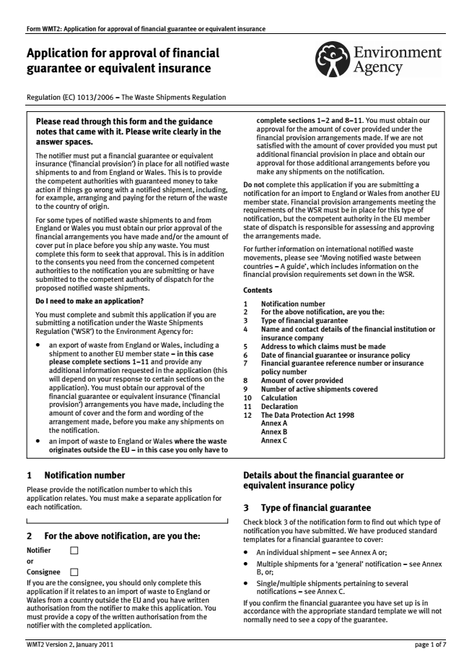
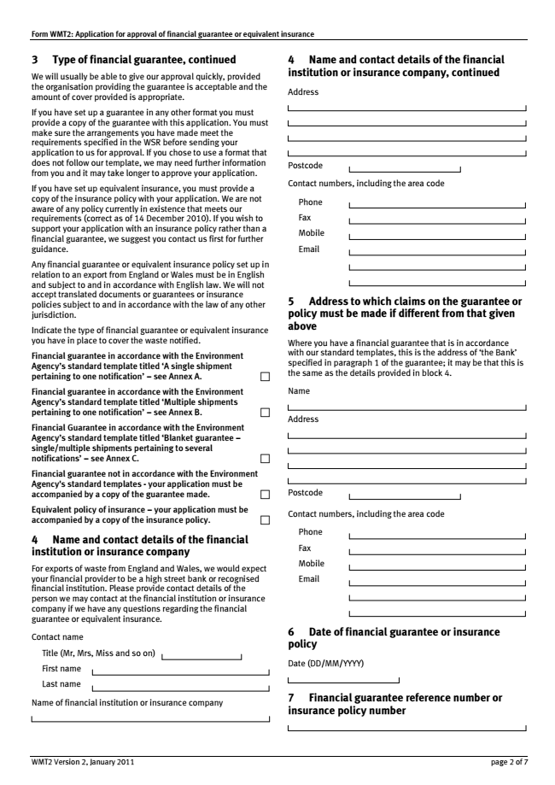
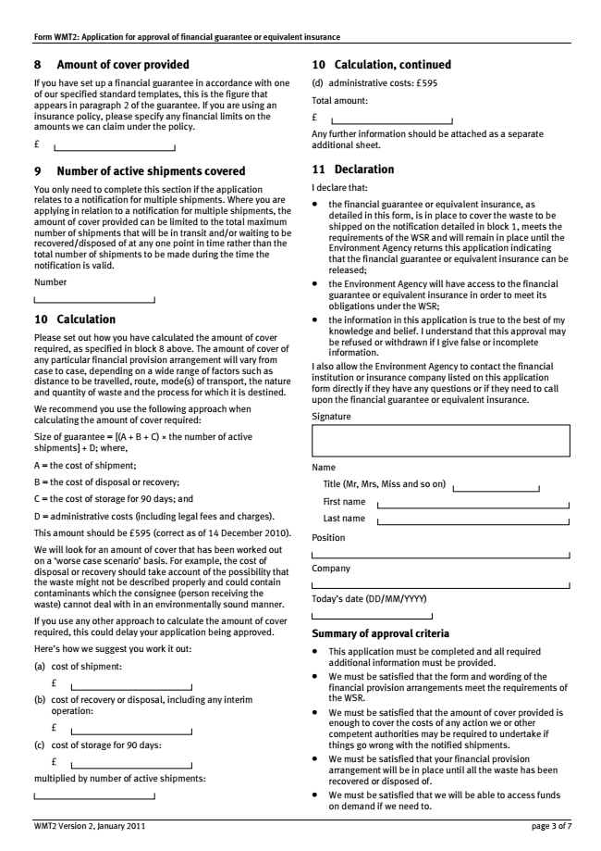
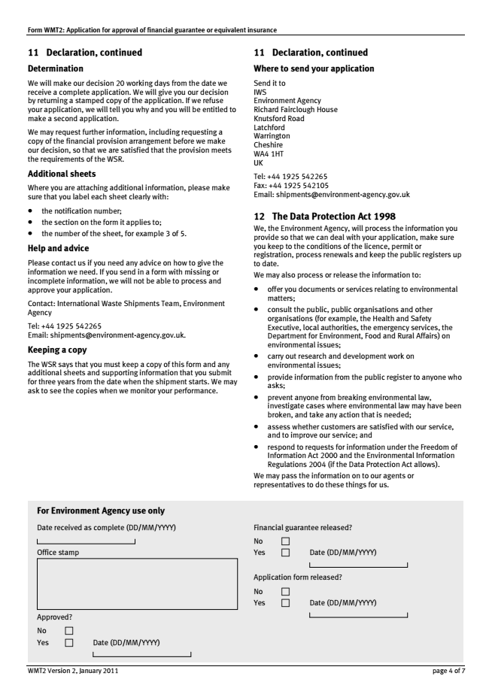
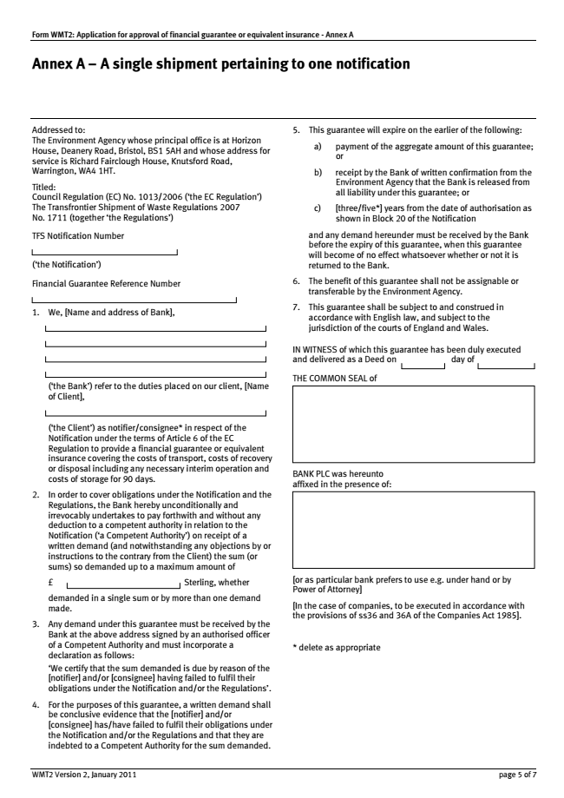
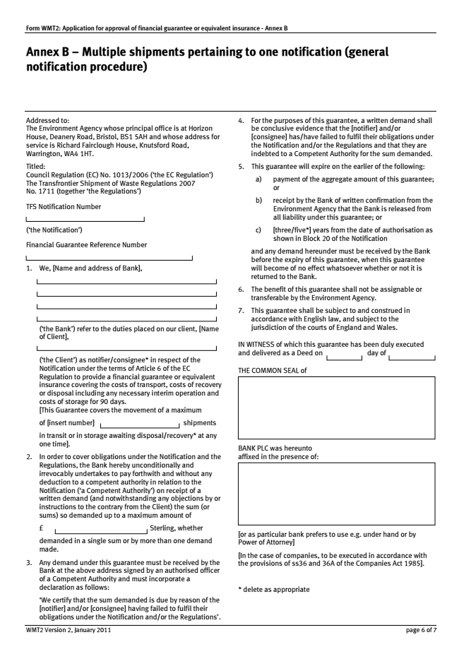
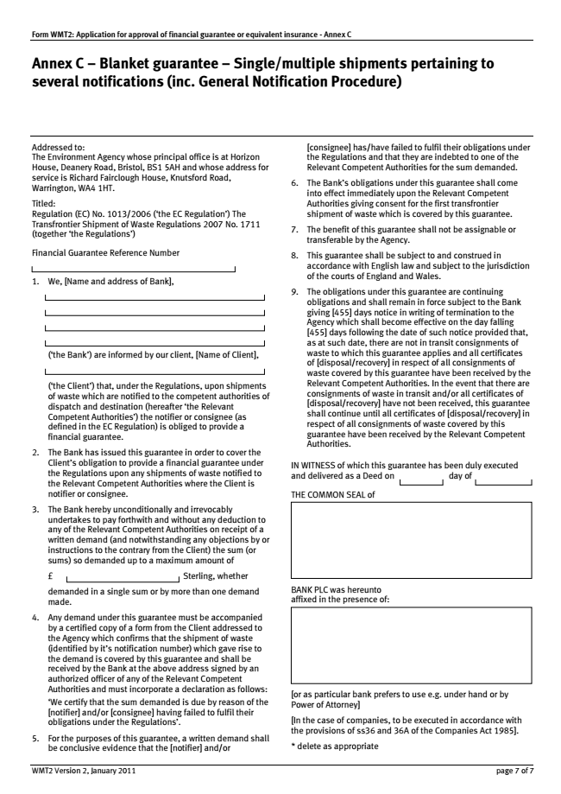

Appendix V

Formulae for calculating the amount of financial guarantee – Austria, Belgium, Germany, Italy, Portugal, Switzerland, the United Kingdom (England and Wales)

A. AUSTRIA1

For Austria, the formula for the determination of the financial guarantee (FG) or equivalent is:

FG = (trans + treat + store) x quantity

trans: transport costs per ton + VAT
treat: treatment costs (typically of intended treatment) per ton + VAT
store: storage costs for 90 days per to + VAT
quantity: total quantity of waste notified

VAT: value added tax of the respective country, where the financial guarantee is laid down.

Storage costs (for 90 days): The following values shall be used, or alternatively an individual offer may be made at a price valid for the Ministry of the Environment.

Non hazardous wastes: € 40/t
Hazardous wastes: € 150/t

Transport costs: (one way) in km in accordance with the notification: As a rough estimate, the figure of 0,10 €/ton/km are used. Alternatively, the transport costs can be made through a presentation of an offer.

Treatment costs: In general, the costs for waste recovery or disposal depend on the specific waste stream and are calculated on the basis of price lists of Austrian waste treatment facilities. When the waste being shipped has a positive net value, meaning that it could be sold for treatment with a net profit, the treatment costs in the calculation can be set to zero.

Interim operation: A supplementary guarantee could cover the final treatment costs and the transport costs from pre-treatment to the final treatment installation. If no supplementary financial guarantee is provided, the financial guarantee shall cover the costs of the alternative final treatment (including the pre-treatment costs) and the transport costs from the location of the sender of the wastes to the consignee, carrying out the final recovery or disposal operation.

The guarantee can be reduced to ¼ provided that
- all notifications of transport – receive – disposal are made in electronic form
- the number of “shipments alive” (notification of transport but no notification of disposal) never exceeds 25% of the total amount.

B. BELGIUM

1. For Flanders Region, the formula for the determination of the financial guarantee (FG) or equivalent is:

FG = Total requested tonnage x 4 x 2 Euro (minimum 1,200 euro) x 2 if exported to non-EU or EVA-countries.

2. For Wallonia, the formula for the determination of the financial guarantee (FG) is:

FG = [A + B + C] x D x [(E / F) + 1] x 1.2 ; or [A + B + C] x D x 1.2 (for single shipment)

where:
A = cost of treatment (replacement or if no alternative real cost);
B = cost of transport;
C = cost of storage (according following tariff: dangerous wastes indoor 140 €/t, dangerous wastes outdoor 70 €/t, non-dangerous wastes indoor 70 €/t, non-dangerous wastes outdoor 35 €/t);
D = maximal quantities per transport;
E = maximal duration of treatment (from departure to certification);
F = minimal duration between two shipments.2

C. GERMANY3

The competent authority shall determine the amount of the financial guarantee at its own discretion, with recourse to past values. For this purpose, we recommend using the following calculation method, which uses so-called specific costs for transportation, recovery or disposal, and storage:

FG = (CT * D * ST + CRD * SRD + CS * SS) * M

FG = Amount of the bank guarantee or equivalent insurance [€]
CT = Return transportation costs per km, per tonne [€/(km * t]
CRD = Recovery or disposal costs per tonne [€/t]
CS = Costs of storage for 90 days per tonne [€/t]
D = Distance [km]
M = Quantity of waste [t]
ST = Safety margin for return shipment (1.0 to 1.3)
SRD = Safety margin for recovery/disposal (1.0 to 1.3)
SS = Safety margin for storage (1.0 to 1.3)

The actual costs can only be ascertained on a case-by-case basis with due regard for the nature and hazardousness of the waste, particularly for the event of an illegal shipment.
For this reason, the waste which is the subject of a shipment application is generally used as the starting point for calculation purposes. Experience has shown that the aforementioned safety margins (ST, SRD, SS) for the respective costs generally cover such unknown variables – cf. in particular nature and hazardousness. Average specific costs may also be used for calculation purposes, to avoid having to re-examine the costs for every subsequent or new notification concerning similar waste.

We would like to point out that a quote – in relation to the recovery or disposal costs – in which the recovery or disposal operation is offered at a price significantly below the average costs can only be accepted as a basis subject to the submission of a binding declaration. In this declaration, the disposal company should undertake to guarantee the quoted prices and acceptance of the specified quantity until such time as the financial guarantee is released.
Below, we provide tips for calculating the relevant costs.

Transport costs (CT) and safety margin (ST):
The cost of return shipment per kilometre, per tonne can only be calculated with due regard for the waste type and the transport conditions required. For example, the calculation could be based on the transport costs for outward transportation, plus a safety margin of 10-30 %. Alternatively, the average costs per tonne for return transportation may be used; this is probably the most common case, so that the distance (D) may be omitted from the above calculation formula.

Distance (D):
If allowance has not already been made for distance in the aforementioned transport costs per tonne, and if no concrete information regarding the distance is available, then the approximate distance should be used, where applicable with a safety margin.

Recovery or disposal costs (CRD) and safety margin (SRD):
The cost of the non-interim recovery or disposal should be ascertained with due regard for the waste type and constituents as well as the required recovery or disposal procedure. These are subject to market-related variations, and often characterised by numerous premiums (e.g. low calorific value or special constituents).

The costs of “all required interim procedures” cited under the recovery or disposal costs should be confined to those costs which are necessary for proper recovery or disposal, including any required repackaging etc. These costs may be covered by calculating a safety margin of e.g. 10-30 %. Farther-reaching measures are impossible to calculate in practice, since these must be known in advance, i.e. when calculating the financial guarantee. It is generally in any case desirable to aspire towards recirculation with direct recovery or disposal.

Storage costs for 90 days (CS) and safety margin (SS):
In accordance with Articles 22 and 24, the waste must be returned within 90 or 30 days of notification, or within another period of time to be unanimously specified by the authorities.
The storage costs can likewise only be ascertained with due regard for the nature and hazardousness of the waste. When calculating the financial guarantee, it is sufficient to use as a basis the average costs of interim storage in relation to the notified waste and the maximum period of 90 days, plus a safety premium of, say, 10-30 %.
The storage costs determined in this way, including the safety margin, should cover the storage costs for the cases pursuant to Article 22, para. 9 and Article 24, para. 7 from the date on which the competent authority of dispatch receives notification through to the date of return (cf. Article 23, para. 1 and Article 25, para. 1).

Volume of waste (M):
The total volume of waste is derived from the notification document. In the case of general notifications, in accordance with paragraph 8, part-quantities may be used as a basis for calculation rather than the total volume. The competent authority shall determine the part-quantities in collaboration with the notifier. However, this method presupposes that the confirmation of recovery or disposal is available for every part-quantity shipped, so that the financial guarantee may be transferred to the next part-quantity.
The hitherto common practice in Germany of partial financial guarantees (specification of a single partial financial guarantee with the proviso that waste may only be shipped within the context of the difference between the part-quantity covered by the partial financial guarantee and the sum total of quantities already shipped for which recovery or disposal confirmations are not yet available) is also consistent with paragraph 8.

D. ITALY4

The formula for the determination of the financial guarantee (FG) or equivalent is:

FG = T (Transport) + S (Disposal / Recovery + Storage)

T = Transport Costs in € = Km x Tonnes x 0,15
S = Disposal /Recovery /Storage = Tonnes x K2

K2:
Recovery of any type of waste € 1.003/t
Disposal of non hazardous waste € 1.003/t
Disposal of hazardous waste € 2.006/t
Disposal of hazardous wastes containing more than 5.000 ppm halogenated solvents € 4.012/t

E. PORTUGAL

The formula for the determination of the financial guarantee (FG) or equivalent is:

FG = (T + E + A) x Q x Ns x 1,4

where:

T = transport costs per tonne of waste;
E = final disposal /recovery cost, including any interim operations, per ton of waste;
A = cost of storage for 90 days per tonne of waste;
Q = average quantity in tonnes per shipment;
Ns = maximum number of shipments that are expected to be carried out simultaneously from the place of expedition to the place of destination.

F. SWITZERLAND

 |  |  |  |  |  |  |  |  |  |  |  |  |  | CH00 | ________________
 |  |  |  |  |  |  |  |  |  |  |  |  |  | (please fill in)
Instructions for calculating the financial guarantee in the case
of transboundary waste shipments
Amount of cover = (DC x PA) + (TC x PA) + AC = |  |  |  |  |  |  |  |  |  |  |  | CHF | 0
Parameters:
DC = |  | Disposal costs per tonne |  |  |  |  |  |  |  |  |  |  |  | CHF/Tonne |  | Please insert
A = |  | Notified annual amount |  |  |  |  |  |  |  |  |  |  |  | Tonnes |  | Please insert |  | ATTENTION: Cells N23 and N25 should be hidden for publication
 |  |  |  |  |  |  |  |  |  |  |  |  |  |  |  |  |  | (i.e. colour numbers and boxes white, without frames)!
NM = |  | Number of months until the disposal is confirmed |  |  |  |  |  |  |  |  |  |  |  | Months |  | Please insert
TC = |  | Transport costs per tonne |  |  |  |  |  |  |  |  |  |  |  | CHF/Tonne |  | Please insert
AC = |  | Additional costs/Interim storage costs |  |  |  |  |  |  |  |  |  |  | 0 | CHF |  | Calculation |  |  |  | capacity t
 |  |  | Lorry or rail wagon (L), Block train (B) or Ship (S) |  |  |  |  |  |  |  |  |  |  |  |  |  |  | For lorries (25t) |  | 25
 |  |  |  |  |  |  |  |  |  |  |  |  |  |  |  |  |  | For trains (800t) |  | 800
 |  |  | Dangerous goods (Enter "1" for no or "2" for yes) |  |  |  |  |  |  |  |  |  |  |  |  |  |  | For ships (1400t) |  | 1400
PA = |  | Partial amount with security reserve |  |  |  |  |  |  |  |  |  |  | 0 | Tonnes |  | Calculation
AOC = |  | AMOUNT OF COVER |  |  |  |  |  |  |  |  |  |  | 0 | CHF |  | Calculation
Explanation of the boxes to be filled in (yellow)
DC: In principle the costs you should enter are the costs you would pay for disposal in Switzerland. If there are no suitable disposal facilities in Switzerland you can enter the actual disposal costs that have been agreed with the disposal facility. If the waste has a positive market value you should enter CHF 0.-- .
The following disposal costs are to be assumed for the waste items listed here: used tyres: CHF 120.--/t (not retreads); used vehicles, electronic components from appliances (e.g. circuit boards), used cables, cooking oils and fats, waste wood: CHF 0.--/t.
A: The amount requested should be entered in Box 5 of the notification form. If a period of more than a year is requested, the scheduled annual amount should be entered.
NM: Enter the number of months within which the foreign disposal facility undertakes to confirm the disposal. Even if shorter periods have been agreed, a period of at least 2 months should be entered. The following types of waste are exceptions from this: used tyres for retreading, used vehicles, electronic components from appliances (e.g circuit boards), used cables (not underground cables), cooking oils and fats, waste wood. 0 months should be entered for these types of waste.
TC: Transport costs are the anticipated costs of return transport to the waste producer.
AC: In calculating additional costs or interim storage costs, details should be provided of the means of transport and the classification of waste according to the law on dangerous goods (ADR/SDR,RID/RSD). A distinction should be made between transport by lorry or individual rail wagon (L), by block train (B) or inland waterway shipping (S).
 |  |  |  |  |  |  |  |  |  |  |  |  |  |  |  |  | Status: 01.11.2014
Explanation of the calculations (blue and red)
AC: The additional costs comprise the costs for any interim storage for 180 days and the necessary analyses. The maximum amount that can be shipped within a week is relevant. The notified amount and the payload of the means of transport are taken into account. A distinction is made between dangerous and non-dangerous goods in the costs for interim storage. A deposit is paid for the analysis costs.
PA: If the disposal contract requires the disposal certificates to be available within a period shorter than 12 months, the relevant partial amount will be insured. In calculating the partial amount 1 month is always added. PA = A/12 x (NM + 1)
AOC: The amount of cover corresponds to the partial amount of waste with a security deposit multiplied by the disposal costs + the partial amount of waste with a security deposit multiplied by the transport costs + the additional costs. AOC = (DC x PA) + (TC x PA) + AC

G. THE UNITED KINGDOM (ENGLAND AND WALES)5

The formula for the determination of the financial guarantee (FG):

FG = [(A + B + C) x the number of active shipments] + D

where,

A = the cost of shipment;
B = the cost of disposal or recovery;
C = the cost of storage for 90 days; and
D = administrative costs (including legal fees and charges = £595).

A/B/C is filled in by the notifier on basis of his actual costs. The CA scrutinizes this amount and may request an additional security calculated on the basis of a “worst case scenario”. For example, the cost of disposal or recovery should take account of the possibility that the waste might not be described properly and could contain contaminants which the consignee (person receiving the waste) cannot deal with.

____________________

1 UNEP/CHW/CC.11/11.
2 The Questionnaire, requested by the ICC (UNEP/CHW/CC.10/14. paragraphs. 52-53), sought information on how Parties are implementing the Provision. Responses to the Questionnaire may be found on the Convention’s website, and are summarized in the Report.
UNEP/CHW/CLI_EWG.3/INF7.
This guidance is not intended to suggest that financial guarantees are necessary in all cases. Some Parties who have prohibited the import or transit of hazardous wastes in their territory have not seen the need for financial guarantees.
Guide to the Control System, Instruction manual for use by those persons involved in transboundary movements of hazardous wastes,” (hereinafter, “Guide to the Control System”), paragraph 44. The Guide was first adopted by the fourth meeting of the Conference of the Parties (1998), and updated by the twelfth meeting of the Conference of Parties (2015). The updated version is annexed to document UNEP/CHW.12/9/Add.3/Rev.1 and is available at: http://www.basel.int/TheConvention/ConferenceoftheParties/Meetings/COP12/tabid/4248/mctl/ViewDetails/EventModID/8051/EventID/542/xmid/13027/Default.aspx.
Id., Step 5, page 17.
A link to the standard movement and notification documents may be found at: http://www.basel.int/procedures/notificationmovementdocuments/tabid/1327/default.aspx.
Basel Convention, Article 2.3 (emphasis added).
Annex V of the Convention also requires that information relating to insurance be provided on notification, although no specific reference to the Provision is made.
The interests of the importing and exporting States overlap in some respects, but are also distinct. The exporting State needs to assure that it can fulfill its obligation to re-import the waste. The importing State is more concerned with ameliorating a problem that may threaten health and the environment within its territory.
However, at least one Party accepts a financial guarantee meeting another Party’s requirements in case of TBM that takes place entirely within the European Economic Area. Finnish regulation, available at http://www.ymparisto.fi/en-US/Forms_permits_and_environmental_impact_assessment/Permits_notifications_and_registration/Transfrontier_shipments_of_waste/Forms_and_document_templates (accessed 17 October 2015).
See http://www.oed.com/view/Entry/97268?redirectedFrom=insurance#eid. (Accessed 17 Oct. 2015).
Merriam Webster Unabridged, http://unabridged.merriam-webster.com/unabridged/bond, definition 5(c). (Accessed 17 Oct. 2015).
Id., http://unabridged.merriam-webster.com/unabridged/surety%20bond. (Accessed 17 Oct. 2015).
RCRA Orientation Manual 2011 Glossary, http://ofmpub.epa.gov/sor_internet/registry/termreg/searchandretrieve/termsandacronyms/search.do?matchCriteria=Contains&checkedTerm=on&checkedAcronym=on&search=Search&term=surety%20bond. (Accessed 17 October 2015.).
U.S. Environmental Protection Agency, “RCRA Subtitle C Financial Assurance Instrument Fact Sheet -- SURETY BOND,” available at http://www2.epa.gov/sites/production/files/2015-08/documents/sbond-fs_0.pdf. (Accessed 25 October 2015).
Oxford English Dictionary (5th Ed, Oxford University Press).
OECD, Guidance Manual For The Implementation Of Council Decision C(2001)107/FINAL, As Amended, On The Control Of Transboundary Movements Of Wastes Destined For Recovery Operations (2009), page 22.
As an example, the U.S. Environmental Protection Agency (EPA) allows the use of surety bonds to satisfy financial responsibility requirements. U.S. law allows EPA to direct payment on the bonds (if properly drafted) when specified conditions are met. By contrast, Switzerland does not allow the use of such instruments, because its competent authority would not have direct access to such instruments under Swiss law. Swiss Notification Procedure for the Export of Waste, available at http://www.bafu.admin.ch/abfall/01508/06061/08962/index.html?lang=en. (Accessed 25 October 2015).
Such guarantees could be more difficult or expensive to obtain, as they would cover incidents caused by actions of third parties, as opposed to the person (usually the exporter/generator) obtaining the guarantee.
In addition, the fifth meeting of the Conference of Parties, by Decision V/32 (1999), decided, on an interim basis, to enlarge the scope of the Technical Cooperation Trust Fund, to allow developing countries and countries with economies in transition to request assistance from the Secretariat in case of an incident occurring during a TBM of hazardous wastes covered by the Convention in order to: estimate the magnitude of damage occurred or damage that may occur and the measures needed to prevent damage; take appropriate emergency measures to prevent or mitigate the damage; and help find those Parties and other entities in a position to give the assistance needed. More information about this mechanism may be found at http://basel.int/Implementation/TechnicalAssistance/EmergencyAssistance/History/tabid/2370/Default.aspx.
Guide to the Control System, para. 44.
Id. (Emphasis added.)
E.g., Belgium, Central African Republic, Madagascar, New Zealand and Honduras. According to the BCRC Uruguay response to the Questionnaire, financial guarantees employed in Uruguay, Guatemala, and Belize all cover some forms of liability.
As of 15 December 2015, there are 11 Parties and 13 Signatories to the Protocol. Pursuant to Article 29 of the Protocol, the Protocol shall enter into force on the ninetieth day after the date of deposit of the twentieth instrument of ratification, acceptance, formal confirmation, approval or accession.
As of that date, no State has yet ratified the HNS Convention. The entry into force of the Convention requires 12 ratifications (or “acceptances”), including at least 4 States representing a minimum amount of shipping tonnage.
Article 1.4 of the Basel Convention exempts waste derived from the normal operation of a ship, if covered by another Convention. However, hazardous waste carried as cargo would not be subject to that exemption.
CRTD, Article 13.
As of that date, the CRTD Convention has been ratified by one country. The entry into force of the Convention requires five ratifications.
Hereinafter, the “European Waste Shipment Regulation” or “the Regulation.”
Among the countries with detailed regulations implementing the Regulation are Belgium, Finland, Germany, and Portugal. Finland’s regulations are available at http://www.ymparisto.fi/en-US/Forms_permits_and_environmental_impact_assessment/Permits_notifications_and_registration/Transfrontier_shipments_of_waste/Forms_and_document_templates (accessed 17 October 2015). Germany implements the Regulation through Section 3 of the German Waste Shipment Act, http://www.gesetze-im-internet.de/abfverbrg_2007/. In addition to its law, Germany has published a considerable body of guidance in this regard. The information in this guidance is based on the 2007 version of the Länder Arbeitsgemeinschaft Abfall (LAGA) Communication 25 (hereinafter, “LAGA Communication 25”). Newer English translations are not available, but German government sources have advised that any changes on this issue are marginal. The LAGA Communication 25 is not legally binding. Belgium implements the Regulation on a Regional basis through the Decree of the Walloon Parliament of 27 June 1996 (art. 23, § 1, 4°) and the Order of the Walloon Government of 19 July 2007 (art. 6), as well as the Decree of the Flemish Parliament of 23 December 2011 (art. 14) and the Order of the Flemish Government of 17 February 2012 (art. 6.2.5). Portugal implements the Regulation through Decree-Law No. 45/2008 of 11 March (Art. 7. And Annex).
E.g., Argentina, response to Questionnaire #1. Madagascar has prohibited the import of hazardous waste until adequate treatment facilities have been installed. Decree No. 2012-753, Ministere de l’Environnement et des Forets. The Decree applies to wastes listed in Annex I of the Decree or containing constituents listed in Annex II of the Decree. With respect to the import or export of end-of-life products, sources of wastes, and wastes that are harmful to the environment, Madagascar imposes a system of notification that includes information on insurance. Importers are required to provide financial support to the government authority in the accomplishment of its tasks. Decree 2012-754.
Oman does not report any legislation, but states that notifications are not processed unless environment protection insurance is provided, adding that “most applicants provide adequate finance protection. “Oman, Response to Questionnaire #3.
In keeping with the terminology used by several Parties, the term “notifier” is used in this sense, and not in the sense of the State of export being the “notifier,” as used in Article 6 of the Convention.
See responses to Questionnaire #5 from Belgium and Central African Republic. In the case of Belgium, the importer is required to obtain a guarantee in cases where no guarantee (or insufficient or inadequate) is foreseen in the exporting country.
For example, the European Waste Shipment Regulation (Art. 6.3) provides: “The financial guarantee or equivalent insurance shall be established by the notifier or by another natural or legal person on its behalf.”
German guidance provides: “The financial guarantee may also be made by a third party (another natural or legal person acting on its behalf), provided the competent authority has been granted access to this guarantee by the notifier by way of a power of attorney or contractual agreement.” LAGA Communication 25, paragraph 1.1.1.2.
See discussion in Section II A. 3. above.
The Finnish financial guarantee template is reproduced in Appendix A.
LAGA Communication 25 Section 1.1.1.3.
See European Commission, “Assessment and guidance for the implementation of EU waste legislation in Member States,” ENV.G.4/SER/2009/0027: Current Implementation Of Financial Guarantees And Equivalent Insurance In All Member States, Including An Impact Analysis” (D 2.1.4)(17 November 2010) (hereinafter, “EC Assessment and Guidance document”), Table 2.2.
For Finland, acceptable collateral includes a guarantee, insurance, or a pledged deposit. Finnish Regulation, “Financial Guarantee for Waste Shipments,” available at http://www.environment.fi/en-US/Forms_permits_and_environmental_impact_assessment/Permits_notifications_and_registration/Transfrontier_shipments_of_waste/Waste_export_and_import_guidelines/Application_for_a_waste_transport_permit/Financial_guarantee_for_waste_shipments.
LAGA Communication 25, paragraph 1.1.1.3.
See EC Assessment and Guidance document, page 8.
EC Assessment and Guidance Document, Table 2-2. The Waste Shipment regulation leaves to Member State discretion the exact type of financial guarantee to be established.
Finnish Regulation, “Financial Guarantee for Waste Shipments,” note 39, supra. Insurance taken out by the company must be submitted to the Finnish Environment Institute in the form of a bank guarantee. The Finnish Environment Institute recommends insuring waste shipments with an on-demand bank guarantee.
BCRC Uruguay, response to Questionnaire, Part IV.
German templates for financial guarantee and insurance may be found in Annexes 5 and 6 to LAGA Communication 25.
OECD, Guidance Manual For The Implementation Of Council Decision C(2001)107/FINAL, as amended, On The Control Of Transboundary Movements Of Wastes Destined For Recovery Operations (2009), page 22.
See, e.g., European Waste Shipment Regulation, Section 6.2; New Zealand Imports and Exports Restrictions Act 1988.pdf0.37mb. Art. 3BB; Swiss Articles 17f and 20 on “Financial Guarantee” of Section 2 “Exportation” of the Ordinance RS 814.610 related to the Movement of Wastes (VeVA) of 22 of June 2005 (amended in accordance with of the Ordinance of 18 December 2013, in force since 1 May 2014), with reference to Articles 33 and 34. See generally, responses to Questionnaire #10.
See Report on the Implementation of Paragraph 11 of Article 6 of the Basel Convention, Pertaining to Insurance, Bond or other Guarantee for Transboundary Movements of Hazardous Wastes and other Wastes , (hereinafter, “Implementation Report”) UNEP/CHW.CC.11.11, Annex, paragraph 21.
Under the Swiss Code of Obligations, the Federal Office of Environment would be able to have direct access to the financial guarantee, but not to a surety. Swiss Notification Procedure for the Export of Waste, available at: http://www.bafu.admin.ch/abfall/01508/06061/08962/index.html?lang=en.
LAGA Communication 25, section 1.1.1.5.
See Implementation Report, paragraph 21.
OECD, Guidance Manual For The Implementation Of Council Decision C(2001)107/FINAL, as amended, On The Control Of Transboundary Movements Of Wastes Destined For Recovery Operations (2009), page 22.
See Implementation Report, paragraph 21.
For calculating the amount of liability insurance required, New Zealand uses the guideline values in the Instruction Manual for the Implementation of the Basel Protocol on Liability and Compensation for Damage Resulting from Transboundary Movements of Hazardous Wastes and Their Disposal. See New Zealand response to Questionnaire, #8.
Belgium response to Questionnaire, #8g.
“Regulation on the Control of Transboundary Movements of Hazardous Wastes and their Utilization/Disposal,” approved by Ukraine Cabinet’s Decree of July 13, 2000, No. 1120, Paragraphs 7 and 25 (as discussed in Ukraine’s response to the Questionnaire #1.paragraph 17). A similar requirement applies to transit of hazardous waste; the notification for transit must contain (inter alia) guarantees on full compensation for any damage which may be caused to human health and environment in the course of waste transportation via the territory of Ukraine. Id., paragraph 25.
BCRC Uruguay, response to Questionnaire #8.
Annex II of the European Waste Shipment Regulation, paragraph 21. This Regulation does not cover damage to the environment.
Portugal’s response to Questionnaire #1, citing Decree-Law No. 147/2008 of 29 July.
See http://ec.europa.eu/environment/legal/liability/ . The Directive does not require operators to take out financial security products.
Response of Environment Agency and Scottish Environment Agency to Questionnaire #2.
Id.
See Response to Questionnaire #9 from Bahrain.
European Waste Shipment Regulation, Article 6.3.
Finnish Regulation, “Financial Guarantee for Waste Shipments,” note 39, supra.
Guide to Control System, page 19, step 15.
See European Waste Shipment Regulation, Articles 6.5, 15 and 16(e).
EC Assessment and Guidance document, Table 2-8 (page 28).
Finnish Regulation, “Financial Guarantee for Waste Shipments,” note 39, supra.
LAGA Communication 25, paragraph 1.1.1.5
Id., page 5.
National banks may not always be willing or able to issue financial guarantees. For example, The Dominican Republic reports that banks located in that country do not offer guarantees in any form. For that reason, exporters provide a guarantee from a foreign institution based abroad to meet the requirements established by the government and the Provision.
Environment Agency and Scottish Environment Agency, response to Questionnaire #9
See Appendix D.
See Appendix A. (Emphasis added.)
Switzerland, Federal Office for the Environment, “Notification Procedure for the Export of Waste,” section 2.4.
E.g., New Zealand, Bahrain. (Responses to Questionnaire #6.)
European Waste Shipment Regulation, Article 6.7.
Presentation of Mr. Andreas Moser, Federal Ministry of Agriculture, Forestry, Environment and Water management, Austria on “Possible methods for calculation of the financial guarantee in the EU”, during the Multicounty Training Workshop on Transboundary Movement of Hazardous Wastes, Bratislava, Slovakia, 9-10 December 2015. (http://www.sazp.sk/bcrc/script/detaily/workshop-11-2015.php)
Lithuania’s response to Questionnaire #1.
Finnish Regulation, “Financial Guarantee for Waste Shipments,” note 39, supra.
The German formula and explanatory guidance is reproduced in Appendix E.
New Zealand Environmental Protection Authority, (Te Mana Rauhi Taiao) “Exporting Hazardous Waste: New Zealand requirements for exporting hazardous waste under the Basel Convention” (July 2011).
See New Zealand response to Questionnaire, #8.
Id., paragraph 4.
Report, paragraph 23.
European Waste Shipment Regulation, Article 6.7.
Report, summary of responses to Questionnaire #11.
Responses to Questionnaire #11 from Bahrain, Germany and Switzerland. It might be more precise to state that insolvency is a reason why notifiers might not fulfill their obligations to respond to a TBM incident. But it is the failure to fulfill those obligations, not the insolvency, which would trigger activation of the guarantee.
Block 17 of the revised notification document for the control of transboundary movement of hazardous wastes includes a certification that that “any applicable insurance or other financial guarantee is or shall be in force covering the transboundary movement”. Block 15 of the revised movement document for the control of transboundary movement of hazardous wastes includes a certification that “any applicable insurance or other financial guarantee is in force covering the transboundary movement and that all necessary consents have been received from the competent authorities of the countries concerned.” UNEP/CHW.12.9/Add.3/Rev.1.
Report, paragraph 25.
Colombia, response to Questionnaire #3.
See. e.g., LAGA Communication 25, paragraph 1.1.1.1.
OECD Council Decision C(2001)107/FINAL, Appendix 8, paragraph (12).
Id., Appendix 7 (13).
Swiss Notification Procedure for the Export of Waste, available at www.bafu.admin.ch/abfall/01508/06061/08962/index.html?lang=en (accessed 12 November 2015), section 2.4.
European Waste Shipment Regulation, Article 6.4.
Finnish Regulation, “Financial Guarantee for Waste Shipments,” note 39, supra.
LAGA Communication 25, paragraph 1.1.1.3
Id., paragraph 1.1.1.6. The guidance envisions that affected authorities would provide the competent authority having access to the financial guarantee with invoices or quotes so that these costs may be requested in writing from the bank or insurance company on the basis of the financial guarantee.
It should be noted that no recommendations were received from the insurance industry.
In keeping with the terminology used by several Parties, the term “notifier” is used in this sense, and not in the sense of the State of export being the “notifier” as used in Article 6 of the Convention.
For example, the European Waste Shipment Regulation (Art. 6.3) provides: “The financial guarantee or equivalent insurance shall be established by the notifier or by another natural or legal person on its behalf.
German guidance provides: “The financial guarantee may also be made by a third party (another natural or legal person acting on its behalf), provided the competent authority has been granted access to this guarantee by the notifier by way of a power of attorney or contractual agreement.” LAGA Communication 25, paragraph 1.1.1.2.
See EC Assessment and Guidance document, page 8.
See, e.g., Finnish template, reproduced in Appendix A.
This guarantee may also be referred to as a pledge, surety, security, bond, bail, or guarantee. EC Assessment and Guidance document, note 1.
It may be desirable to define the term “bank” and perhaps include some criteria regarding the bank’s location, financial condition, etc.
EC Assessment and Guidance document, page 31.
EC Assessment and Guidance Document, page 14.
Given the potential need for urgent action to respond to a TBM crisis, it may also be desirable to require that the financial guarantee be payable in a freely convertible currency. For example, Switzerland requires that the guarantees be payable in Swiss francs.
In some cases, guaranteed funds may be available to deal with cases of illegal export. See discussion in Part I, Section 1.7.2, supra.
See discussion in Part I, Section 3.3b, supra.
For example, the European Waste Regulation has separate requirements regarding the establishment of insurance policies for liability to third parties. EC Regulation 1316/2006, Annex II. See discussion in Part I, Section 3.3a, supra.
As Honduras has pointed out in its response to the Questionnaire (Part IV, “additional observations”), applying a regulatory guarantee in a developing country requires consideration not only of the potential risk of contamination, but of avoiding the encouragement of illicit trafficking, or "smuggling" Companies may seek alternatives to high-cost control measures and export without meeting the minimum requirements.
As noted above, The European Waste Shipment Regulation, section 6.3, provides that the financial guarantee shall be effective at the time of the notification, but may be delayed if the competent authority permits, until the time at which the shipment begins.
EC Assessment and Guidance Document, page 15.
Guide to Control System, page 19, step 15.
German guidance is explicit on this point, stating: “In the event of the return of waste * * *, the competent authority which has access to the financial guarantee is obliged to reimburse the other affected authorities for the costs incurred in conjunction with the return (e.g. storage costs for impoundment * * * or if, for example, an alternative form of recovery or disposal in the receiving country has been specified by the affected authorities * * *, the resources required for this purpose). The guidance calls on affected authorities to provide receipts or evidence – in the form of invoices or quotes – so that these costs may be requested in writing from the bank or insurance company that has issued the financial guarantee. “LAGA Communication 25, section 1.1.1.5.
This could also be true in the case of transit States enacting similar requirements.
New Zealand and Bahrain, per responses to the Questionnaire.
See, e.g., Appendix E (formulae of Austria, Belgium, Germany, Italy, Portugal, Switzerland and the United Kingdom).
See EC Assessment and Guidance Document, page 14. In some cases, deviation is allowed for specific waste codes.
E.g., Greece requires 1 million euros. Id. Canadian law on liability insurance sets a minimum amount of C$5,000,000 for hazardous waste and C$1,000,000 for hazardous recycling material. Canada, “Export and Import of Hazardous Waste and Hazardous Recyclable Material Regulations,” SOR/2005-149.
The Environment Agency and Scottish Environmental Protection Agency expressed the view that: “It is totally impractical (without excessive cost) for competent authorities to establish a robust value to be covered. Markets vary considerably; companies will have their own commercial rates they have negotiated. In addition, any situation when funds need to be called in will involve an unquantifiable element as the waste is unlikely to be as described. E.g. metal could be contaminated with anything from plastic to clinical waste to radioactive waste and costs would vary considerably. Expectations on the extent of checking financial provision need to be pragmatic and factor in the frequency they are called on.” Response to Questionnaire, Part IV.
It might be desirable to allow a limited time, where possible, for the guaranteed party to remedy the situation without resort to the financial guarantee.
See LAGA Communication, paragraph 1.1.1.3.
In the absence of meaningful constraints on the beneficiary’s ability to draw on the guarantee, it could be more difficult or expensive to obtain one, as the guarantor might assume that the guarantee would inevitably be used.
The Swiss Notification Procedure recognizes that where the competent authority in the States of export and import impose separate financial guarantee requirements, it may be required to provide two financial guarantees. However, the Swiss Federal Environment Agency states that it “will endeavour to find an acceptable solution with the competent authorities to avoid such double guarantees.” Swiss Notification Procedure for the Export of Waste, 2.4.
1 Presentation of Mr. Andreas Moser, Federal Ministry of Agriculture, Forestry, Environment and Water management, Austria on “Possible methods for calculation of the financial guarantee in the EU”, delivered during the Multicounty Training Workshop on Transboundary Movement of Hazardous Wastes, Bratislava, Slovakia, 9-10 December 2015. (http://www.sazp.sk/bcrc/script/detaily/workshop-11-2015.php)
2 Id, #12b.
3 reproduced from LAGA Communication 25, section 1.1.1.1
4 Presentation of Mr. Andreas Moser, Federal Ministry of Agriculture, Forestry, Environment and Water management, Austria on “Possible methods for calculation of the financial guarantee in the EU”, delivered during the Multicounty Training Workshop on Transboundary Movement of Hazardous Wastes, Bratislava, Slovakia, 9-10 December 2015. (http://www.sazp.sk/bcrc/script/detaily/workshop-11-2015.php)
5 Presentation of Mr. Andreas Moser, Federal Ministry of Agriculture, Forestry, Environment and Water management, Austria on “Possible methods for calculation of the financial guarantee in the EU”, delivered during the Multicounty Training Workshop on Transboundary Movement of Hazardous Wastes, Bratislava, Slovakia, 9-10 December 2015. (http://www.sazp.sk/bcrc/script/detaily/workshop-11-2015.php)

