UNITED  NATIONS |  |  | BC  UNEP/CHW/POP-SIWG.2/10
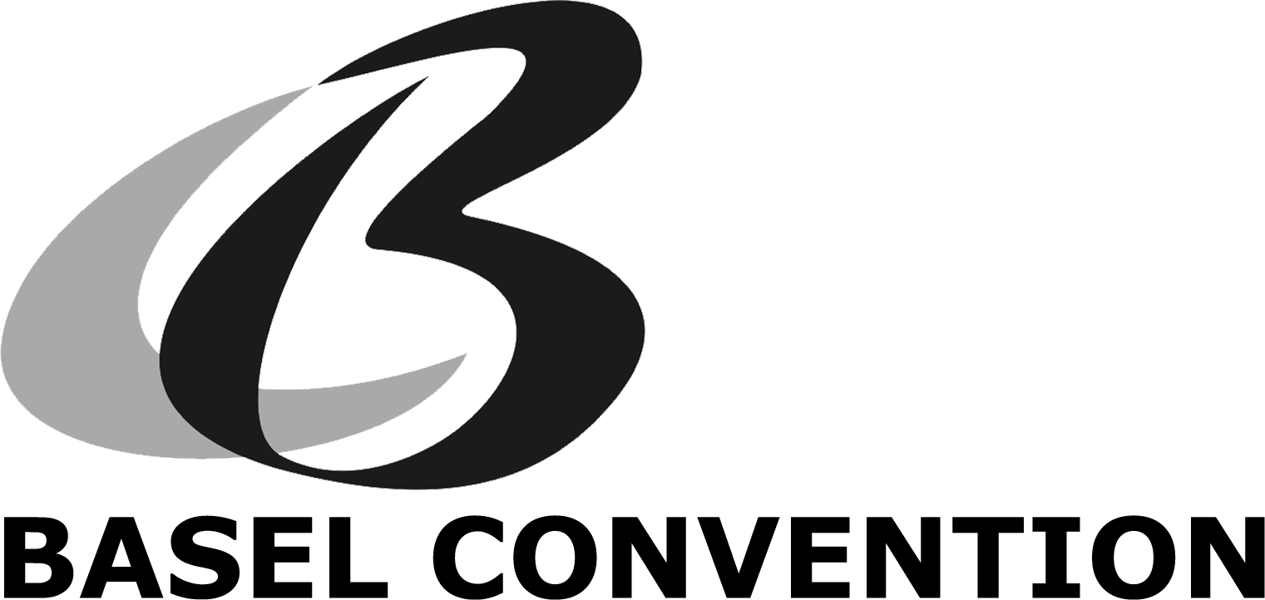 |  | Distr.: General  31 March 2017  English only
POPs SIWG meeting
Bonn, Germany, 20-22 February 2017

Report of the meeting of the small intersessional working group on technical guidelines on persistent organic pollutants

- The meeting of the small intersessional working group (SIWG) on technical guidelines on persistent organic pollutants was held in Bonn, Germany, from 20 to 22 February 2017.
- Opening of the meeting
- Ms. Jacinthe Seguin (Canada), the chairperson of the meeting, made opening remarks and welcomed all participants to Bonn.
- The representative of the Secretariat expressed its appreciation to all SIWG members who have contributed to the work during the intersessional period. She also thanked meeting participants for their attendance, and especially expressed its appreciation to the Government of Canada, for providing in-kind contribution on the updating of the General Technical Guidelines, to the Government of Japan for providing in-kind contribution on the updating of the Technical Guidelines on PCBs and for providing financial support for the Secretariat to engage consultants to work on other four technical guidelines under discussion in the meeting, and to the Government of Norway for leading the development of the analysis of the information received by the Basel Convention related to decaBDE as called for in decision BC-12/3.
- The Secretariat updated the group on the status of implementation of its work programme, as well as on the status of preparation of meeting documents for the thirteenth meeting of the Conference of the Parties (24 April−5 May 2017, Geneva).
II. Organizational matters
A. Adoption of the agenda
- The small intersessional working group adopted the agenda for the meeting on the basis of document UNEP/CHW/POP-SIWG.2/1
III. General technical guidelines
- Low POP content
- The group discussed the values currently available in the technical guidelines, especially those for the most recently listed POPs. The group discussed that it would be important to improve the documentation of the various values proposed, including their supporting background.
- One of the decisions taken by the group was to harmonize the values in the different documents and to have a new information document on low-POP content for COP-13, to be prepared by Canada, which should explain the criteria for the decisions, the different values proposed for limits and their respective sources.
- It was highlighted that when deciding on the low POP content values, it is important to consider the limited capacity available in developing countries (e.g. analytical methods, enforcement) to deal with the management of the various waste streams.
- The group discussed that guidance (e.g. template) could be developed for submissions on low POP content values taking as a basis documents UNEP/CHW/OEWG9.INF/9/Add.1 and UNEP/CHW/OEWG9.INF/9/Add.2 for the development of section III of the General Technical Guidelines on the environmentally sound management of wastes consisting of, containing or contaminated with persistent organic pollutants. This would facilitate the examination, comparison and discussion of low POP content proposals.
- Destruction technologies
- In discussing new information on destruction and irreversible transformation methods (section IV. G) in the General Technical Guidelines, it was found that the working group would benefit from writing down its approach to reviewing methods. A template could be developed to guide the submission of information in order to respect criteria already discussed at previous meetings and ensure consistency and thoroughness of submissions.
- There is a need to identify the world capacity for the destruction of POPs with the eleventh destruction and irreversible transformation methods presented in the General Technical Guidelines. A continental inventory of capacity would be beneficial for regions with predominantly developing countries.
- There is an issue with the availability of literature or other reports to confirm the Destruction Efficiency (DE) of certain technologies, in particular evidence that they can destroy the newer POPs. There needs to be investments in testing listed methods for the destruction of a broader range of POPs or work to extrapolate current data to these newer substances in order to provide reliable and safe recommendations for the management of these wastes. The appropriateness of data from pilot or lab scale tests could be discussed further since at this time data from such work have generally been excluded.
- The categorization of incineration under two technologies (Advanced Solid Waste Incineration and Hazardous Waste Incineration) was found to be an arbitrary labelling which does not necessary reflects their categorization in many countries. The two technologies should be reviewed to examine if there is a better way to categorize and present the incineration as a waste management option for POPs.
IV. Outstanding comments received and remaining harmonization issues of the POPs technical guidelines.
- The group worked on all the six technical guidelines as prepared for the COP-13 and solved outstanding issues, such as the introduction of a few new paragraphs, the outstanding harmonization aspects among the documents, the addition of new references, and the introduction of information which was missing or was inconsistent.
- The group decided on a few harmonizational items to be observed by the various authors when finalizing the documents after the meeting:
- Introductory paragraph in all relevant technical guidelines to indicate the status of the document, e.g. that a new version supersedes a previously adopted version;
- The low POP content values should be the same in the General Technical Guidelines and in the specific guidelines;
- Harmonize country names (former USSR, former Czechoslovakia);
- Harmonize references for ESWI and UBA 2015 (as per General TG);
- Harmonize references to annexes A, B and C of the Stockholm Convention, by mentioning their qualifications (elimination, restriction, unintentional production);
- In the specific technical guidelines, remove listing of destruction technologies and replace with generic sentence; and
- For UPOPs technical guidelines, use order of chemical in title when UPOPs are mentioned.
- It was noted that in the European Union, HBCD is now referred to as HBCDD to reduce the potential confusion with the HCBD which is also being discussed. Basel could consider such as change when appropriate to reduce the potential for confusion and mistakes.
- Additionally, it was discussed that the provisional definition of low POP content value for dioxins (PCDDs) and furans is expressed with the Toxic Equivalency (TEQ) in the Basel Convention General Technical Guidelines and the U-POPs Technical Guidelines. It was noted that the current TEQ value is calculated taking into consideration PCDDs and PCDFs only and exclude PCBs. As the World Health Organization (WHO) recognizes that PCBs can be taken into account in the determination of the TEQ, the Basel Convention could consider further work to assess if it needs to change its method to incorporate the many options offered under the WHO approach.
V. Report on deca-BDE
- On behalf of Norway, Mr. Alexander Potrykus from BIPRO GmbH gave a presentation on the analysis of the information received by the Basel Convention related to decaBDE as called for in decision BC-12/3. The analysis is put forward for COP-13’s consideration as set out in document UNEP/CHW.13/INF/14.
- After the presentation a discussion took place among the different meeting participants, where the various views were put forward about the possibilities, currently available and necessary ones in the future, on the environmentally sound management of wastes consisting of, containing or contaminated with decaBDE, based on the possible listing of this chemical in the Stockholm Convention.
VI. Other matters and next steps
- The group discussed the candidate POPs to be listed in the Stockholm Convention and the possible consequences for the development or the update of the technical guidelines on POP wastes. Specifically, on HCBD, it was discussed that if this chemical is listed in Annex C of the Stockholm Convention, a review of a few guidelines may become necessary (i.e. the General, the HCBD and the UPOPs technical guidelines).
- The respective authors of the various technical guidelines agreed to send the final revised versions of the documents, to the Secretariat, by March 3, 2017.
- It was agreed that all the six technical guidelines revised in the meeting would become information documents for consideration by COP-13. These documents should be considered together with their respective Addenda versions, which were made available to Parties before the SIWG meeting in Bonn.
VIII. Closure of the meeting
- Following the customary exchange of courtesies, the meeting was declared closed at 1 p.m. on Wednesday, 22 February 2017

____________________

This and other meeting documents are available on the Basel Convention website: http://www.basel.int/Implementation/POPsWastes/Meetings/SIWGGermany2017/tabid/5491/Default.aspx

