UNITED  NATIONS |  | BC
 |  | UNEP/CHW/OEWG.11/INF/20
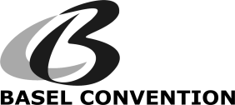 |  | Distr.: General  16 July 2018  English only
Open-ended Working Group of the Basel Convention
on the Control of Transboundary Movements of
Hazardous Wastes and Their Disposal
Eleventh meeting
Geneva, 3−6 September 2018
Item 3 (b) (ii) of the provisional agenda∗
Matters related to the work programme of the
Open-ended Working Group for 2018−2019:
scientific and technical matters: national reporting
Compilation of information from Parties on the types of waste for which practical guidance on the development of inventories would be useful
Note by the Secretariat
As referred to in the note by the Secretariat on national reporting (UNEP/CHW/OEWG.11/5), the annex to the present note contains a compilation of information submitted by Parties on the types of wastes for which practical guidance on the development of inventories would be useful. The present note, including its annex, has not been formally edited.
Annex
Information submitted by Parties on the types of waste for which practical guidance on the development of inventories would be useful

Contents
Argentina 3
Liberia 4
Madagascar 5
Mexico 8
State of Palestine 12
Yemen 13

Argentina

Message received by the Secretariat via electronic mail on 1 March 2018:
“Pursuant to decision BC-13/8, where Parties are invited to submit the types of wastes for which additional practical guidance on the development of inventories would be useful, Argentina would recommend to consider:
· Spent catalysts
· Lithium-thoinyl chloride batteries and lithium-ion batteries
· Mercury fluorescent lamps
· Used cartridges and tonners
· Used tires”

Liberia

Message received by the Secretariat via electronic mail on 1 March 2018:

“I am not sure if we have inventory guidelines on the following: used tyres, plastics, lead paint waste containers, obsolete or used pesticide containers. If not, they are proposed candidates. If they already exist then its ok.”

Madagascar
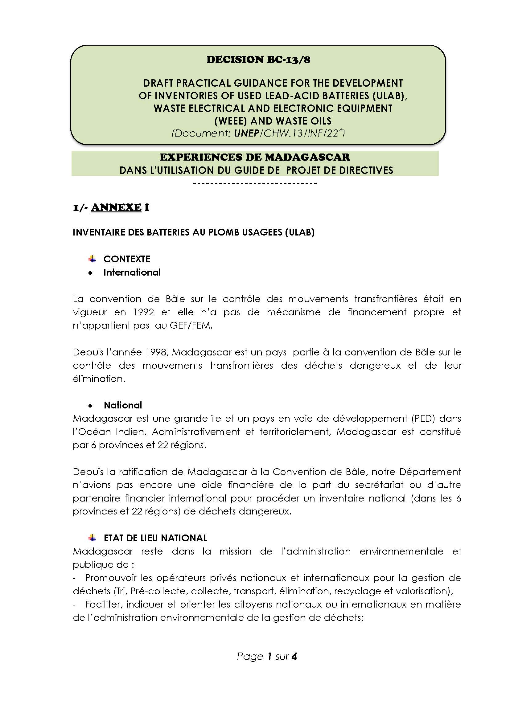

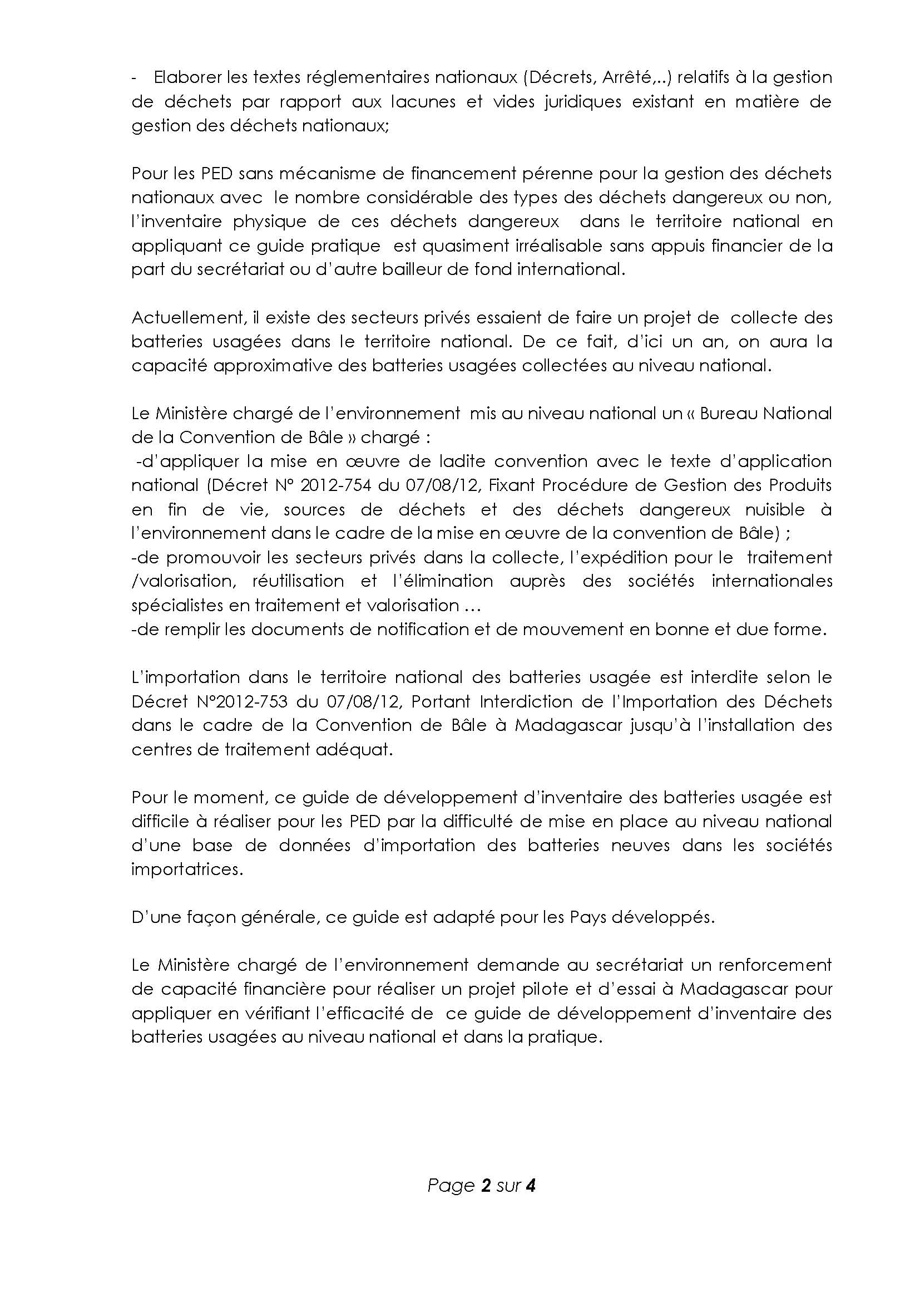

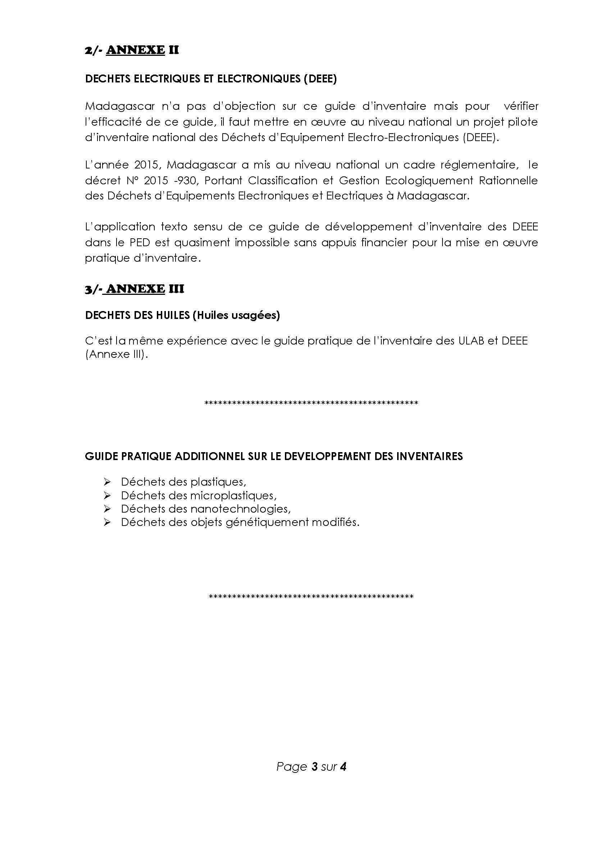

Mexico
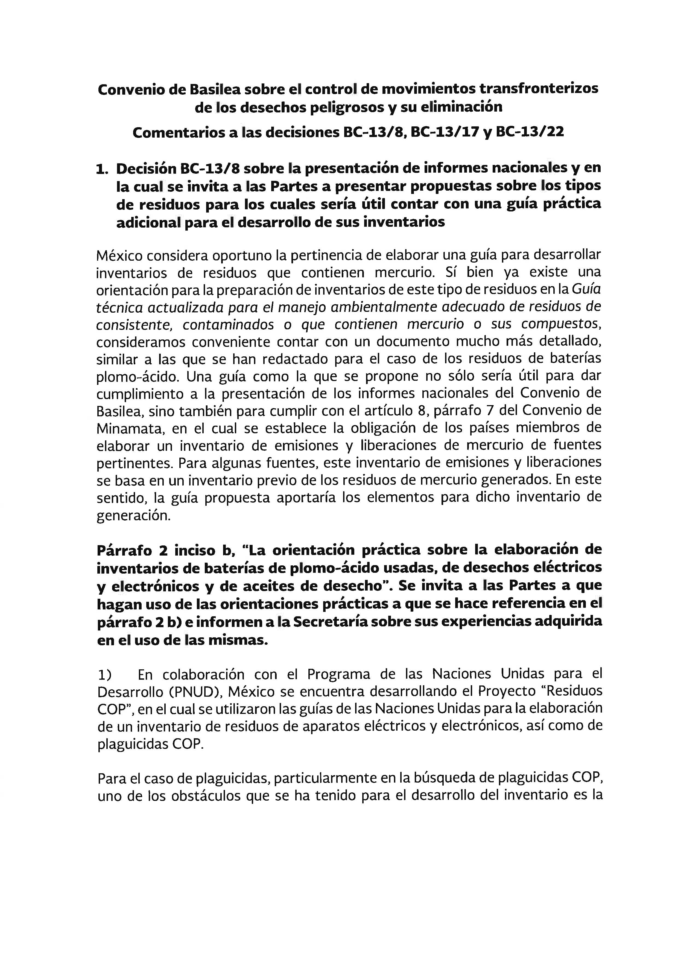

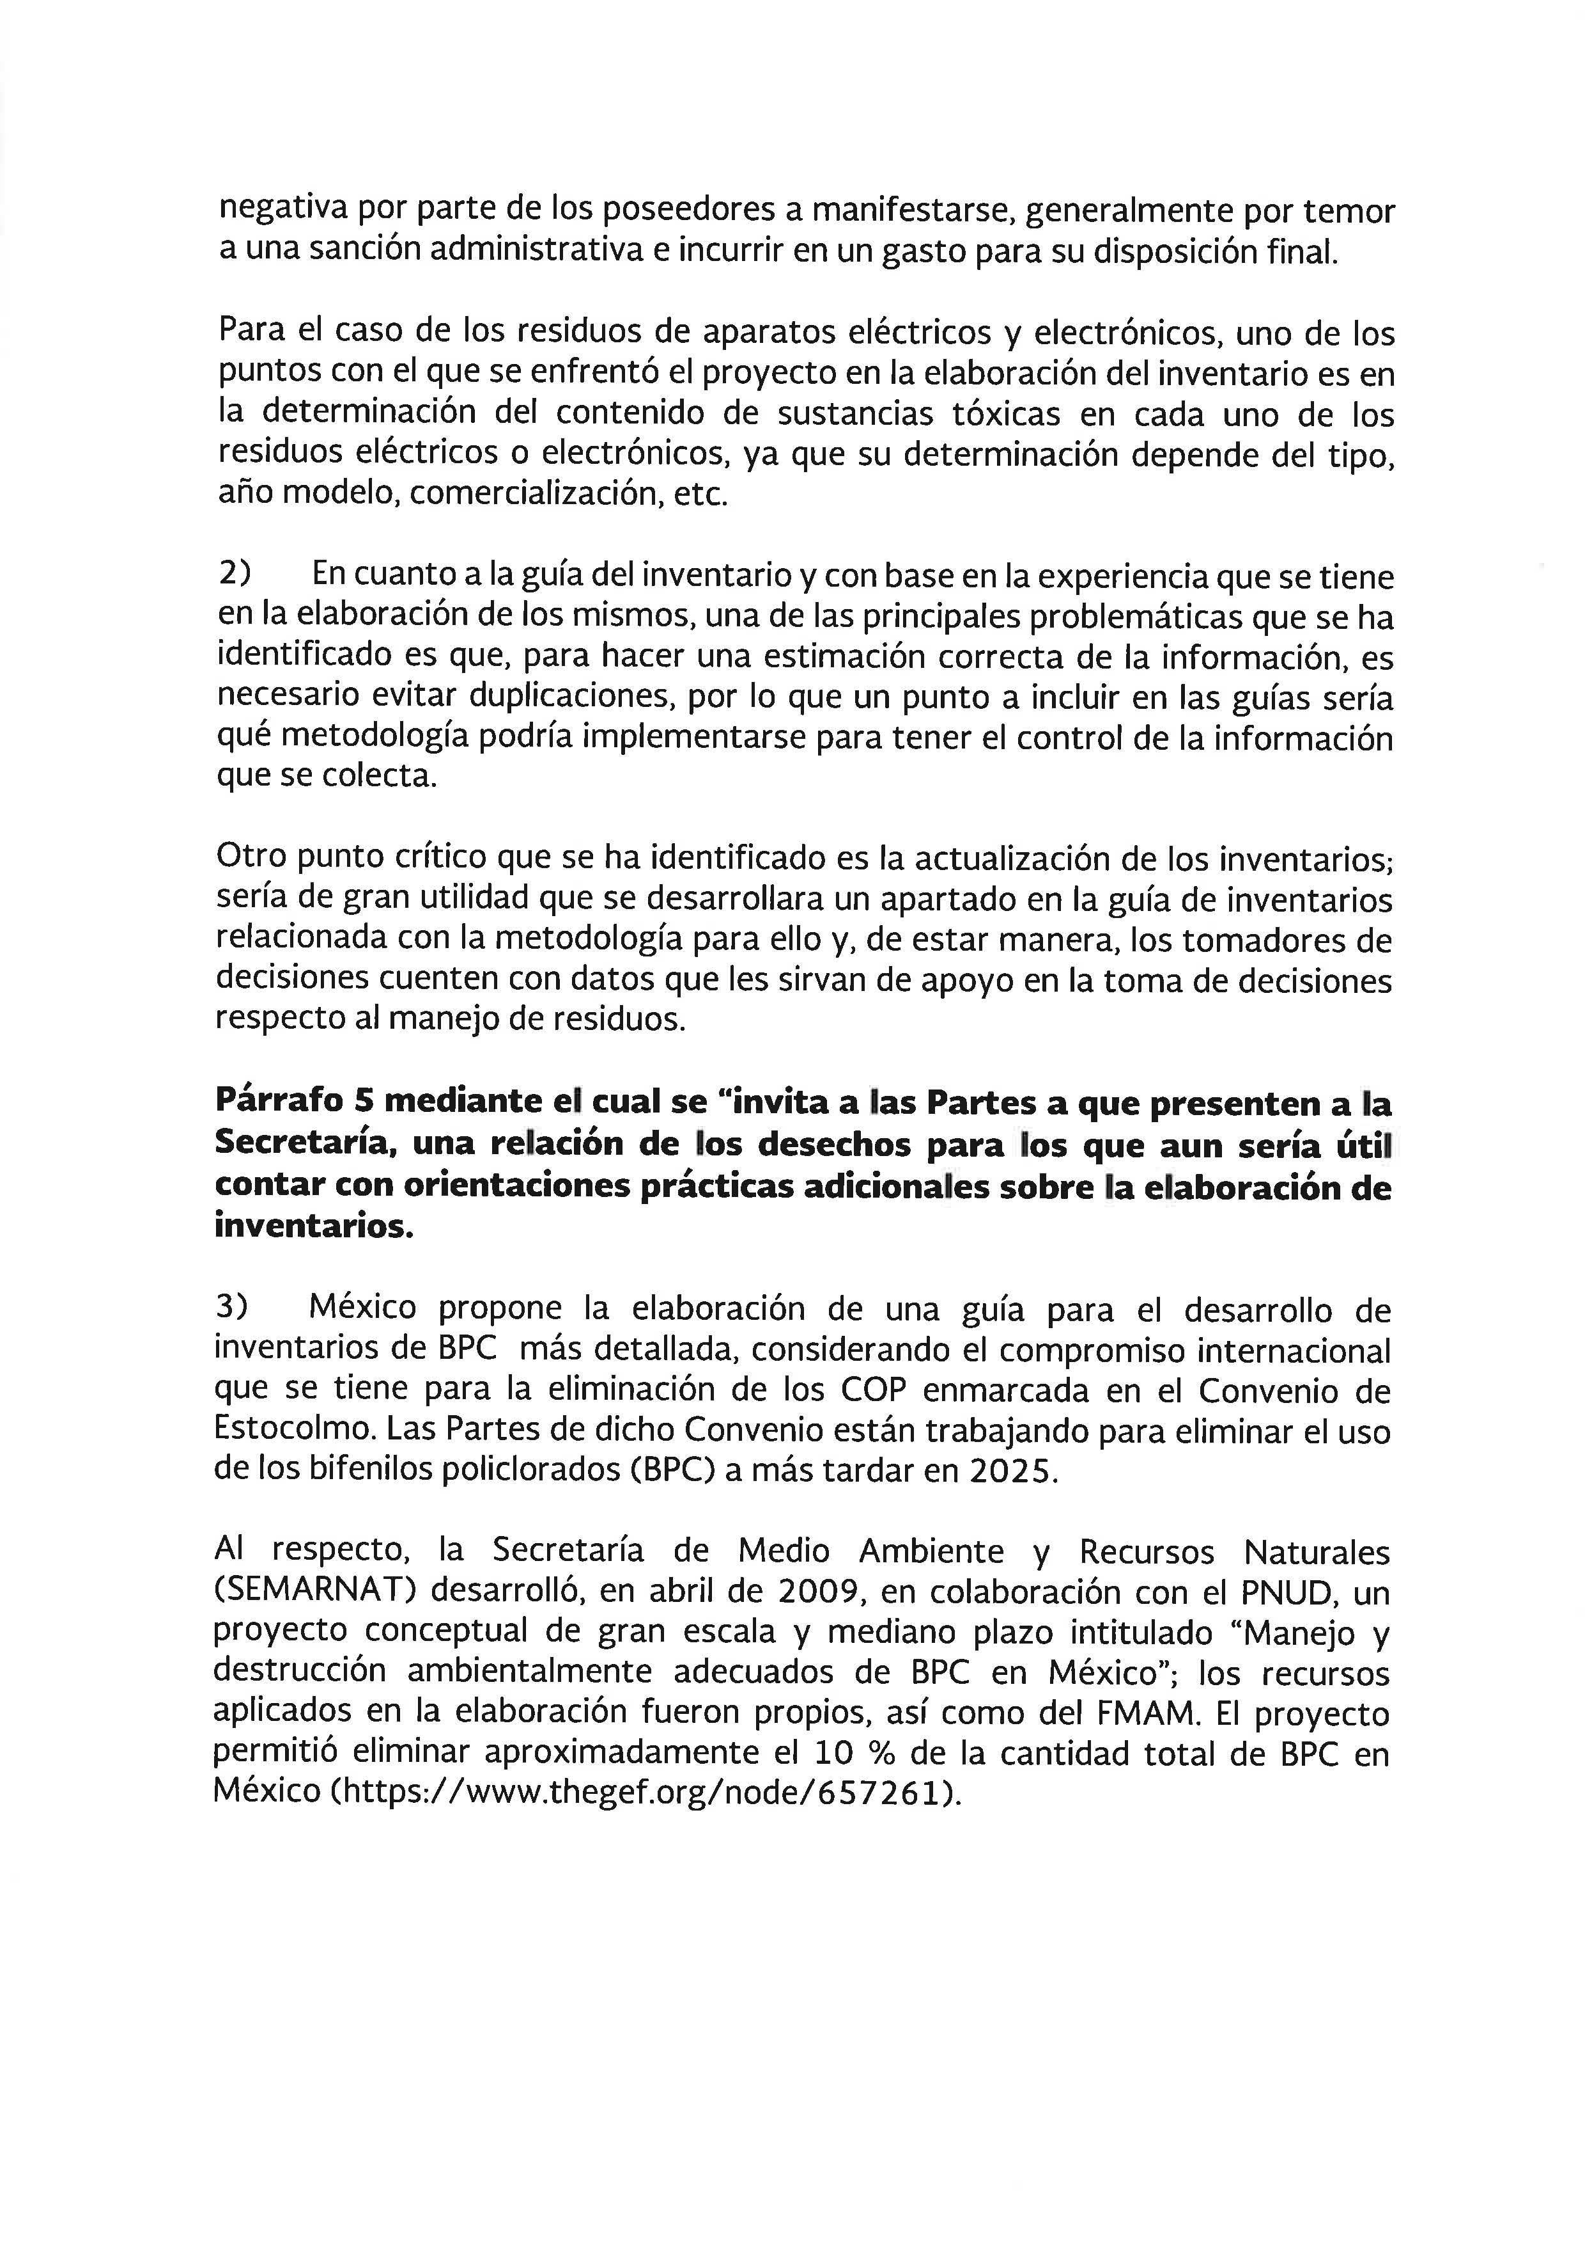

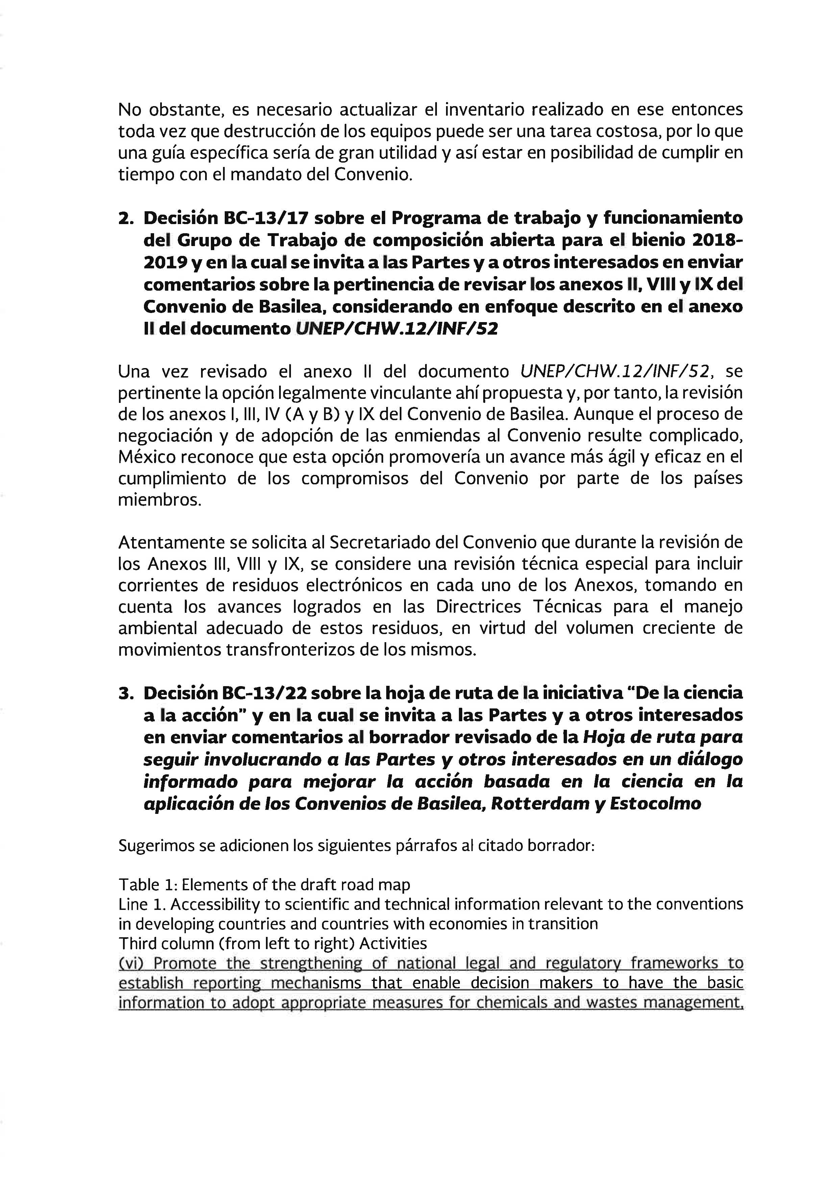
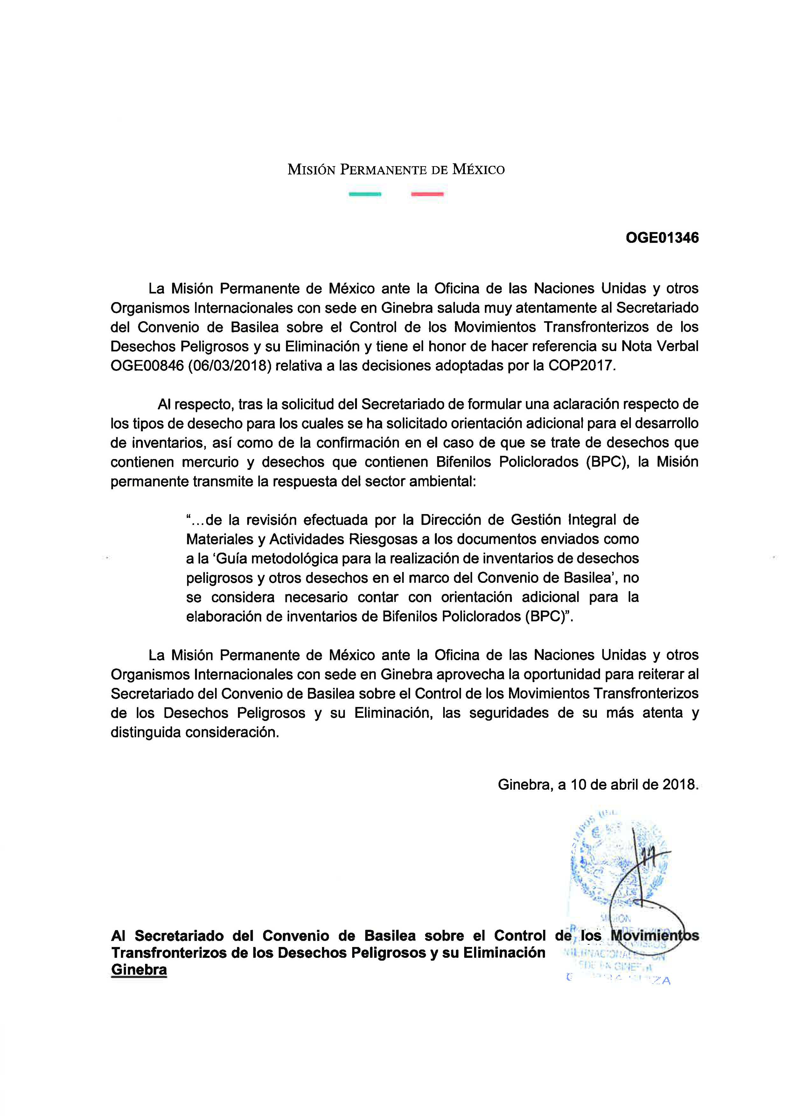

State of Palestine

Message received by the Secretariat via electronic mail on 28 February 2018:
“Dear all I hope this e mail finds you all in good health, following to your communication letter for information in follow up the decisions taken by the Conference of Parties to the Basel Convention (BC COP 13), specifically BC-13/8, BC-13/17 and BC-13/22.
I have some comments on the issue raised in your communication as follows:
1) BC 13/8 regarding the development of inventories of electrical and electronic waste (e- waste):
The illegal import of e-waste is considered as a big problem in State of Palestine. As well as the operations in which such waste takes place by informal sector (e -waste facilities) that present in Area C (Area C is a Palestinian land fully controlled by the Israeli occupation that represents more than 61% of the Palestinian lands). As well as Israel has control over the Palestinian border and trade gates.
So that it is a very difficult for State of Palestine to control, monitor and to access the informal sector due to Israeli procedures on Area C and borders.
Thus, the e waste inventory is only possible for local production not accounting for activities taking place in Area C, and only takes place in a formal manner.
2) BC 13/8 regarding the development of inventories of used lead acid batteries and of waste oil:
It is only possible for the Palestinian vehicles, and as a result of Israeli occupation to the Palestinian lands and controlling borders and trade gates:
a) Hundreds of Israeli vehicles are illegally entered in daily basis to Palestinian lands which end up disposed in our lands;
b) Illegal import (transportation) of used batteries and used mineral oils from Israel;
c) Illegal import of vehicles scrap, again most these shops and scrap yards are present in Area C with limited control, same as above.
In general, we looked through the inventory guidelines, it seems that they are useful instruments to do inventory only for the local production to make sure that we can cope with such tool in the future. So we will try it during the upcoming period and will provide feedback during the discussion.
In addition, it is important if we have space to report on illegal wastes as mentioned above and to deal with issues related to lack of access and control over boarders and areas.
3) BC-13/8 for additional practical guidance on the development of inventories:
I think it is important to have a practical guideline for olive oil wastes on the topic (management of olive oil wastes) - I think this is a problem not only in Palestine, but also Tunisia, Morocco, Jordan, Greece, Spain, Italy...etc.
4) In regards to BC-13/17, review the Annexes Ⅱ, Ⅷ, Ⅸ to the Convention:
Please find attached the comments embedded in the document.”

Yemen

Message received by the Secretariat via electronic mail on 15 February 2018:
“Please note that Yemen has used the following draft guidelines:
1. Draft user manual for the electronic reporting system of the Basel Convention (Electronic Reporting System of the Basel Convention (Year: 2016)). The report was submitted on 12 November 2017.
2. Draft practical guidance for the development of inventories of used lead-acid batteries, waste electrical and electronic equipment and waste oils: The questionnaire was submitted on 14 October 2017 (BC TG eWaste - Stakeholders). But it was used in a limited way because the guidelines were not translated into Arabic. So Yemen confirms the request to translate the guidelines into Arabic, as this will contribute effectively to the wide use of these guidelines).
Yemen requests the development of additional practical guidance for the establishment of waste inventories, for example:
1. Dry zinc batteries that do not contain mercury, in addition to dry zinc batteries that contain mercury.
2. Expired and old pesticides.
3. Expired and old industrial chemicals.”

____________________

∗ UNEP/CHW/OEWG.11/1/Rev.1.

