UNITED  NATIONS | 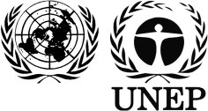 | BC
 |  | UNEP/CHW/OEWG.11/INF/31
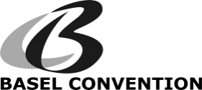 |  | Distr.: General  24 July 2018  English only
Open-ended Working Group of the Basel Convention
on the Control of Transboundary Movements of
Hazardous Wastes and Their Disposal
Eleventh meeting
Geneva, 3−6 September 2018
Item 3 (c) (ii) of the provisional agenda∗
Matters related to the work programme of the
Open-ended Working Group for 2018–2019:
legal, governance and enforcement matters:
providing further legal clarity

Compilation of comments received on whether to consider the review of Annexes II, VIII and IX to the Basel Convention

Note by the Secretariat
As referred to in the note by the Secretariat on providing further legal clarity (UNEP/CHW/OEWG.11/10), the annex to the present note sets out the compilation of comments received on whether to consider the review of Annexes II, VIII and IX to the Basel Convention submitted by Argentina, Central African Republic, Iraq, Madagascar, Mexico and the Philippines. These comments are also available on the website of the Convention. The present note, including its annex, has not been formally edited.
Annex
Compilation of comments on whether to consider the review of Annexes II, VIII and IX to the Basel Convention

Contents
1. Argentina 3
2. Central African Republic 4
3. Iraq 5
4. Madagascar 6
5. Mexico 7
6. Philippines 12

Argentina
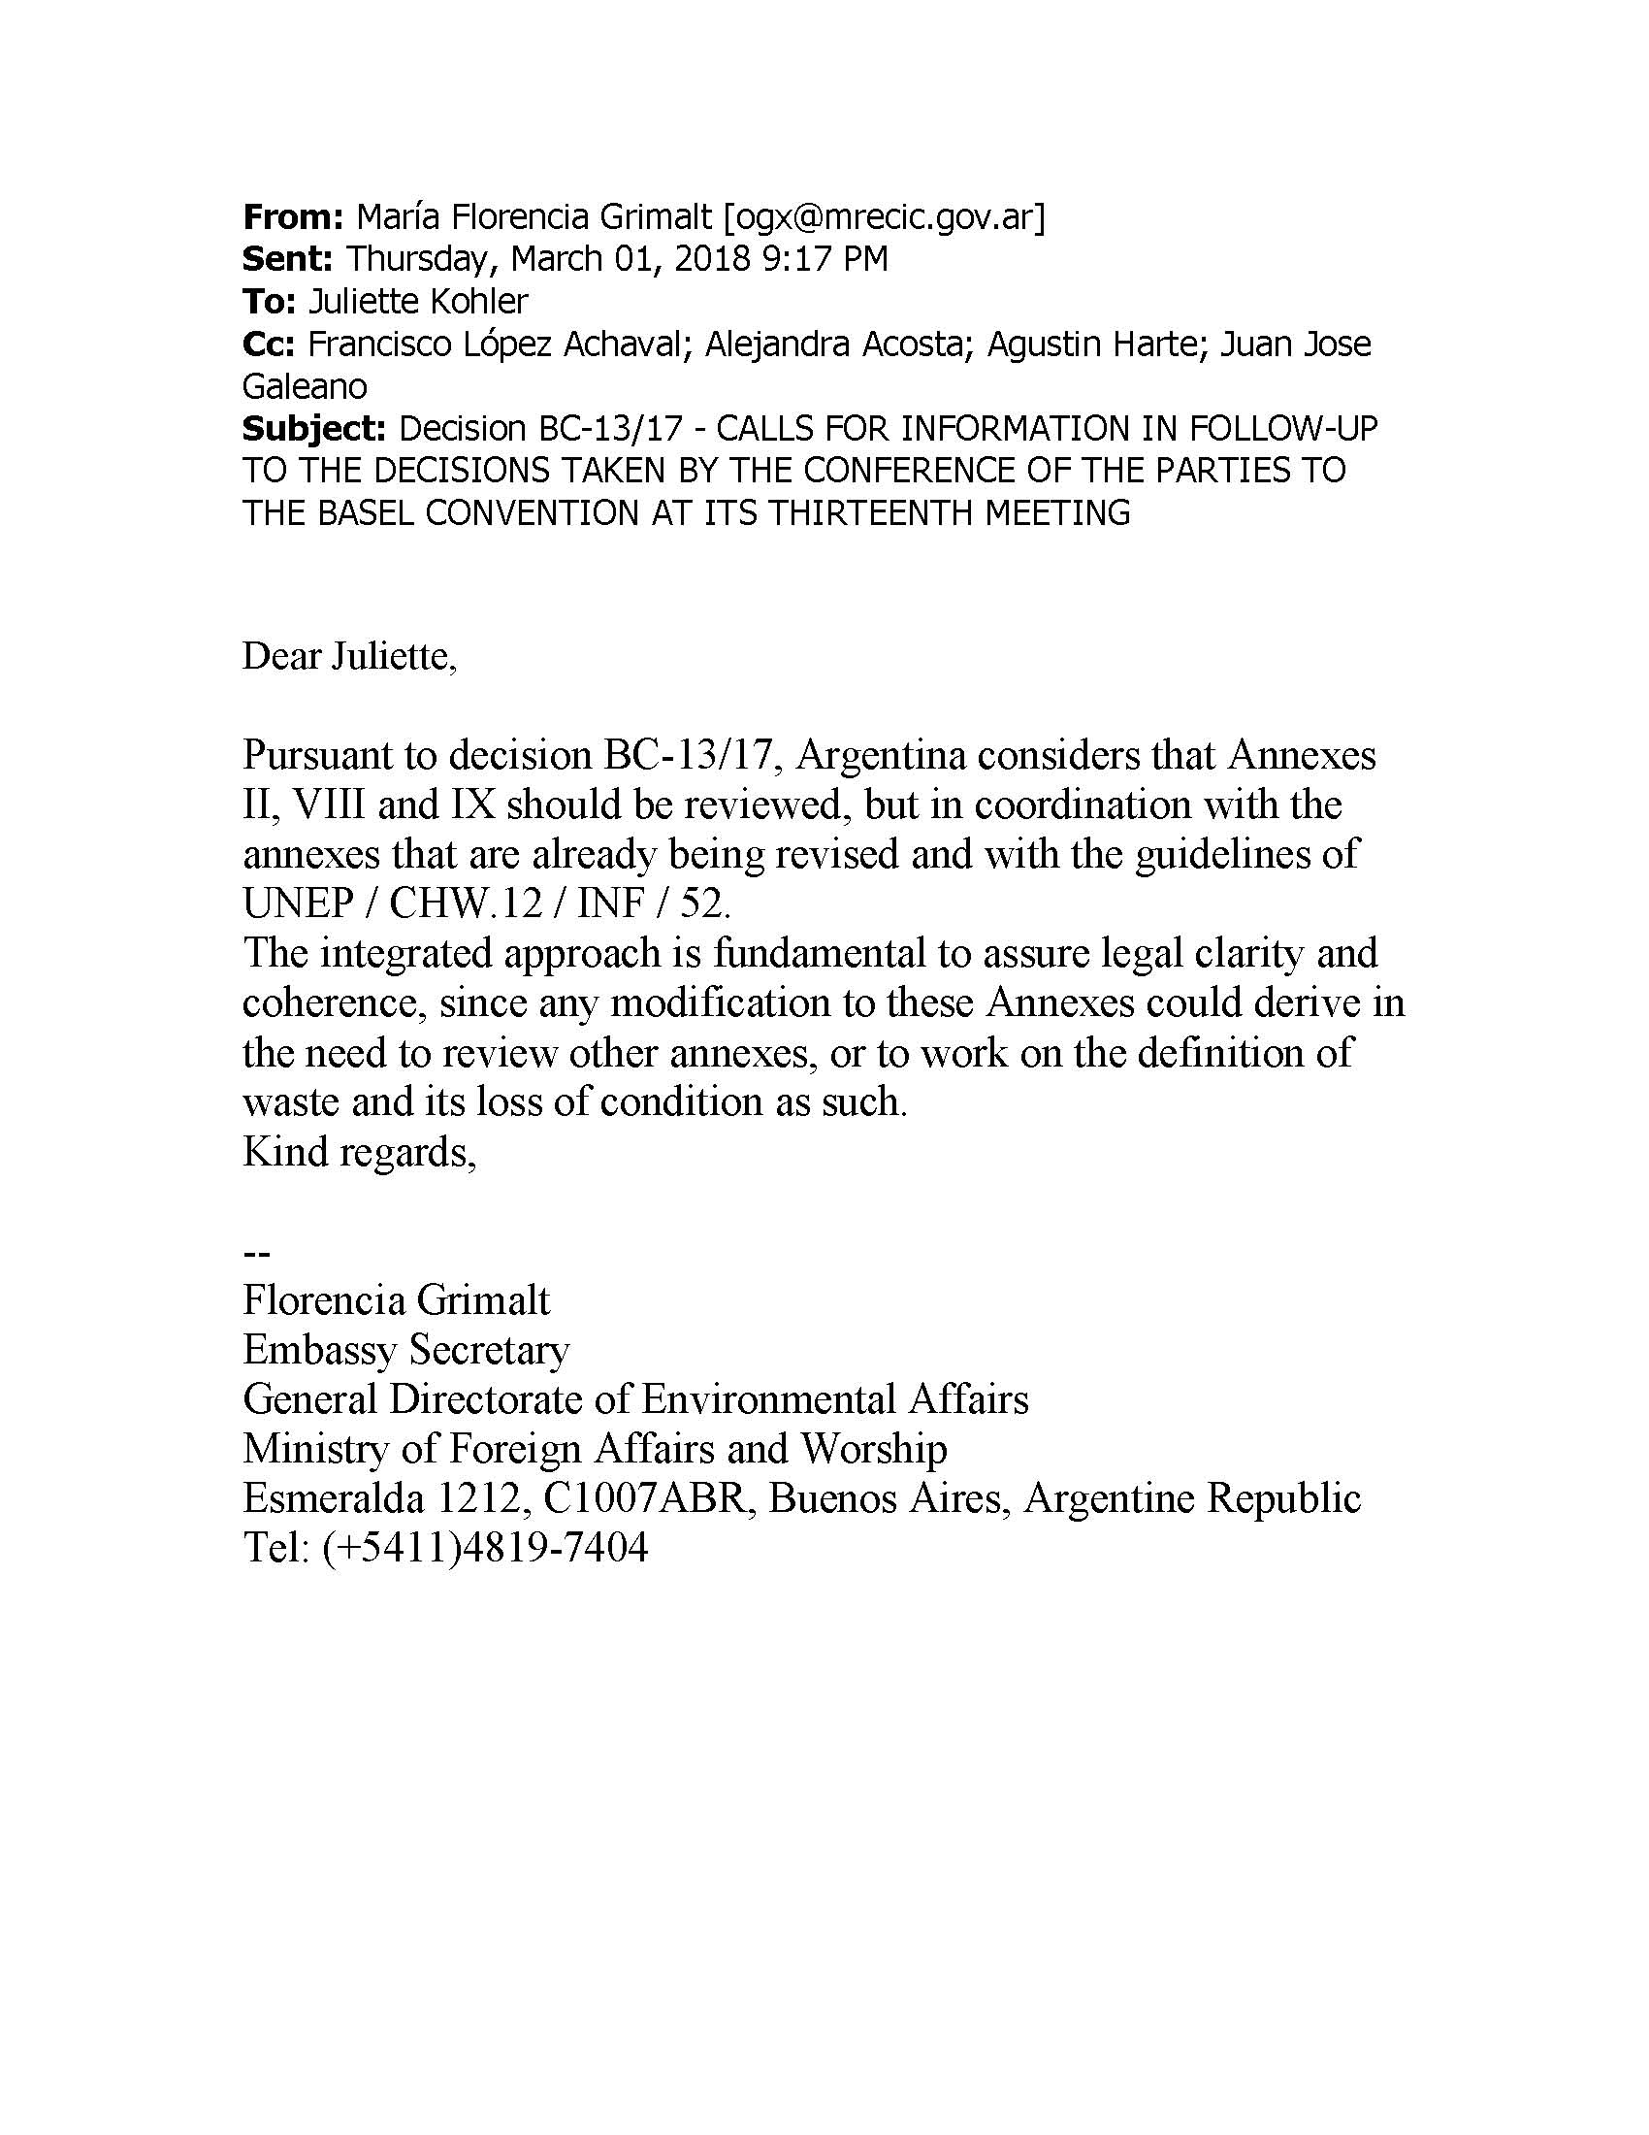

Central African Republic

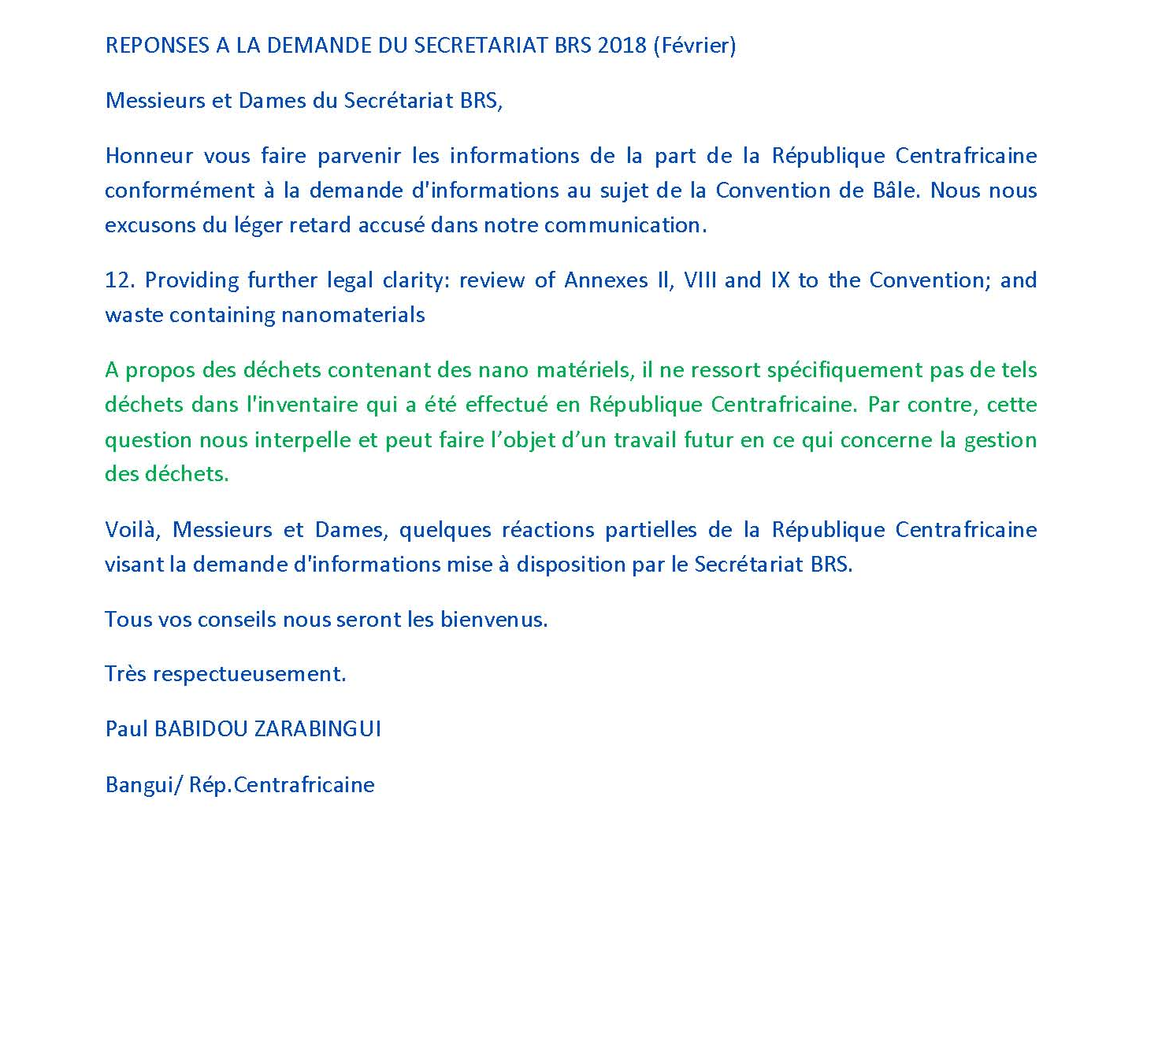

Iraq
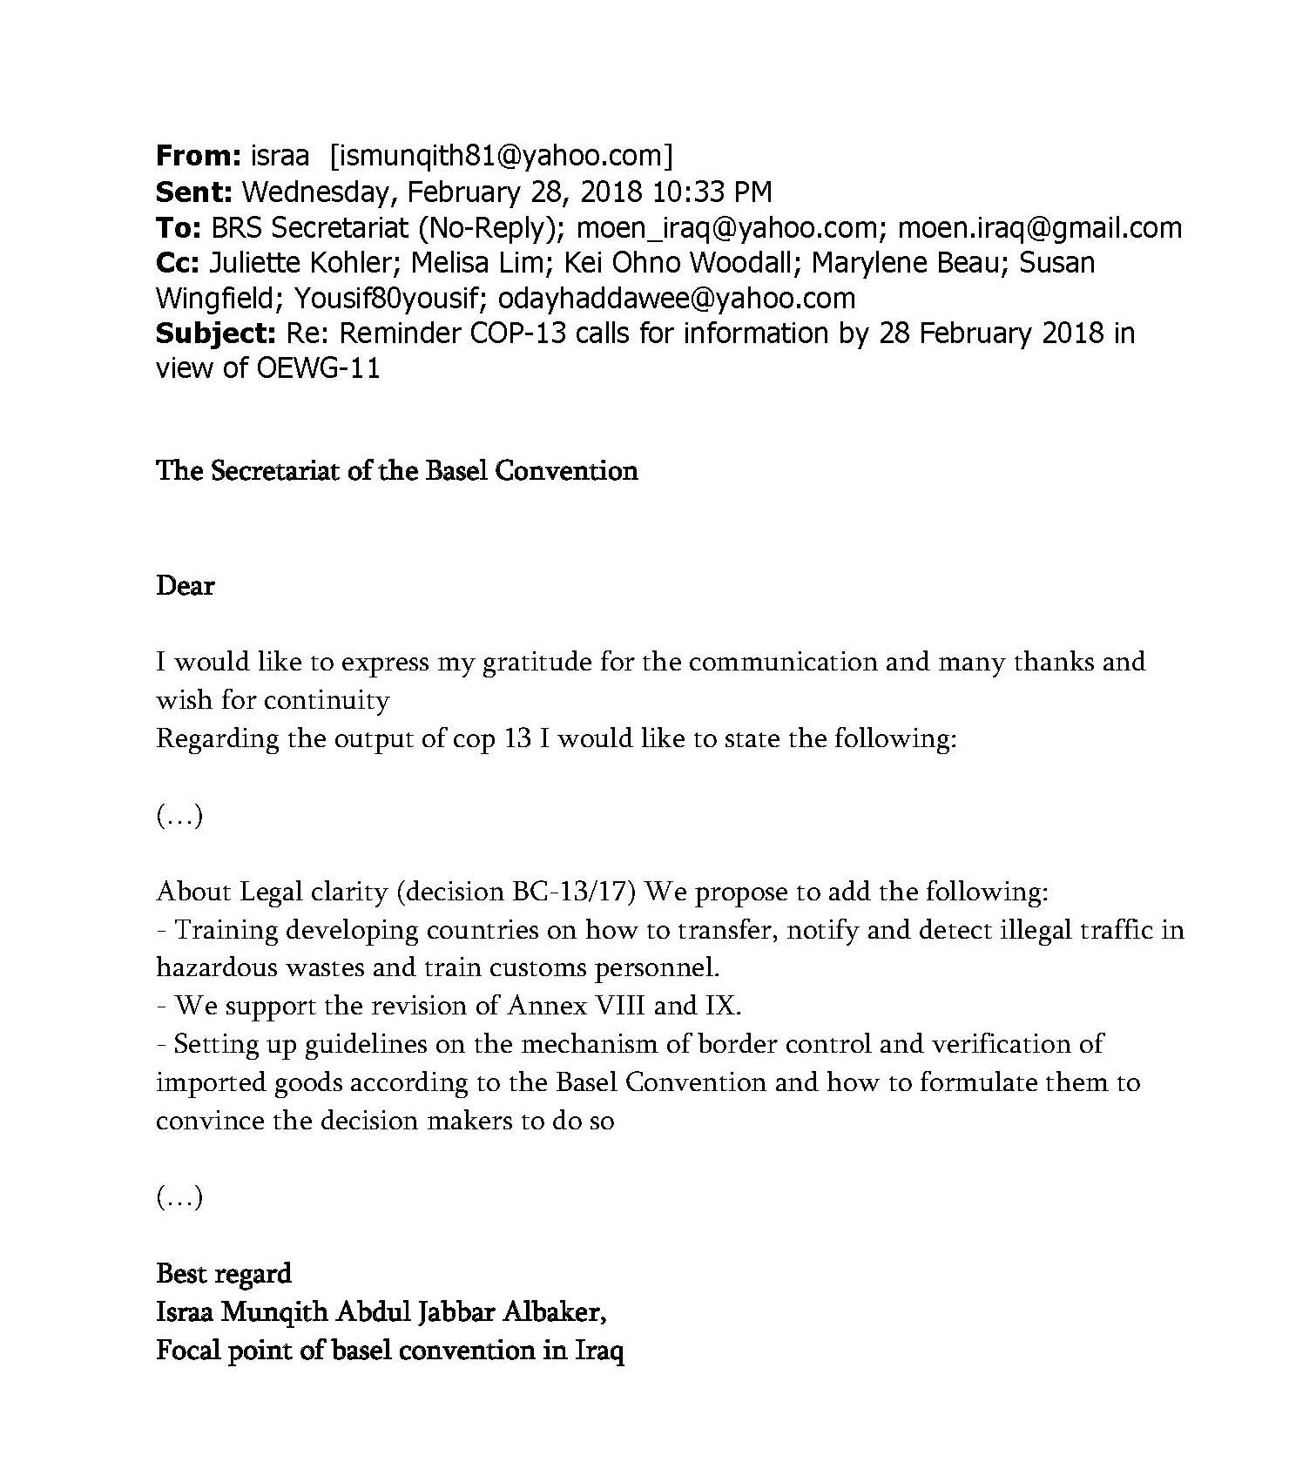

Madagascar
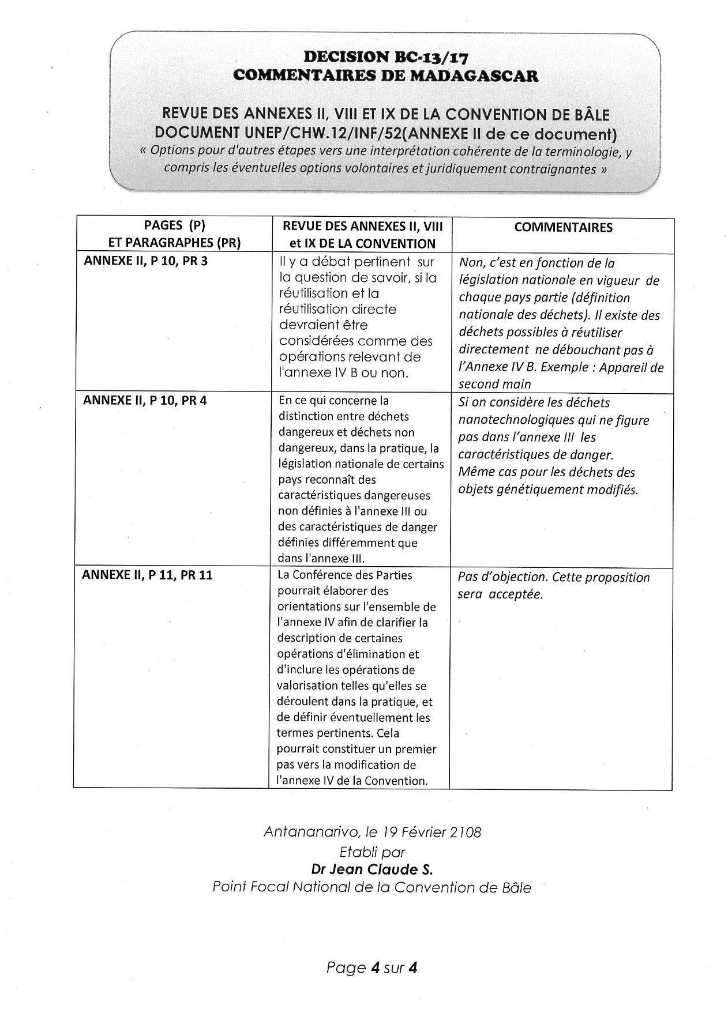

Mexico
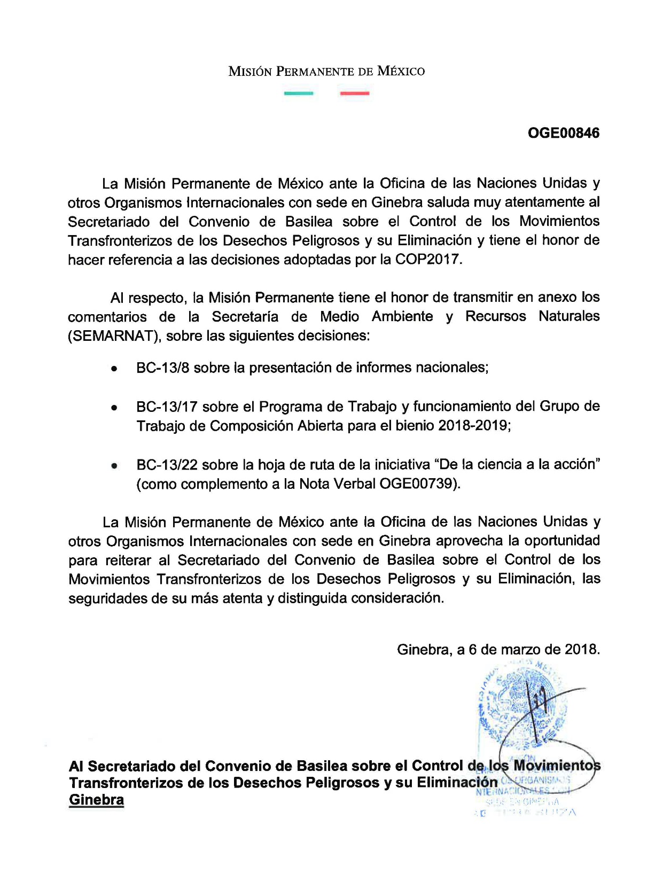

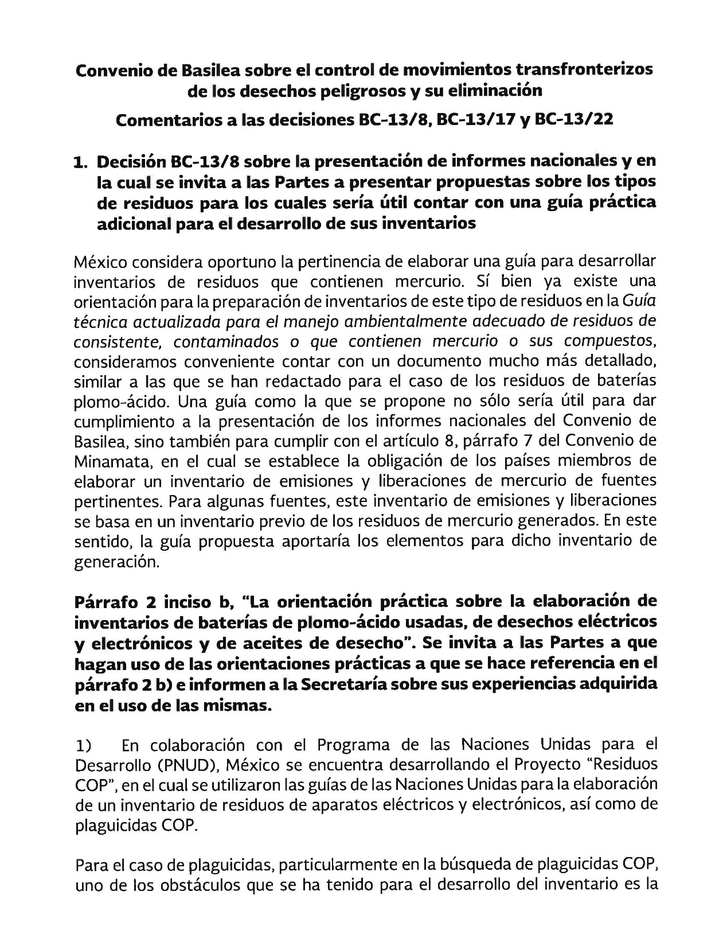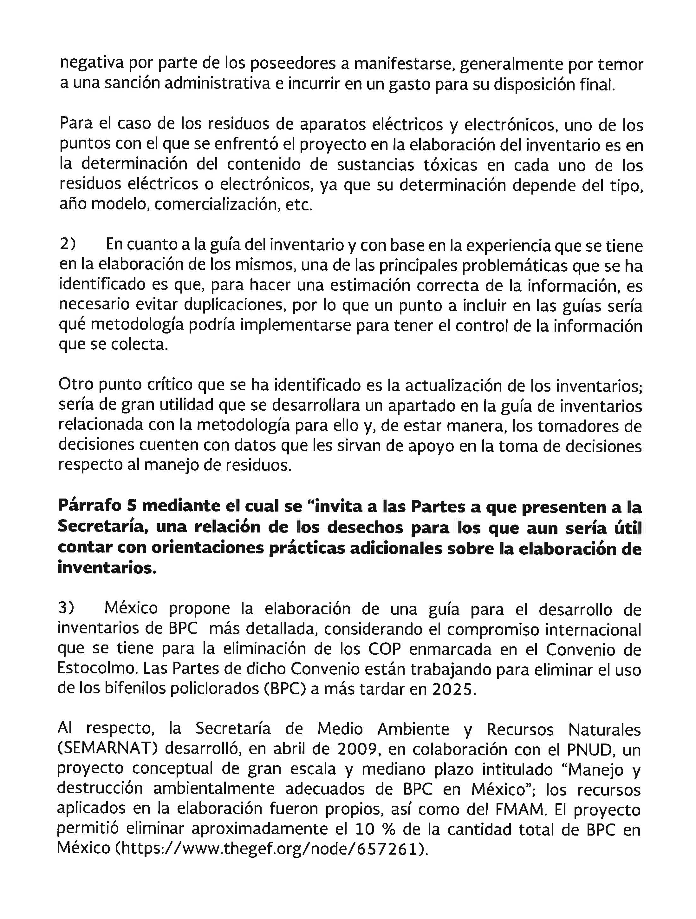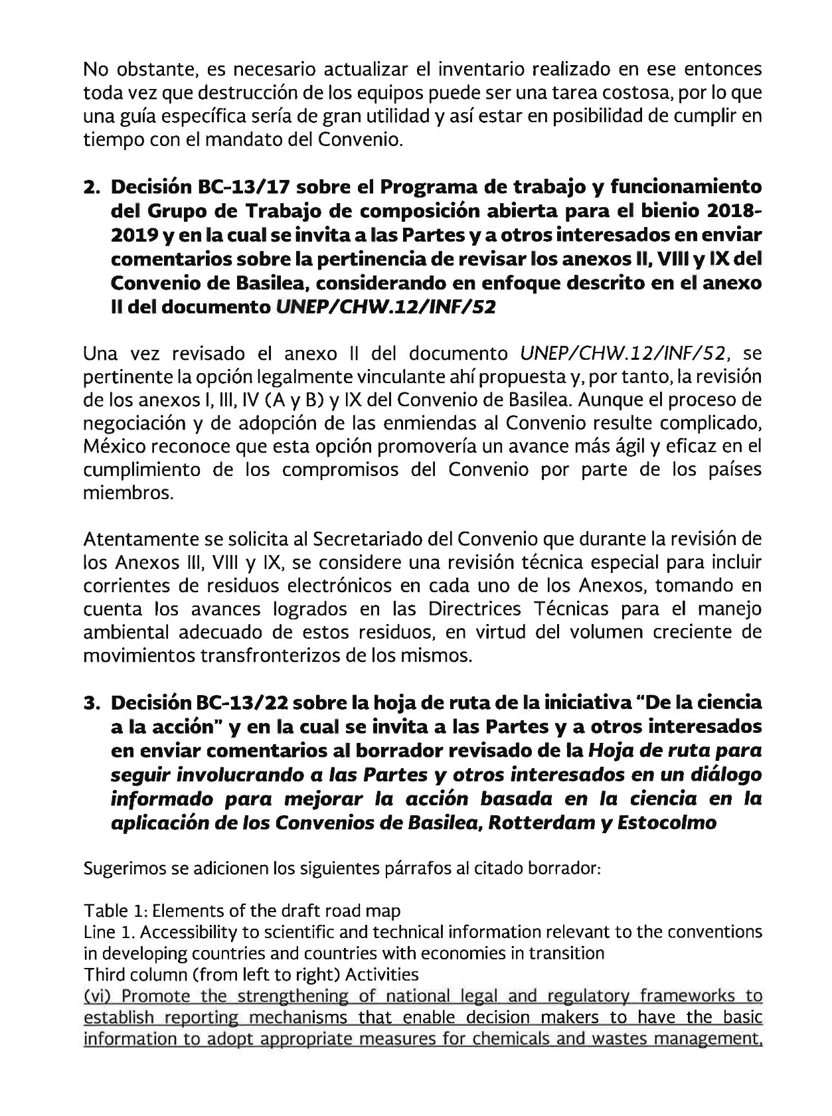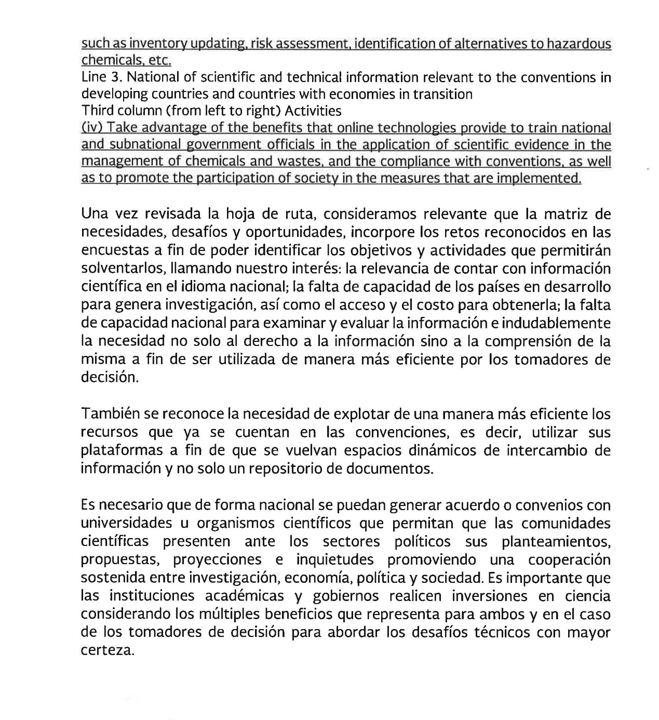

Philippines
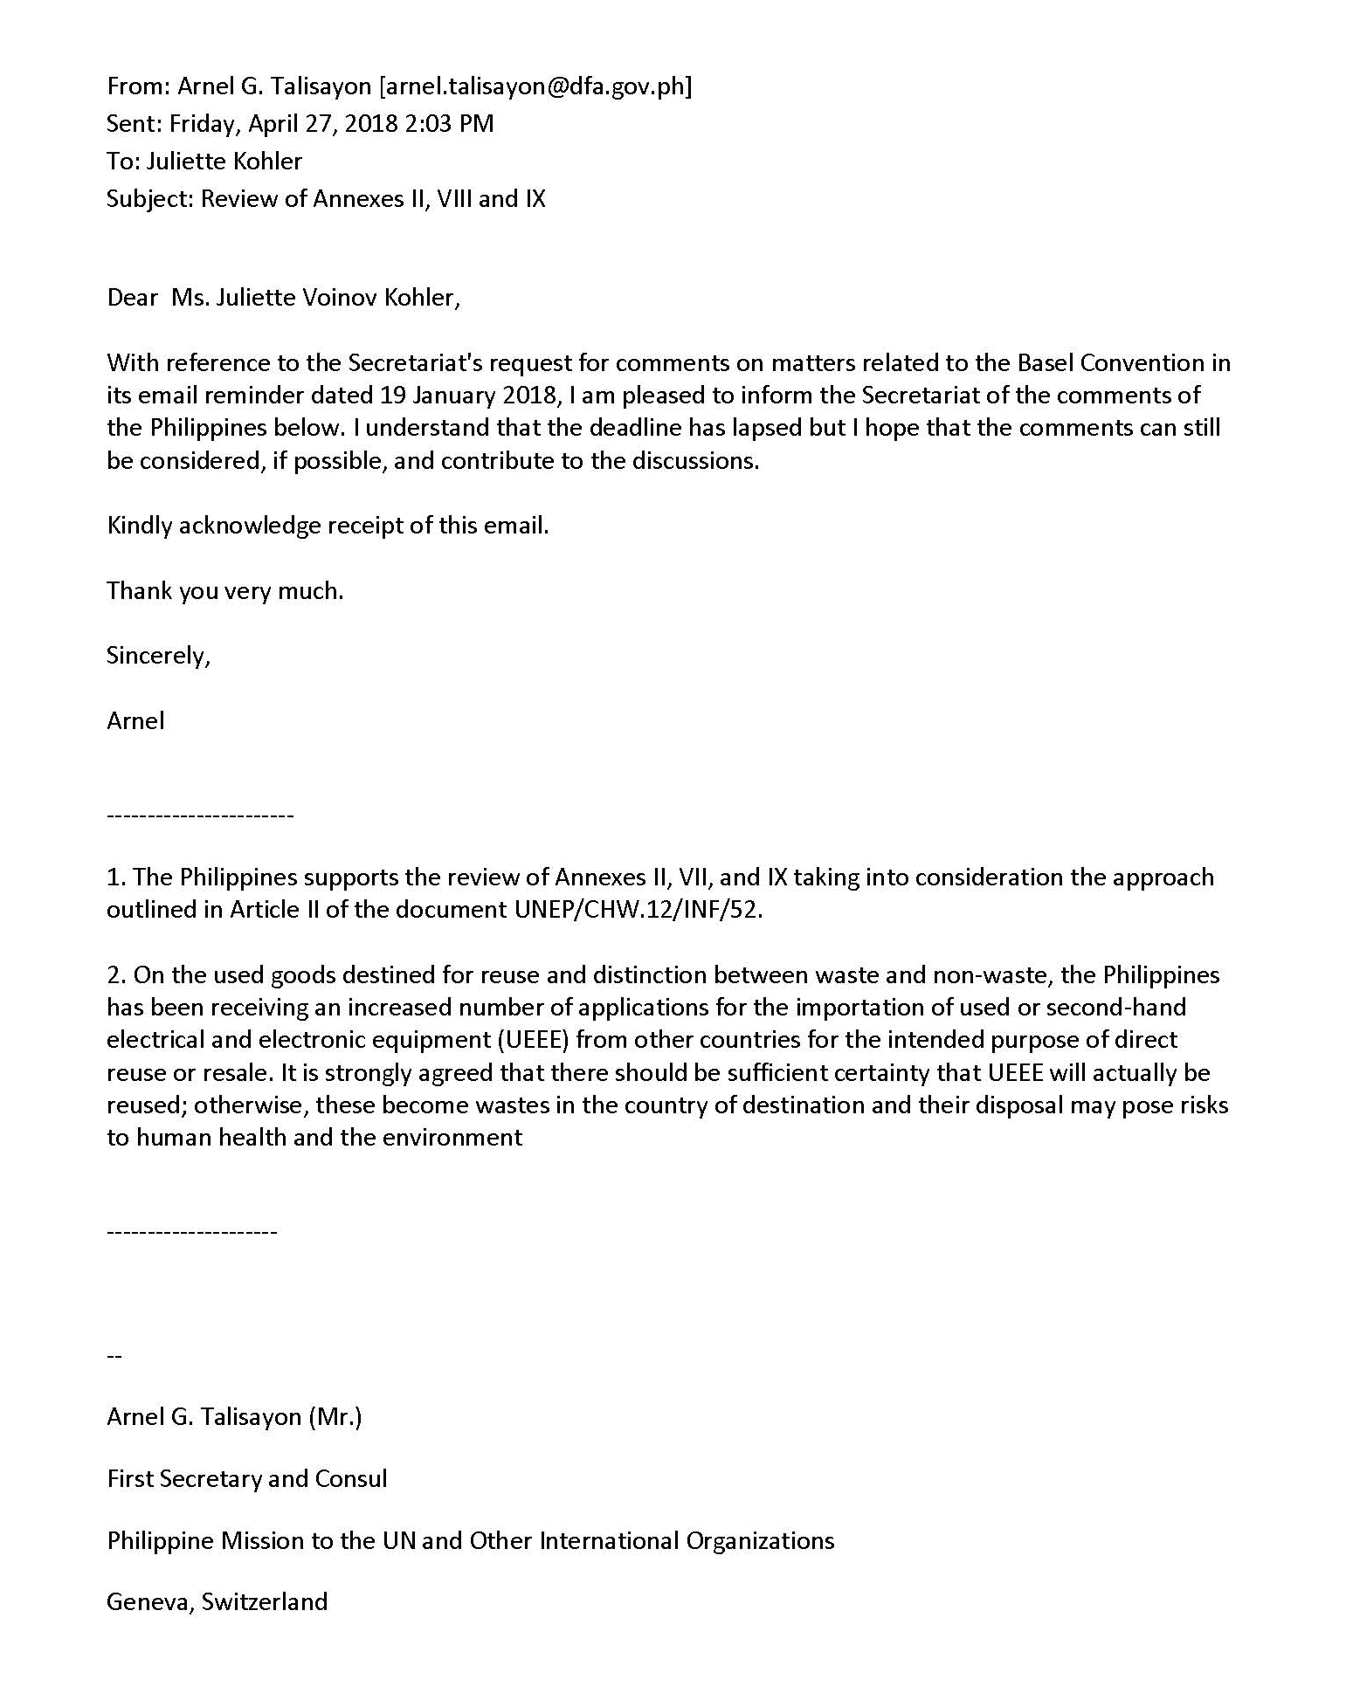

____________________

∗ UNEP/CHW/OEWG.11/1/Rev.1.
See http://www.basel.int/Implementation/LegalMatters/LegalClarity/ReviewofAnnexes/AnnexesII,VIIIandIX/tabid/6270/Default.aspx

